Summer Holiday 2021 in St. Anton am Arlberg, Austria
Safe spaces to reenergise
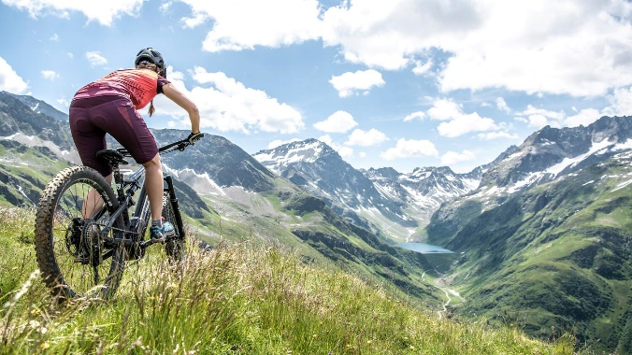
What makes the perfect Tyrolean mountain summer? For some, it's exhilarating moments in the great outdoors. Mountain air, lush greenery and panoramic views that banish everyday life from the mind and flood the senses with alpine sunshine. For others, its replenishing flagging energy levels with active sports, steering their bikes along scenic trails or around challenging serpentine bends, allowing their boot-clad and enthusiastic feet to carry them through the landscape, before savouring that inimitable adrenalin rush on reaching a mountain summit. Some, on the other hand, prefer a more laid-back holiday and set off to explore the local history, immersing themselves in the myths and legends of exciting historic sites. If you want to be part of all of this, why not spend your mountain summer in the St. Anton am Arlberg region? The season starts on 19th June 2021. Current information on safety measures can be found here. www.stantonamarlberg.com
Photo Swap the ascent for a view - summery St. Anton am Arlberg/Tyrol epitomises alpine nature and authentic mountain sports experiences for every level of ability.
Picture courtesy of: St. Anton am Arlberg Tourist Board/photographer Patrick Bätz

Biking, hiking, alpine summit experiences. With fitness training included: lower oxygen levels at medium altitudes are a valuable side-effect of mountain sports, which is why many athletes take advantage of the myriad of opportunities for fitness and endurance training in St. Anton am Arlberg (1,304 metres above sea level). Speedy mountain ascents are facilitated by Arlberg cable cars that whisk holidaymakers to Mounts Rendl, Gampen, Kapall, Galzig and the 2,811-metre high Valluga. Once at the top, nature enthusiasts will discover a huge variety of hiking tours, food lovers can sample culinary delights at rustic mountain inns, while holidaymakers have ample room to enjoy the perfect mountain summer.

For families with kids. Parents don't have to wait until Hoppl the floppy-eared mascot takes off with their young ones before they can relax on holiday. From Mondays to Fridays, four to sixteen-year-olds learn all kinds of practical things during the professionally guided forays through nature, such as how to build a dam or a sundial. Families are also highly recommended to visit the pram friendly Verwalltal Valley, not far from the village centre. The flat cycling or hiking route leads past natural playgrounds, interactive stations on local myths and legends, as well as the emerald green Lake Verwallsee, whose magnificence is truly captivating.

The ticket to your holiday. Anyone visiting the St. Anton am Arlberg region, even for as little as one night's stay in a hotel or guesthouse, receives the St. Anton Summer Card. The free ticket is valid for the entire duration of your stay and includes many free services, as well as special rates on an array of activities.

Events and dates in summer 2021

Start of the summer season: 19th June 2021

E-Bike Fest from 25th to 27th June 2021. Electric exhilaration put to the test and alpine combinations in summer: at the third E-Bike Festival, there will also be guided "E-bike & Hike" tours in the mountain world of St. Anton am Arlberg for the first time on all three days of the event.

Montafon Arlberg Marathon on 10th July 2021. Possibly the most beautiful mountain marathon in the Alps takes its participants over the provincial border and some 42 kilometres (1,600 metres in elevation difference), through alpine forest and hiking trails and the Verwall European Nature Reserve to St. Anton am Arlberg.

Arlberg Giro on 1st August 2021. This classic road bike race on narrow tyres takes its contenders from St. Anton over the Arlberg Pass to Bludenz, through Montafon, over the Silvretta High Alpine Road and back via Paznauntal, over a route encompassing 150 kilometres and 2,500 metres in elevation difference.

Dynafit Transalpine-Run on 5th and 6th September 2021. Probably Europe's toughest Alpine crossing from Hirschegg in Kleinwalsertal/Vorarlberg to Sulden am Ortler/South Tyrol takes ambitious trail runners into the mountain world of St. Anton am Arlberg in Tyrol over two stages.

Mountain Yoga Festival from 9th to 12th September 2021. Take a deep breath, roll out your mat and soak up the the energy: the international yoga scene is convening in St. Anton am Arlberg for the fifth time. All sessions and workshops are based on the motto stronger together.

… all topics and dates in the detailed summer overview

