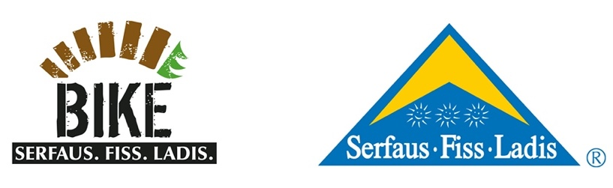
On the hunt for the best bike reel -
Serfaus-Fiss-Ladis presents the #bestbikereel challenge
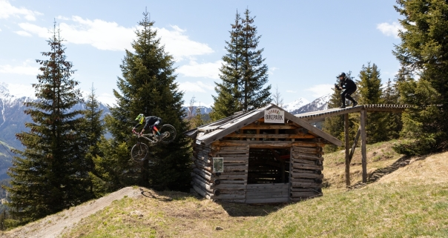

Serfaus-Fiss-Ladis, Austria - After the incredible success of last year's #bestbikebanger challenge, the family-friendly holiday region Serfaus-Fiss-Ladis, situated on the sunny plateau high above the Tyrolean Upper Inntal valley, is going to challenge bike guests once again. With the #bestbikereel challenge - the competition for the best bike reel – the 2021 season offers another chance to win attractive prizes. Any rider with an Instagram account and a smartphone who has reached the age of 16 can take part. All videos from the Bikepark Serfaus-Fiss-Ladis as well as clips created on the surrounding single trails that are posted with the hashtags #serfausfissladis and #bestbikereel and on which the account @bikeparkserfausfissladis has been tagged, will be part of the challenge. To help riders get started, Fabio Wibmer’s cinematographer Marius Prell – known for his work on films like “Urban Freeride Lives 3” or “Home Office” – gives tips for the perfect reel.
For the 2021 season, everything in Serfaus-Fiss-Ladis revolves around the best bike clip. The #bestbikereel challenge is hosted on Instagram and the bike region is looking for the best bike clip, or more precisely, the best bike reel from the Serfaus-Fiss-Ladis family region. There are almost no limits to your creativity - the lush range of routes in the bike park and the surrounding single trail network offer the perfect amount of variety and enable various approaches to video creation across all disciplines.
To set the mood for the challenge, professional filmmaker and editor Marius Prell gives you his tips and tricks for the perfect clip. In the video, he explains and illustrates what to keep in mind when filming and how to put the finishing touches on your #bestbikereel.
youtu.be/H7V5mRLNQgY
The jury, made up of Marius Prell himself as well as representatives of the Serfaus-Fiss-Ladis Tourist Board and the Bikepark Serfaus-Fiss-Ladis, will announce the winner of the #bestbikereel challenge at the end of the bike season. The winner can look forward to a stay of two nights with breakfast in Serfaus-Fiss-Ladis, including All-Mountain Ride tickets for the Serfaus-Fiss-Ladis bike region for a family of four for the 2022 summer season.
“When I was asked whether I would like to be a judge in this year's #bestbikereel challenge, I was really happy. I love the idea of the challenge and I am sure that we will see a lot of good content. Of course, as a filmmaker, I will pay particular attention to the camera work and the general quality of the video clips. To give the participants a helping hand while filming, we shot a little tutorial with simple tricks for better videos in the Bikepark Serfaus-Fiss-Ladis. I can’t wait to see the first clips and I keep my fingers crossed for all participants!” – Marius Prell.
Please find Marius’ answers to the most crucial questions here in a short interview:
Filming with a smartphone - is that possible?
Absolutely. Smartphones nowadays have amazing capabilities when it comes to the integrated camera. Use wide angles when it makes sense. Practice good framing and keep the camera steady, that's what distinguishes a good beginner from someone whom you should rather not hand a camera, haha.
What tips do you have for correct positioning when filming?
That’s difficult to answer. Make sure that your protagonist is free, especially when you’re in the forest. If you can't really see him or her in front of the trees in the background or because of the dark jersey, the shot quickly gets muddy. So you should make sure that you can do it clean. It’s a question of framing, the aperture that can blur the background, clothing, light, etc.!
How do I recognize interesting objects/sceneries?
Your favourite feature can be anything, a beautiful panorama, a puddle that reflects, the bike train with your buddies. There will always be a new best shot somewhere down the road. Interesting scenarios can be found anytime and anywhere, and every weather situation has new ones up its sleeve. A flow line that looks boring in the sun simply gives off the coolest scenarios in the fog and is a must for filming. But the most important thing is to have fun while doing it.
To take part in the competition, you must be at least 16 years old and have an Instagram account and a smartphone. It is also important to tag the posts with the hashtags #bestbikereel and #serfausfissladis and to tag the Instagram account @bikeparkserfausfissladis directly in the reel (not the caption!). That’s it!
All posts from the 2021 season (12 June 2021 – 17 October 2021) that meet the above requirements will automatically be counted. So, get your camera ready and live out the perfect holiday – with either an exciting or relaxing stay in the Serfaus-Fiss-Ladis bike region.
All information about the #bestbikereel challenge in Serfaus-Fiss-Ladis and its terms and conditions can be found here: www.bike-sfl.at/en/service/bike-challenge
Further information on biking in Serfaus-Fiss-Ladis is available at: www.bike-sfl.at/en. Details on the Serfaus-Fiss-Ladis holiday region, the precautions and measures relating to the current Covid situation as well as information on the possibilities to refund or postpone your stay can be found at www.serfaus-fiss-ladis.at/en.
Find us on:
#bestbikereel #serfausfissladis #wearefamily #weilwirsgeniessen
#bikesfl #bikeparksfl #bikeschulesfl #gooddaysfl
Reprint free of charge
Copy requested
Texts and pictures for download: www.bike-sfl.at/en/service/press
Media Contact:
Serfaus-Fiss-Ladis Tourist Board
Alexandra Hangl
Gänsackerweg 2
6534 Serfaus
Telefon: +43 (0)5476 6239 72
E-Mail: a.hangl@serfaus-fiss-ladis.at
About the region Serfaus-Fiss-Ladis
Serfaus-Fiss-Ladis is the place to be for a family holiday. Regardless whether it is summer or winter, there is always something going on. In summer the cable cars and bus shuttles connect the mountainous region of Serfaus-Fiss-Ladis. Apart from many other attractions the Serfaus-Fiss-Ladis high plateau offers bike fun for the whole family. From gentle bike rides for young and old, to mountain bike tours in the middle of breath-taking mountain scenery, to action-packed descents on single trails or courses through Bikepark Serfaus-Fiss-Ladis. The Waldbahn takes riders and their bikes to the trails within the bike park, which have different levels of difficulty from blue (easy) and red (medium) to black (expert). There is also a kids park, slopestyle area with a landing bag, pumptrack, dirt line and training area at the bottom station, where beginners can try out and get used to their new equipment. Experts in the bike shop advise in bike and safety equipment matters and the bike school and rental office shop can also be found here. Beside the shop there is also a chill out area and a snack bar.

