St. Anton am Arlberg, Austria, Tyrol
Family delights and Tyrolean summer ambiance

Enjoy a leisurely hike to alpine pasturelands early in the morning and welcome the new day with a picnic on a flower-strewn meadow. After a refreshing splash in a mountain stream, parents and children can make plans on how to spend the rest of the day: Who fancies a climb on the high and low rope course? How about an (e)-mountain bike tour? Do we want to watch the wildlife, or would we rather go canyoning? Families can enjoy a varied yet relaxed summer holiday in the Austrian region of St. Anton am Arlberg. Everything is so close together, it's easy to reconcile a wide variety of interests, while the St. Anton Summer Card allows families to enjoy many extras, including free participation in the weekly and children’s programme.
Photo (download): The Verwalltal Valley recreation area and emerald-green Verwallsee Lake are popular destinations in the Tyrolean region of St. Anton am Arlberg, not just for families.
Picture courtesy of: St. Anton am Arlberg Tourist Board/photographer Patrick Bätz

For buggy pilots, trackers and budding climbers. Parents don't have to wait until Hoppl the floppy-eared mascot takes off with their young ones before they can relax. From Mondays to Fridays, four to sixteen-year-olds learn all kinds of practical things during the professionally guided forays through nature, such as how to build a dam or a sundial, while mum and dad indulge in the essential pleasures of rest and relaxation. Families are also highly recommended to visit the pram friendly Verwalltal Valley, not far from the village centre. Its flat cycling or hiking route leads past natural playgrounds, interactive stations on local myths and legends, a climbing area and the emerald green Verwallsee Lake, whose magnificence is truly captivating. The Stanzertal cycle path between St. Anton am Arlberg and Schnann is asphalted from start to finish, making it particularly suitable for families with small children.

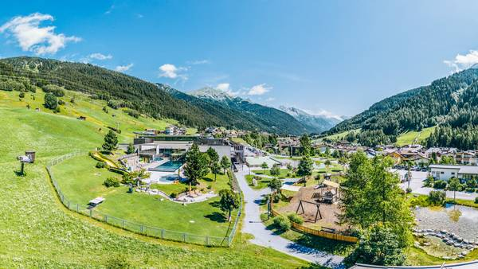
New: quiz tour through the village. In summer 2021, the range of activities for families in St. Anton am Arlberg will be extended with the Detective Trail, where guests can playfully learn interesting facts about the Tyrolean mountain village and its eventful history along an interactive scavenger hunt. The creative quiz tour begins and ends at the tourist information office and includes 14 stops along a route that encompasses around five kilometres, including the Galzigbahn cable car with its visionary "Ferris wheel", the old railway station and remains of Arlen Castle at Schlosskopf, in the St. Anton district of Nasserein. Route descriptions and pictures guide "detectives" from puzzle to puzzle, to be solved with the help of on-the-spot clues. Price from € 7 (incl. a small surprise at the finish), children up to age of 6 can participate free.
Photo (download): From summer 2021, families can take part in the “Detective Trail”, an interactive scavenger hunt through St. Anton am Arlberg/Austria
Picture courtesy of: St. Anton am Arlberg Tourist Board/photographer Patrick Bätz

Hiking holidays for inquisitive kids. The “Mutspuren - Feel the Courage” Panorama Trail on Galzig at 2,100 metres above sea level is conveniently accessible via cable car. Once at the top, families can learn about the St. Anton am Arlberg region’s fascinating history at the lovingly designed “Erlebniswelt - Adventure World”. Another loop trail with treasure hunt entitled “Faith and History” in the neighbouring municipality of Schann, focuses on various themes such as the Swabian Children, alpine farming and the ”Golden City“. Senn’s WonderWalkingTrail at the Sennhütte above St. Anton am Arlberg offers just as much entertainment. The trail extends to Lake Maiensee in St. Christoph and connects adventure stations in the herb garden, on the tree house, along the "Kuh'len Weg" trail or in the WunderWald Forest, where QR codes facilitate convenient smartphone assistance. The various stages were awarded the golden innovation prize for ”Ideas and Nature“ and ”Best Offer for Children”. Trained herbalist and Sennhütte hostess, Tanja Senn, also organises weekly guided tours.

A blooming world record. Every year in August, a small floral "Sennsation" is presented above St. Anton am Arlberg in Austria: where well over 100,000 edelweiss flowers grow in the form of a single giant edelweiss at the Sennhütte. The world's largest flower arrangement has also been officially listed by Guinness World Records since 2017. Visitors can find out more about this powerful alpine symbol at the Edelweiss-Stadl and adjacent nature trail, which is part of the WonderWalkingTrail.

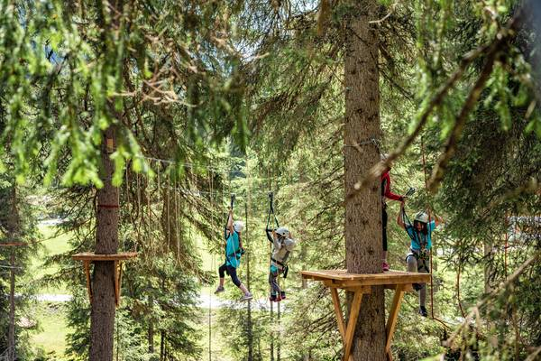
The Versatile Verwall Valley. A particularly charming hiking and cycling route leads through the Verwalltal recreation area, not far from St. Anton's village centre. Passing alpine meadows, forests, mountain streams and the emerald green Lake Verwallsee, the trail is flat and easy to negotiate, even when using a pram. Young climbing fans especially will enjoy making a stop at the high and low rope course, with a total of 22 climbing stations at heights of up to twelve metres. Those that dare can conquer their fear of heights on the “Flying Fox” zip wire over the Rosanna Gorge. There is a playground with a fire pit by the lake and another grill and picnic area near the Wagner Hut (open daily from 10 am to 6 pm). Interactive nature stations allow kids to playfully immerse themselves in the myths and legends of the Tyrolean region of St. Anton am Arlberg. The 35 metre long steel cable suspension bridge at the waterfall has also provided many an adrenalin rush, while bike enthusiasts can look forward to sampling the delights of the Pump Track, Northshore Trail and Kick-Off & Co. at the “EldoRADo“ Bike Areal. "EldoRADo” also features easy curves and obstacles for younger riders and is even suitable for balance bikes.
Photo (download): Like Tarzan in Tyrol - the high and low rope course in the Verwalltal valley of St. Anton am Arlberg is home to 22 climbing stations at heights of up to twelve metres.
Picture courtesy of: St. Anton am Arlberg Tourist Board/photographer Patrick Bätz

