St. Anton am Arlberg, Tyrol: Upgrade for your ski holiday
Winter start with a world first

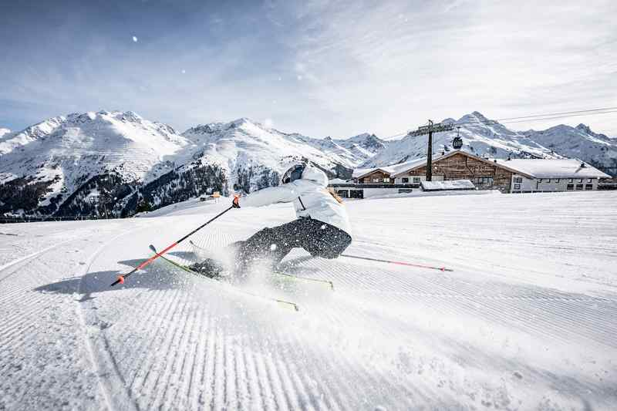
When the lifts and cable cars of St. Anton am Arlberg commence operations for the new winter season, holidaymakers can once again glide up to the perfectly groomed slopes of the world's fifth largest ski resort. A total of over 300 kilometres of marked slopes as well as 200 kilometres of backcountry terrain make the return of winter at the birthplace of alpine skiing an annual highlight for every kind of snow enthusiast. Special offers ranging from discounted children's lift passes and action cameras, to combined tickets comprising of travel, accommodation and ski pass will add an upgrade or two to your Arlberg stay in winter 2021/22. Moreover, the Tyrolean region is presenting a worldwide innovation in edge grinding technology at Stanton Service Centre. Tip: Those travelling environmentally friendly by rail get off the train right in the centre of St. Anton am Arlberg. www.stantonamarlberg.com
Photo (download): Back with a bang - the new ski season in St. Anton am Arlberg/Austria
Picture courtesy of: St. Anton am Arlberg Tourist Board/photographer Patrick Bätz

Always at the cutting edge. As the birthplace of Alpine skiing, St. Anton am Arlberg has shaped the history of winter sports. True to its reputation as the "Silicon Valley of Tyrol,” the mountain village has once again come up with an innovation that is a real world first for the industry. Stanton Service Centre, the largest workshop of its kind, will be using revolutionary V Edge Technology from world market leader Wintersteiger for edge grinding from now on. The ingenious "fine-tuning" twist: while the edge angle varies at the front and back of the ski, it remains constant in the binding area. The result is optimum edge grip and and effortless turns on the mountain. This translates to easy control for skiers of every ability and an entirely new skiing experience.

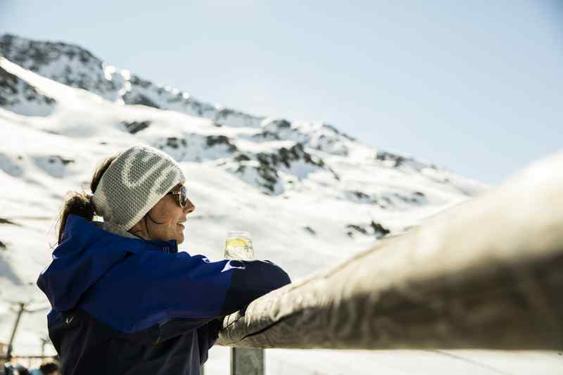
Ladies First at Arlberg. Female winter sports lovers enjoy some very special benefits in and around St. Anton am Arlberg from 8th to 29th January 2022. An attractive programme with an array of special perks and discounts for spas, shopping, restaurants and on the slopes await them as part of the “Ladies First” weeks. St. Anton am Arlberg tourist office has a personal "Ladies First Book" and a small welcome gift ready for every lady staying in in St. Anton, Pettneu, Flirsch or Strengen.
Photo (download): Good prospects for her - as part of the “Ladies First” weeks, St. Anton am Arlberg Tourist Board has special conditions and offers in store in January 2022
Picture courtesy of: St. Anton am Arlberg Tourist Board/photographer Christoph Schöch

Children’s season ticket for ten Euros. Children up to the age of eight (born in 2014 or later) can ski throughout the entire St. Anton am Arlberg ski resort all winter long for just ten euros with the “Snowman” ticket.”. Young skiers are able to look for hidden forest inhabitants and playfully learn the FIS skiing rules along the Hoppelweg Trail together with the ski school mascot, Hoppl the Hare. Despite its sporting reputation, the Arlberg region is also well geared up for younger skiers, with 130 kilometres of blue runs and many designated nursery slopes. It is with good reason that kids who have learnt to ski here are particularly confident on the slopes.

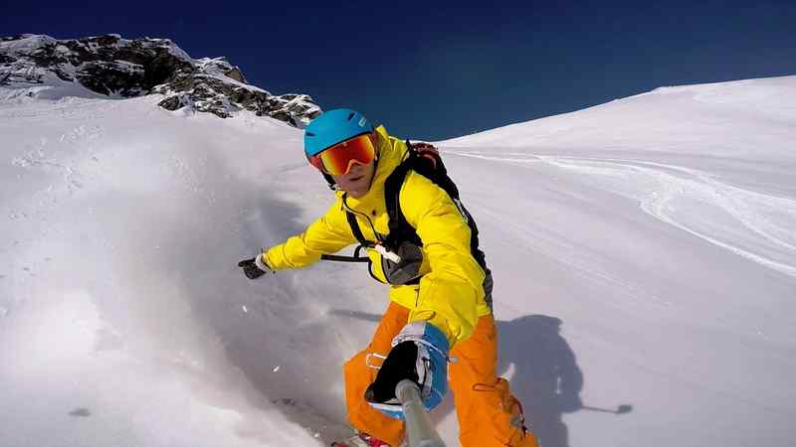
Ski holidays to go. Whether attached to your chest, as an extension of your arm, or mounted in classic style on your helmet: From the end of January to mid-April 2022, holidaymakers will once again be able to capture their skiing fun in St. Anton am Arlberg with the latest action camera models and free of charge. The pros from Mountain Media Center then edit the recorded sequences and transform them into a personal video with soundtrack, which is then available to download or view on YouTube. The daily “Sun & Snow Report“ for the Tyrolean region also makes use of the roughly one-minute clips.
Photo (download): Deep-snow fun at your fingertips - holidaymakers can equip themselves with diverse action cameras for free at the MountainMediaCenter in St. Anton am Arlberg until April 2022
Picture courtesy of: MountainMediaCenter

Comfortable and climate-neutral travel. Austrian Rail (ÖBB) is offering special combined tickets for guests from certain regions again in winter 2021/22. Holidaymakers can travel comfortably to St. Anton am Arlberg from Hamburg, Düsseldorf, Amsterdam, Vienna or Graz without the nuisance of traffic. The Nightjet Combi-Ticket includes the train journey (return) in the ÖBB Nightjet including seat reservation, a 3 to 6-day lift pass, as well as transfer to the desired hotel in the Tyrolean mountain village. For more information and bookings, please visit: kombitickets.railtours.at

Further information is available from the Information Office in St. Anton am Arlberg/Austria
under +43 5446 2269-0 or www.stantonamarlberg.com

About St. Anton am Arlberg. St. Anton am Arlberg is one of the world’s most renowned winter sports resorts. Skiers and freeride fans from over 50 nations visit this mountain village and ski area with a total of over 300 kilometres of marked runs, 200 kilometres of backcountry terrain and 88 lift and cable car systems every year. The Arlberg-Arena extends from St. Anton in Tyrol to Lech and Zürs, as well as Warth and Schröcken in Vorarlberg. Cross-country skiing, tobogganing or a tour of one of the most beautiful winter via ferrate routes in the Alps are just as inherent to the inimitable Arlberg experience as its iconic events, international World Cup races and multi-award-winning Tyrolean cuisine. The “birthplace of alpine skiing” is also a founding member of the “Best of the Alps“; a quality association of the 13 most prestigious mountain resorts in the Alps.

