Winter holidays with or without skis in St. Anton am Arlberg, Austria
Crunching snow and climbing

When the lifts and cable cars of St. Anton am Arlberg commence operations for the new ski season, holidaymakers will once again glide up to the perfectly groomed slopes of one of the most snow-sure winter ski resorts in the Alps. This Tyrolean mountain village is, however, not only popular with ski fans: Those who fancy leaving their skis or board at home for a change, or not hit the slopes at all, have a plethora of thrilling activities to choose from. www.stantonamarlberg.com

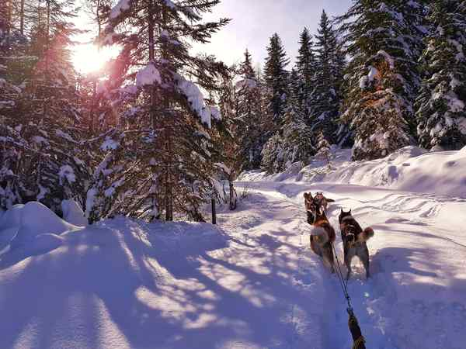
A whole pack of new winter adventures. They are considered intelligent, gentle and just as soft as fresh powder snow: Huskies are heading to St. Anton am Arlberg! From season 2021/22, the Austrian region will offer guided husky tours by Wild Paws Adventures for the first time. On Monday and Friday mornings, holidaymakers with or without children can accompany these tenacious dogs on foot or sleds through the spectacular winter landscapes surrounding this Tyrolean mountain village. Sled rides start at 9 hrs (1 to 1.5 hours in duration), walks start at 11 hrs (1.5 hours). Please visit www.stantonamarlberg.com for information and registration
Photo (download): Furry winter adventures - holidaymakers can go on husky tours for the first time in St. Anton am Arlberg/Tirol in the 2021/22 season. Picture courtesy of: Wild Paws Adventures++

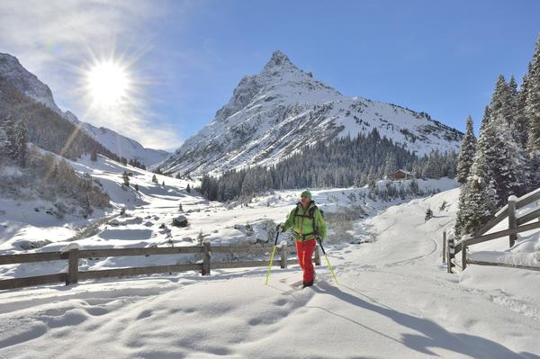
On foot or boards. Almost no other sound defines winter pleasure so succinctly as the sound of snow crunching beneath one’s boots. Hikers with sturdy footwear can explore the area around St. Anton am Arlberg along 17 sign-posted routes, including the snow-covered landscapes of the mystical Verwalltal Valley (10 kilometre round trip), or the ice crystal coated landscape of Erlen on the “Stanzertaler Rundwanderweg” (Stanzertal circuit - 24 kilometre round walk). A shorter route leads to Gasthof Almfrieden (6 kilometres), while the winter hiking trail at Galzig (1 kilometre) can be reached by cable car. If you fancy sampling the inimitable experience of a snowshoe hike through snow-covered landscapes, you should book the services of a trained guide. Those who prefer to have “planks” underfoot whilst out and about in the driving snow, can opt for one of the seven cross-country ski trails (1.5 to 22 kilometres in length).
Photo (download): Alpine wellness with altitude training - holidaymakers can choose from seven different snowshoe tours in St. Anton am Arlberg Picture courtesy of: St. Anton am Arlberg Tourist Board/photographer Josef Mallaun

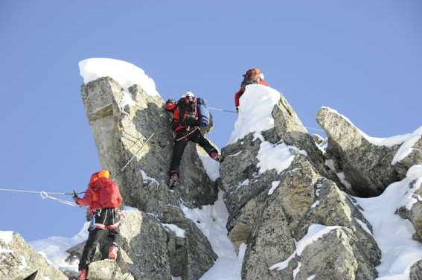
Scrambling, climbing and even flying. Tennis, volleyball, squash, bowling or bouldering are on the programme all year round at „arl.rock“ sport and climbing centre. Facilities even include a trampoline hall with a total surface area of 1,000 square metres. There are also around 100 climbing routes for beginner to professional climbers. Those with a good head for heights can see places otherwise not visible from a gondola during a tandem paragliding flight - or climb even higher than the ski lift takes you: because the entrance to one of Tyrol’s most beautiful winter climbing routes can be found at 2,645 metres above sea level near the top terminal of the Riffel II chairlift, high above St. Anton. Those wanting to attempt this high alpine ascent are recommended to do so as part of a guided tour, which can be booked with one of the St. Anton am Arlberg ski schools.
Photo (download): The scenic winter via Ferrate route on the Rendl above St. Anton am Arlberg in Austria is only suitable for experienced ski touring enthusiasts.
Picture courtesy of: St. Anton am Arlberg Tourist Board/Photographer Thomas Klimmer

About St. Anton am Arlberg. St. Anton am Arlberg is one of the world’s most renowned winter sports resorts. Skiers and freeride fans from over 50 nations visit this mountain village and ski area with a total of over 300 kilometres of marked runs, 200 kilometres of freeride terrain and 88 lift and cable car systems every year. The Arlberg-Arena extends from St. Anton in Tyrol to Lech and Zürs, as well as Warth and Schröcken in Vorarlberg. Cross-country skiing, tobogganing or a tour of one of the most beautiful winter via ferrate routes in the Alps are just as inherent to the inimitable Arlberg experience as its iconic events, international World Cup races and multi-award-winning Tyrolean cuisine. The “birthplace of alpine skiing” is also a founding member of the “Best of the Alps“; a quality association of the 13 most prestigious mountain resorts in the Alps.

