At last: Comeback of winter love(rs) to the Arlberg
St. Anton am Arlberg opens its ski slopes on 13th December 2021

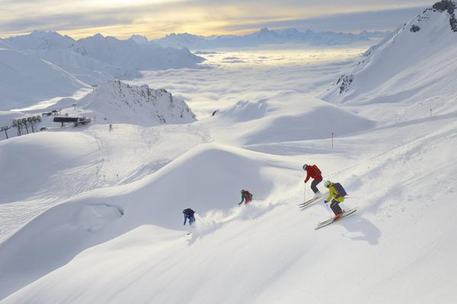
Now it's official: St. Anton am Arlberg/Tyrol and its ski area can start the winter season on 13th December 2021. "We are grateful and can hardly wait to finally be able to live out our greatest passion again - that of being hosts," says Martin Ebster, St. Anton am Arlberg’s tourism director. The resort is open exclusively for vaccinated and recovered persons. The ski area, hotels, restaurants as well as all public transport can only be accessed with proof of valid 2G certificate (vaccinated or recovered). Throughout Austria, it’s mandatory to wear FFP2 mask in all indoor areas. In the “Cradle of alpine skiing”, holidaymakers can look forward to more than 300 kilometres of marked downhill runs as well as 200 kilometres of off-piste variants. Our top priority is our guests’ safety, even before skiing, snowboarding, cross-country skiing, tobogganing or winter hiking. Information on current safety measures and rules can be found here. www.stantonamarlberg.com
Photo (download): Where freeride experts "ski down" 200 kilometres of terrain - the Austrian cosmopolitan village of St. Anton am Arlberg and its ski area start the winter season on 13 December 2021. Picture credits: TVB St. Anton am Arlberg/Photographer Sepp Mallaun

For further information contact the information office in St. Anton am Arlberg/Austria
under +43 5446 2269-0 or www.stantonamarlberg.com

About St. Anton am Arlberg. St. Anton am Arlberg is one of the world’s most renowned winter sports resorts. Skiers and freeride fans from over 50 nations visit this mountain village and ski area with a total of over 300 kilometres of marked runs, 200 kilometres of freeride terrain and 88 lift and cable car systems every year. The Arlberg-Arena extends from St. Anton in Tyrol to Lech and Zürs, as well as Warth and Schröcken in Vorarlberg. Cross-country skiing, winter hiking or a ride on one of the five winding toboggan runs in the region are just as inherent to the inimitable Arlberg experience as its iconic events, international World Cup races and multi-award-winning Tyrolean cuisine. The “birthplace of alpine skiing” is also a founding member of the “Best of the Alps“; a quality association of the 13 most prestigious mountain resorts in the Alps.

