Nordic Combined Triple Seefeld
Nordic highlight before Olympic Games

Three days, three competitions - one triple winner: from 27 to 30 January 2022, the Nordic Combined
Triple in Seefeld will be the final test of strength for the combined athletes before the Olympic Games.
A number of innovations concerning the format will provide additional excitement.
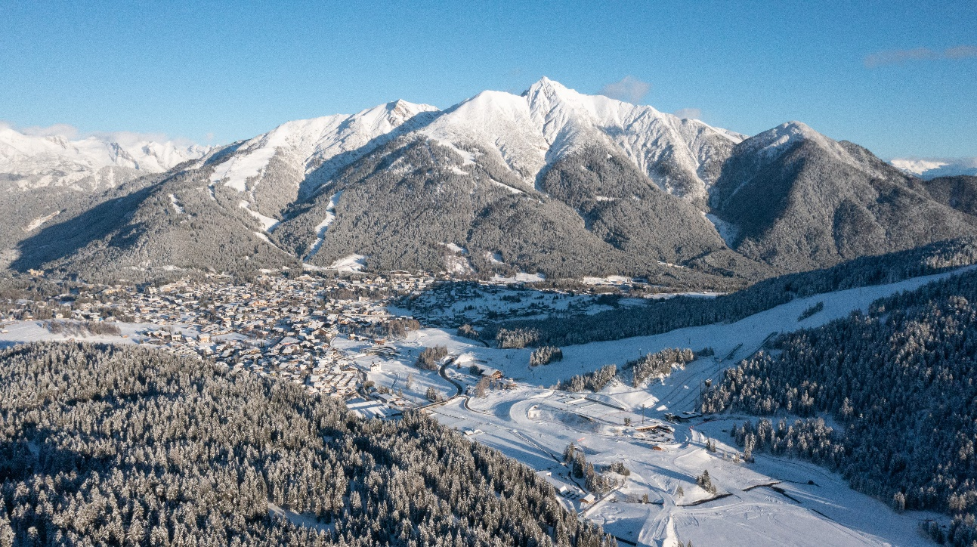
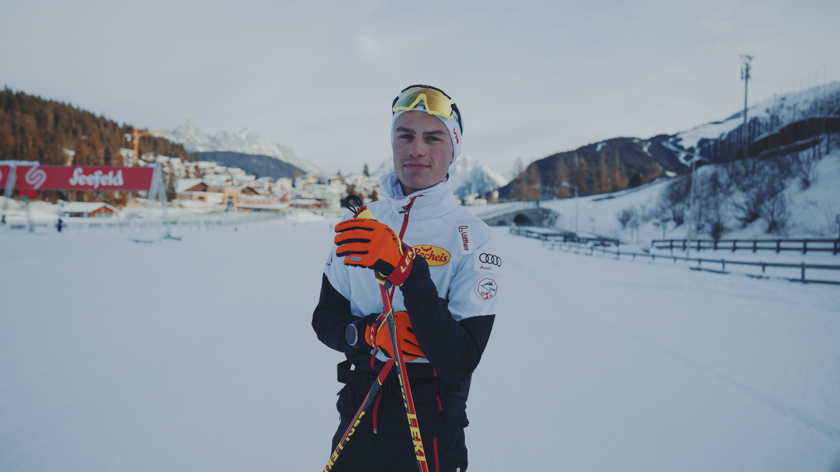
photo 1: Perfect World Championships-Infrastructur will be again site for the Nordic Combined Triple//credit: Olympiaregion Seefeld//Download in full size.
phote 2: Johannes Lamparter could celebrate his first World Cup victory last weekend in Val di Fiemme. The double World Champion prepares himself in Seefeld//credit: Bizcomburnz.com//Download in full size.
There are less than three weeks to go until a real Nordic highlight awaits on Tyrolean soil with the Nordic Combined Triple Seefeld. The seventh edition impresses with some innovations that make the format even more lively and exciting.

Distances:
Whereas on Friday, the first day of the competition, there were originally five kilometres of cross-country skiing to be completed, this year there are 7.5 kilometres. On Saturday, the ten kilometres will be maintained. Finally, 12.5 kilometres await on Sunday, instead of the usual 15. There will be a competition jump on all three days.

Starting field:
Unlike in previous editions, the number of starters will only be reduced after the first day of competition - in 2022, all participating athletes will be allowed to start on the first day, and on the other days the best 50 of the first day of competition in each case.

Bonus points:
Probably the biggest change is in the calculation of time gaps: Whereas in the past the cumulative time gaps of the previous days were taken into account, now the top 15 athletes in the daily rankings of the first and second day of the competition will receive fixed bonus points, regardless of the actual lead at the finish: "This keeps the tension up until the final day of the competition," explains Thomas Unterfrauner, OC Director of the Nordic Combined Triple.

Double the number of World Cup points and double the prize money
Whoever crosses the finish line first on the final day is the winner of the triple and can look forward to double the number of World Cup points and double the prize money in the best-paying competition of the World Cup circuit.

Austria's combined athletes eagerly await home World Cup
Austria's combined athletes, who used the World Cup infrastructure in Seefeld for their training over Christmas, are also looking forward to the highlight on home soil. So is Johannes Lamparter, who celebrated his first World Cup victory in Val di Fiemme last weekend: "The format is extremely cool and something very special. But to show top performances over three days is also extremely demanding. You have to be at the top of your game from the very first competition and you can't leave anything behind."
Norway's super combined Jarl Magnus Riiber has made his mark on the format in the past two years. However, the record winner of the Triple is Germany's Eric Frenzel, who has secured the overall victory four times in a row.
Infos Nordic Combined Triple Seefeld and https://www.weltcup-seefeld.com/en/

Copyright ©2022 Steinacher & Maier Public Relations, All rights reserved.www.smpr.at
Kontakt: Daniela Maier: dani@smpr.at // +43 664 23 422 11

