51. Euroloppet Ganghoferlauf
A REAL CLASSIC RACE, FOR SKATERS TOO.

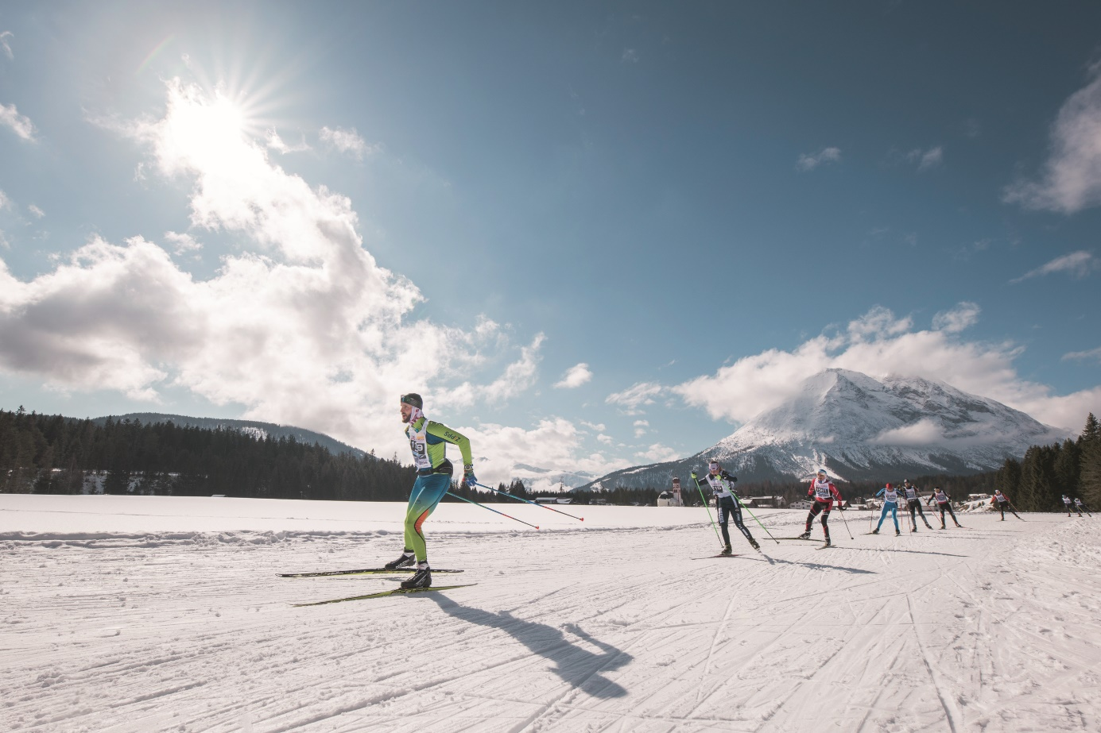

Until almost exactly 100 years ago, the Bavarian author Ludwig Ganghofer enjoyed writing his nature-loving novels in the valley, the Gaistal, near Leutasch and today, Austria's most popular cross-country race still commemorates this literary legend in name while its participants enjoy the same awe-inspiring winter landscape from the trails. After a fabulous 50th anniversary edition in spring 2020, the race was cancelled last year because of the pandemic and so is only now going into its 51st edition. From 5th to 6th March 2022 in Leutasch.
The cross-country race has long been known far beyond the Tyrolean borders. The competition distances are 25 or 50 kilometres in classic style and 20 or 42 kilometres in skating. The Ganghoferlauf
herefore offers ideal competition conditions for both amateur athletes and cross-country skiing professionals alike.
Supported by numerous volunteers, regional associations and the Leutasch Ski Club, this grandiose race is held in line with the current responsible safety concepts and in compliance with all official requirements.
The 51st Ganghoferlauf 2022 will once again be held as an official Euroloppet race and is also part of the Visma Ski Classics Challengers race series for both long distances.
Those looking for a very special challenge should register for the Ganghoferlauf Combined where you compete in both the classic and skating long distances and take part in the combined ranking!
All young skiers between the ages of 3 and 17 can also celebrate success on what is probably Austria's most spectacular cross-country skiing weekend as they take to the starting line for the Mini Ganghoferlauf on Saturday. The Special-Ganghoferlauf will also be held together with the small-scale people's race and will be sure to provide unforgettable sporting memories along the 300 or 1000 metre distances.
The varied cross-country trails of the Olympiaregion Seefeld have been open to amateur and professional athletes for their individual training needs since mid-November. Depending on fitness levels, endurance and skiing styles, the trails can be combined to allow for impressive circuits across the entire plateau.
Info & registration: www.ganghoferlauf.at

You can download free photo material HIER Photo credits must be given (Olympiaregion Seefeld incl. photographer) and are included with each photo. Reprint free of charge.

