FINALLY TOGETHER AGAIN
51st EUROLOPPET GANGHOFERLAUF

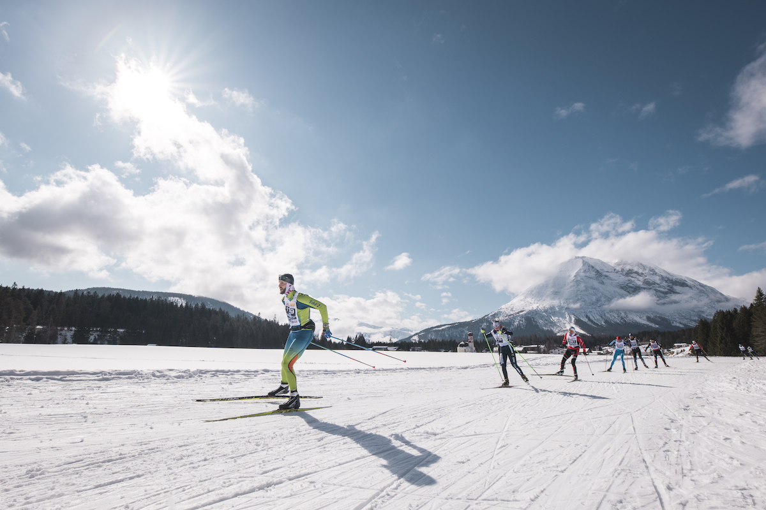

Finally, we are looking forward to celebrating real competitions again: On the weekend of March 5th and 6th 2022, the extensive Leutasch valley will once again transform into a spectacular competition arena for all the highly motivated cross-country skiers at Austria's most popular people’s run! Fittingly, this year's 51st Ganghoferlauf will be held under the motto "Finally together again".

FINALLY TOGETHER AGAIN
Since its beginnings, the Ganghofer race in Leutasch can look back on more than 50 successful events. A thoroughly impressive success story, which also significantly characterizes the continuing quality of the oldest and most popular cross-country skiing race in Austria.
After last year’s run had to be cancelled due to the pandemic for the first time in history, we are now more than pleased to be celebrating the most popular cross country race FINALLY TOGETHER AGAIN!
The legendary Ganghoferlauf was not only the last race before the first lockdown, but is also the first popular race to be held again since the beginning of the pandemic in Austria. An absolutely special occasion for all participants, organizers and volunteers alike. We really can't wait to celebrate real sports moments together again!

CLASSIK, SKATING & COMBINED
The 16-kilometer long Leutasch Valley is known far beyond the borders for its incredibly beautiful and varied trails - a true cross-country skiing El Dorado.
Starting with the classic discipline on Saturday 5th, men and women will compete over 25 and 50 kilometers. Another highlight: At the expo-area in the finish area at the Leutasch soccer field, well-known manufacturers will showcase their latest high-tech equipment and offer professional waxing services.
Sunday 6th is all about skating, with men and women competing over 20 and 42 kilometers. Whoever is up for a real challenge, may choose to compete at the Ganghofer Combined, where the classic and skating long distances of both days are ranked together.
The 51st Ganghoferlauf will again be held as an official Euroloppet race and is also part of the Visma Ski Classics Challengers race series on both long distance races.
All participants can of course again look forward to receiving numerous goodies - such as our traditional functional starter gift plus free admission to the ErlebnisWelt Alpenbad Leutasch (only at the competition weekend). There will be no big celebration after the race this year. Instead, the official flower ceremony will take place directly in the finish area, where each participant will also receive their winner's medal. Additionally, all starters will receive a meal voucher that can be redeemed in one of the many excellent restaurants in the region – for all the big moments with your small group of besties.

MINI- & SPECIAL-GANGHOFER RACE
At the traditional Mini-Ganghofer race on Saturday, all sporty youngsters between 3 and 17 are looking forward to celebrating their very first successes at the probably most renowned cross-country skiing weekend in Austria. Together with the Minis also the Special-Ganghofer will be held at 01:00 pm on Saturday – with impressive sporting moments along the 300 and 1000 meter competition distances.

LEUTASCH FEATURING A REAL LEGEND
For the 51st time in history, the popular Ganghoferlauf in Leutasch is organized and held with the incredible support of a good 15 different Leutasch clubs and countless volunteers. For a whole weekend, the entire Leutasch valley is dominated by the great run, which is traditionally organized together with the Ski Club Leutasch and the Seefeld Tourism Board. Only with the help of numerous volunteers, the legendary Ganghoferlauf finally marks an absolute highlight in the winter event calendar again.

REGISTRATION
The preparations for the Euroloppet Ganghoferlauf are already in full swing and the anticipation is growing by the day. The online registration is open until 2nd of March 2022.
From 3rd of March 2022 at 08:00 AM onwards, late registrations are due until 1 hour before the start of the respective competition via App (IOS App, Android App) or from Friday (4th of March) directly in the Race Office on site.
Info & registration: www.ganghoferlauf.at

You can download royalty-free images here.
Photo credits according to the copyright metadata of each photo. Reprint free of charge.

For inquiries:
Olympiaregion Seefeld, c/o Christian Weittenhiller | Kirchplatzl 128a, 6105 Leutasch |
+43 664 88227490 or christian.weittenhiller@seefeld.com | www.seefeld.com

THE GANGHOFER RACE IN DETAIL
Friday, 04.03.2022
5:00 bis 5:00 PM Starter Check-In & late registrations (classic race)
Saturday, 05.03.2022
from 07:00 AM Starter Check-In & late registrations classic race
from 07:00 AM Waxing-Service at the Expo-Area in the Ganghofer Ski-Stadium
09:00 AM Start 25 km and 50 km classic – adults
Flower-Ceremony shortly after finish
from 10:00 AM Starter Check-In & late registrations Mini-Ganghofer & Specials
from 1:00 PM Start Special-Ganghofer & Mini-Ganghofer
2:00 bis 5:00 PM Starter Check-In & late registrations skating race

Sunday, 06.03.2022
07:00 AM Starter Check-In & late registrations skating race
from 07:00 AM Waxing-Service at the Expo-Area in the Ganghofer Ski-Stadium
09:30 AM Start 20 km skating - adults
10:00 AM Start 42 km skating – adults
Flower-Ceremony shortly after finish

Start and finish of the competitions are located in the Ganghofer Ski-Stadium (at the Leutasch soccer field). The Flower Ceremony will take place directly at the finish area, where each participant will also receive a medal. The registration and start number distribution (Check-In) including the distribution of the raffle prizes is located in the Wettersteinhalle next to the ErlebnisWelt Alpenbad Leutasch.

Please note all valid COVID measures. We reserve the right to adjust the conditions depending on the current specifications.

