Springtime Skiing 2022 in St. Anton am Arlberg, Tyrol
Pleasure filled, groovy and spectacular fun

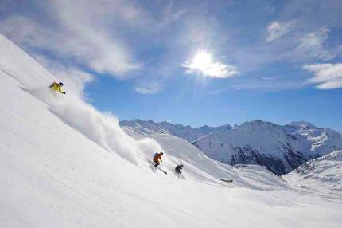
Even in springtime, winter is far from over in the Tyrolean mountain village of St. Anton am Arlberg, where guests can look forward to a varied season in the birthplace of alpine skiing right up to the 24th April 2022. With sunshine in abundance, the delights of downhill skiing can be combined with a few hours spent relaxing in a deck chair. Moreover, holidaymakers can experience a weekend full of funky music as well as what is probably the most legendary race in the Alpine region. www.stantonamarlberg.com
Photo (download): Hungry for the slopes, southern sounds and sunshine galore – the St. Anton am Arlberg/Austria region welcomes guests to springtime skiing until 24th April 2022. Picture courtesy of: St. Anton am Arlberg Tourist Board/photographer Josef Mallaun

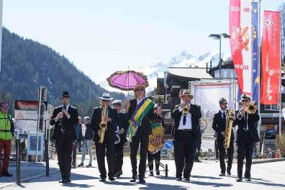
New Orleans meets Snow - southern states flair in Tyrol
From 8th to 10th April 2022, the “New Orleans meets Snow“ Festival will get everyone dancing in the streets, bars and mountain huts of St. Anton am Arlberg from 11 a.m. onwards - be it up on the mountain or down in the valley, in street shoes or ski boots. Austrian musician and cabaret artist Markus Linder is the initiator of this concert series, which brings the Mississippi to the Rosanna with sounds ranging from jazz to rhythm and blues to funk. Under his direction, the Marching Band traditionally grooves through the St. Anton pedestrian zone on Friday and Saturday (8th/9th April). Admission to all concerts is free.
Photo (download): Tyrol in the groove - the Marching Band led by Markus Linder provides feel-good sounds in the Austrian town of St. Anton am Arlberg and its ski area during the annual "New Orleans meets Snow" festival. Picture courtesy of: St. Anton am Arlberg Tourist Board/photographer Patrick Säly

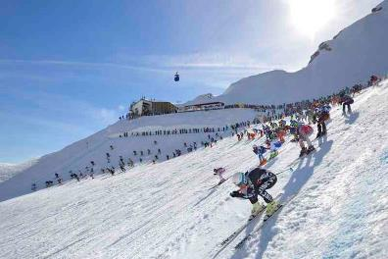
The White Thrill - saving the best for last
The brave, inquisitive and their supporters will gather again on 23rd April 2022 for what is most probably the most legendary downhill race in the Alpine region. “The White Thrill” in St. Anton am Arlberg has been captivating ambitious athletes and thousands of spectators for almost quarter of a century now. The course presents a Herculean task for its 555 participating skiers, snowboarders and telemark enthusiasts from all over the world, who hurtle simultaneously down to the valley after the mass start at Vallugagrat Ridge. The fastest cross the finishing line in just under eight minutes after completing the nine kilometres and 1,300 metres in altitude difference on unprepared slopes. Olympic ideals and great ambitions provide an eclectic mix here. But no matter whether you are a medal aspirant or a leisurely spectator runner - everyone who slides over the finish line is a winner here. All those born in 2005 or later pay an entry fee of €70/person, younger ski enthusiasts can join the shortened version “The White Thrill MINI” for €20/person Check out scenes in the video Der weisse Rausch 2019.
Photo (download):Starting signal on the Valluga Ridge - over 500 winter sports enthusiasts compete annually at the iconic „White Thrill" in St. Anton am Arlberg/Austria
Picture courtesy of: St. Anton am Arlberg Tourist Board/photographer Josef Mallaun

Take the Nightjet to the snow - comfortable and eco-friendly
Those arriving by rail get off the train right in the centre of St. Anton am Arlberg. Austrian Rail (ÖBB) will again offer special combined tickets for guests from certain regions in winter 2021/22. Holidaymakers can travel comfortably from Hamburg, Düsseldorf, Amsterdam, Vienna or Graz to the Tyrolean ski resort without having to worry about traffic. The Nightjet Combi-Ticket includes the train journey (return) in the ÖBB Nightjet including seat reservation, a 3 to 6-day lift pass, as well as transfer to the desired hotel.

About St. Anton am Arlberg St. Anton am Arlberg is one of the world’s most renowned winter sports resorts. Skiers and freeride fans from over 50 nations visit this mountain village and ski area with a total of over 300 kilometres of marked runs, 200 kilometres of backcountry terrain and 88 lift and cable car systems every year. The Arlberg-Arena extends from St. Anton in Tyrol to Lech and Zürs, as well as Warth and Schröcken in Vorarlberg. Cross-country skiing, tobogganing or a tour of Tyrol’s only winter via ferrate route are just as inherent to the inimitable Arlberg experience as its iconic events, international World Cup races and multi-award winning Tyrolean cuisine. The “birthplace of alpine skiing” is also a founding member of the “Best of the Alps“; a quality association of the 13 most prestigious mountain resorts in the Alps. www.stantonamarlberg.com

