

Family bike paradise Serfaus-Fiss-Ladis
heads into 2022 season
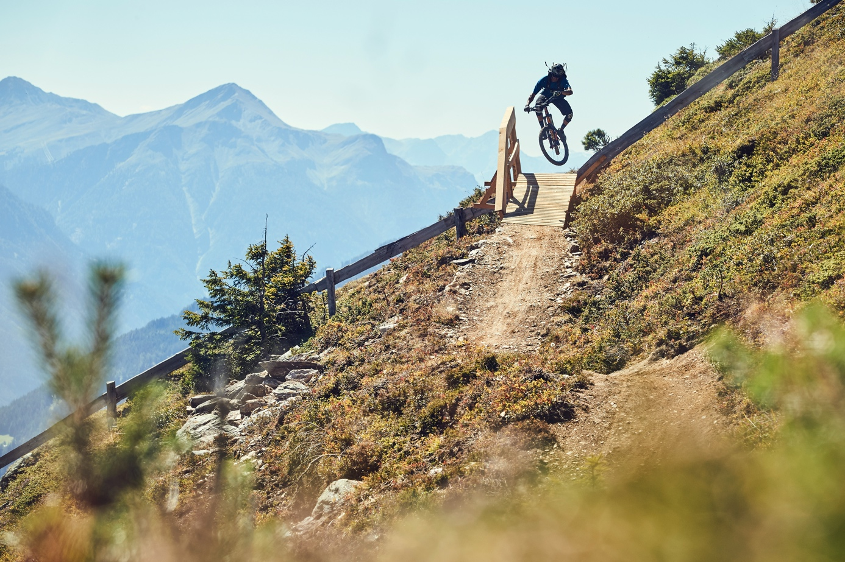
Spring weather and rising temperatures in Serfaus-Fiss-Ladis can mean only one thing - following a successful winter season, it's time to trade in steel edges for knobby tires. The trail crew of what is probably the most family-friendly holiday destination in Austria has been hard at work in order to make sure the bike park and the single trails are good to go for the start of the season, on 11 June.
Owing to the work and investments put in over the last few years, Serfaus-Fiss-Ladis offers visitors a wide selection of lines and between the eight Alpine single trails and nine action-packed bike park tracks, there's something for everyone. Sticking true to their "We are family!" tagline, trail builders always keep an eye on the learning curve of the trails, making sure that beginners can have just as much fun as more experienced riders. Downhill beginners, children and families will be able to shred to their heart's content on the “Milky Way”, “Vuelta” and “Morning Glory” lines in the bike park itself, while also be able to explore alpine single trails like the “Alpkopftrail”. The more experienced bike park riders will be able to test their skills on the "Hill Bill" or the challenging "Downhill" track.
For those looking to explore the region to the fullest, a large selection of alpine single trails awaits riders outside of the bike park. While riders should definitely tackle the legendary "Frommestrail", which winds itself through the high alpine and descends into dense woods, totaling over 9 kilometers in length and 1000 meters of vertical descent, the "Jochtrail" offers mountain bike fans a different experience, such as rock gardens and North Shore elements. The blue-marked "Högtrail", which is now an award-winning trail after winning the "Family Trail" category of the Great Trails Tirol 2022 campaign, received distinction for being "suitable for young people and active families, offering a challenge without overtaxing riders, resulting in a fun learning experience. It's easily reachable and has a high standard of safety measures." That being said, even the most experienced riders will be able to find challenges on the trail thanks to the root sections, doubles and playful North Shore elements, which ensure a smile on the face of every rider.
Bikepark-Manager Christian Zangerl is already excited about the upcoming season:
"Following a very successful and exciting winter season, we're already looking forward to the summer. The trail builders are extremely motivated and have already started clearing the snow that is still on the trails in order to prepare everything for our first guests. What's even better is that we also finally get to host a full calendar of events again."
The Serfaus-Fiss-Ladis calendar is filled with camps, workshops and more, such as the famous Early Rides, which transform the way down the Frommestrail into something magical. Traditionally, the second half of August is all about the Propain Rookie Camp, during which the next generation of riders can hone their skills for five days. During individual coaching sessions, the riders will be taught how to conquer wallrides, ride drops and send jumps, while also receiving valuable tips and tricks from pro mountain bike riders.
For those looking for a more relaxed ride, Serfaus-Fiss-Ladis’ offer is no less impressive. For families with small children looking to see the beautiful surroundings, there is a wide selection of mapped out mountain bike tours which reward cyclists with amazing panoramas and alpine vistas of the Tyrolean bike area. Next to incredible rides on the sunny high plateau a comprehensive network of charging stations and bike rentals offer e-MTB riders the possibility to cover numerous kilometers in the saddle, making even the most daunting ride an absolute joy.
Making its return for 2022 is the #bestbikereel-Challenge, which will once again demand the highest degree of creativity as riders will need to share the best Serfaus-Fiss-Ladis bike video they can possibly create, of course while riding the bike park and surrounding single trails. In order to be in for a chance to win, riders will need to shoot a cool bike reel in Serfaus-Fiss-Ladis, upload it to Instagram using the #bestbikereel and #serfausfissladis2022 hashtags in the caption and tag @bikeparkserfausfissladis. That's all there is to it. The challenge kicks off on 1 July and will run until closing day, 16 October 2022.
More information about biking in Serfaus-Fiss-Ladis can be found on www.bike-sfl.at/en, while those looking for more information about the region should look here: www.serfaus-fiss-ladis.at/en.

Find us on:  

#serfausfissladis #wearefamily #weilwirsgeniessen
#bikeschulesfl #bikesfl #bikeparksfl #gooddaysfl #propain
#bestbikereel #serfausfissladis2022

Reprint free of charge
Copy requested

Texts and pictures for download: www.bike-sfl.at/en/service/press

Media Contact:

Serfaus-Fiss-Ladis Tourist Board
Alexandra Hangl
Gänsackerweg 2
6534 Serfaus
Telefon: +43 (0)5476 6239 72
E-Mail: a.hangl@serfaus-fiss-ladis.at

About the region Serfaus-Fiss-Ladis
Serfaus-Fiss-Ladis is the place to be for a family holiday. Regardless whether it is summer or winter, there is always something going on. In summer the cable cars and bus shuttles connect the mountainous region of Serfaus-Fiss-Ladis. Apart from many other attractions the Serfaus-Fiss-Ladis high plateau offers bike fun for the whole family. From gentle bike rides for young and old, to mountain bike tours in the middle of breath-taking mountain scenery, to action-packed descents on single trails or courses through Bikepark Serfaus-Fiss-Ladis. The single trails can be accessed via cable cars, while the Waldbahn takes riders and their bikes to the trails within the bike park, which have different levels of difficulty from blue (easy) and red (medium) to black (expert). There is also a kids park, slopestyle area with a landing bag, pumptrack, dirt line and training area at the bottom station, where beginners can try out and get used to their new equipment. Experts in the bike shop advise in bike and safety equipment matters and the bike school and rental office shop can also be found here. Beside the shop there is also a chill out area and a snack bar.

