St. Anton am Arlberg, Austria: Training, competition, recovery
Sporting summer highlights on the Arlberg

Biking, hiking and alpine mountain experiences: are all synonymous with the year-round, sport-loving St. Anton am Arlberg during the summer months. An array of events have established themselves against the striking alpine backdrop of the Austrian “global village”. Competitions like the Arlberg Giro are always fast-paced and physically challenging. It is, however, the picturesque landscape of the 150-kilometre route that also attracts participants to the starting line. Not those competing for top rankings, but who appreciate the racing bike classic as an experience instead. A beneficial side-effect from exercise on the mountain: lower oxygen levels at medium altitudes, is perfect for fitness and endurance training, which is why numerous professional athletes take advantage of the alpine surroundings of St. Anton am Arlberg (1,304 metres). Things become more relaxed in September, when balance and dance in the soothing Tyrolean air round off the warmer season. www.stantonamarlberg.com

From Feats of Strength to Country: Top Events in Summer 2022

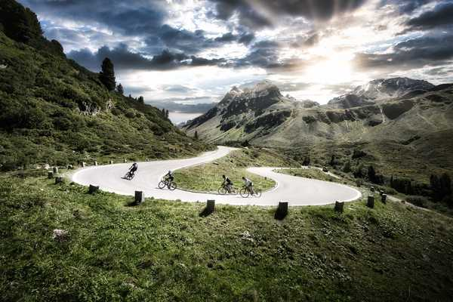
Racing bike cult in a whole new guise:
Arlberg Giro on 31st July 2022
The classic Arlberg Giro road bike race on narrow tyres takes its contenders from St. Anton over the Arlberg Pass to Bludenz, through Montafon, over the Silvretta High Alpine Road and back via Paznauntal and Stanzertal, over a route encompassing 150 kilometres and 2,500 metres in elevation difference. The starting pistol will be fired at 6 a.m. in the pedestrian zone at St. Anton am Arlberg. Now in its 11th year, the Giro “legend” is also starting with new corporate branding, all revealed on the official trailer on YouTube.
Photo (download): During the classic ”Arlberg Giro“ bike race, cyclists surmount 2,500 metres in elevation difference over a course distance of 150 kilometres from St. Anton to Bludenz. Montafon, Silvretta and back. Picture courtesy of: St. Anton am Arlberg Tourist Board/photographer Patrick Bätz

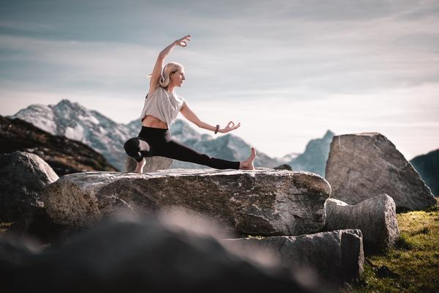
Balance meets Diversity:
Mountain Yoga Festival from 1st to 4th September 2022
Roll out your mat, take a deep breath, and soak up the the energy: the international yoga scene is coming together for a sixth time in St. Anton am Arlberg. The Tyrolean mountain village is transformed into a gigantic- open-air studio, as eminent yogis such as Sandra Wijkman Donovan, Alexandra Sagorz-Zimmerl or Manel Rodrigues share their in-depth knowledge about the crow, warrior and co. poses. The four-day programme - entitled “Diversity” this year - includes sessions in diverse styles for every level of ability, whereby participants can decide for themselves how intensive or relaxed they want their stay to be. Beyond the yoga mat, yogis can look forward to guided hikes, workshops, lectures, gentle music and healthy cuisine with regional ingredients.
Photo (download): Feel the power of the Tyrolean mountains - at the annual St. Anton Mountain Yoga Festival, where beginners are just as welcome as experienced yogis.
Picture courtesy of: St. Anton am Arlberg Tourist Board/photographer Patrick Bätz

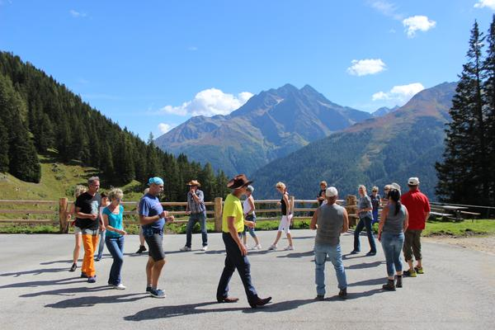
Country Feeling with World Record Attempt:
Line Dance Festival from 9th to 11th September 2022
St. Anton am Arlberg will be transformed into a giant dance floor for the fifth time in September 2022. Participants from near and far will demonstrate their sense of rhythm and celebrate together what line dancing is all about: pure joie de vivre. The successful world record attempt in 2010 was quickly followed by a veritable "line dance boom" - a new record will hopefully be set in 2022, during which 20 fully choreographed dances must be accomplished in just one hour.
Photo (download): I like to move it – the line dance community will meet again in St. Anton am Arlberg/Tyrol from 9th to 11th September 2022 in an attempt, amongst others, to set a new world record.
Picture courtesy of: St. Anton am Arlberg Tourist Board

About St. Anton am Arlberg St. Anton am Arlberg is one of the world’s most prestigious winter sports resorts, with over 300 kilometres of exciting downhill runs and 200 kilometres of backcountry terrain. The Austrian holiday region also impresses in summer with various activities and sporting events against a spectacular Alpine backdrop. Gourmet holidaymakers appreciate the multiple award-winning cuisine in the tradition-conscious Tyrolean mountain village. Entente Florale awarded St. Anton am Arlberg with gold for its projects on quality of life, sustainability and environmental protection and named it “Europe’s most beautiful village in bloom.” In spring 2021, St. Anton am Arlberg was selected as an official Climate Change Adaptation Model Region. www.stantonamarlberg.com

