Through to 3rd October 2022: late summer highlights in the Tyrolean mountain village
St. Anton am Arlberg extends the summer season

Summer guests can experience the striking Alpine scenery of the Austrian “global village" of St. Anton am Arlberg for longer than usual this year. All services covered by the St. Anton Summer Card, including the weekly programme and cable cars, can be used until 3rd October 2022. The late Tyrolean summer reveals its exciting side not only when it comes to hiking and (e-)biking. In the valley, all kinds of scenic highlights such as the 26th St. Anton Film Festival, the international Mountain Yoga Festival and Line Dance Festival with another world record attempt attract guests and locals alike. As the first autumn leaves turn to gold, ornately decorated cattle will be returning to the valley from their summer alpine pastures. This is traditionally celebrated on 17th September with the “Almabtrieb” cattle drive and farmer’s festival - a great experience for the whole family.www.stantonamarlberg.com
Photo (download): Late into autumn - the summer season in the Austrian region of St. Anton am Arlberg continues up to and including 3rd October 2022. Picture courtesy of: TVB St. Anton am Arlberg/Fotograf Patrick Bätz

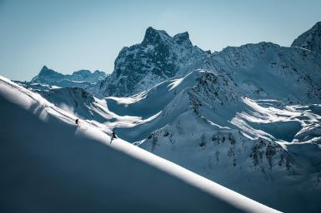
Feel the adrenalin rush:
St. Anton Film Festival from 24th to 27th August 2022
The late summer get-together for outdoor film enthusiasts takes place annually under the motto "Mountains, People, Adventure". In 2023, movie lovers can look forward to the 26th edition of this event, with exciting screenings every evening from 20.00 hrs in the welcoming flair of the Tyrolean mountain community of St. Anton am Arlberg at Arlberg Wellcom. In addition to fascinating footage, extreme athletes and film directors talk live about their experiences and adventures and comment on the works being presented, with an award for the best film at the end. Ticket prices range from €12/pers (reduced evening ticket) to €44/pers (4-day festival pass). Official teaser on YouTube, while all stage guests and trailers of the individual films can be found on www.filmfest-stanton.at.
Photo (download): "Mountains, People, Adventure" - Mount Patteriol on the Tyrolean side of the Verwall Group is emblematic of the motto of St. Anton Film Festival, which will once again bring movie-lovers and mountain sports enthusiasts together at Arlberg WellCom on the last weekend in August 2022. Picture courtesy of: Daniel Bear

Balance meets Diversity:
Mountain Yoga Festival from 1st to 4th September 2022
Roll out your mat, take a deep breath, and soak up the the energy: the international yoga scene is coming together for a sixth time in St. Anton am Arlberg. The Tyrolean mountain village is transformed into a gigantic- open-air studio, as eminent yogis such as Sandra Wijkman Donovan, Alexandra Sagorz-Zimmerl or Manel Rodrigues share their in-depth knowledge about the crow, warrior and co. poses. The four-day programme - entitled “Diversity” this year - includes sessions in diverse styles for every level of ability, whereby participants can decide for themselves how intensive or relaxed they want their stay to be. Beyond the yoga mat, yogis can look forward to guided hikes, workshops, lectures, gentle music and healthy cuisine with regional ingredients.
Photo (download): Feel the power of the Tyrolean mountains - at the annual St. Anton Mountain Yoga Festival, where beginners are just as welcome as experienced yogis.
Picture courtesy of: St. Anton am Arlberg Tourist Board/photographer Patrick Bätz

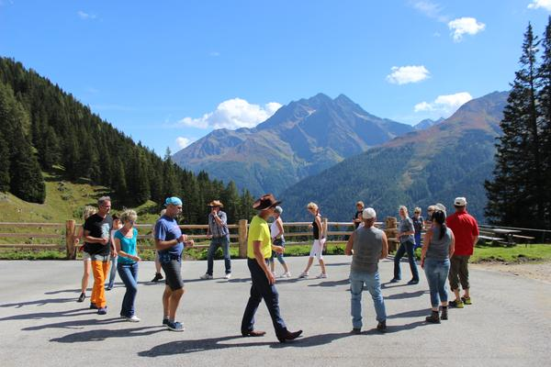
Country Feeling with World Record Attempt:
Line Dance Festival from 9th to 11th September 2022
St. Anton am Arlberg will be transformed into a giant dance floor for the fifth time in September 2022. Participants from near and far will demonstrate their sense of rhythm and celebrate together what line dancing is all about: pure joie de vivre. The successful world record attempt in 2010 was quickly followed by a veritable "line dance boom" - a new record will hopefully be set in 2022, during which 20 fully choreographed dances must be accomplished in just one hour.
Photo (download): I like to move it – the line dance community will meet again in St. Anton am Arlberg/Tyrol from 9th to 11th September 2022 in an attempt, amongst others, to set a new world record.
Picture courtesy of: St. Anton am Arlberg Tourist Board

The ticket to your holiday. Anyone visiting the St. Anton am Arlberg region, even for as little as one night's stay in a hotel or guesthouse, receives the St. Anton Summer Card. The ticket is valid for the entire duration of your stay and includes many free services, participation in the weekly and children's programme, as well as special rates on many other activities. Each Summer Card entitles the bearer, for example, to one free admission to the Arlberg WellCom or Arlberg Stanzertal wellness park swimming pools, to St. Anton am Arlberg Museum and the Bergbau Gand hiking circuit. The weekly programme includes (once weekly) free yoga sessions, guided hikes, archery, a torchlit hike and one green fee for the 9-hole golf course in the Nasserein district (handicap certificate required). Moreover, there is a €20 discount on the daily or half-day use of an e-bike in participating sports shops. All rides on the buses between Landeck and St. Christoph, as well as one day’s use of the St. Anton cable cars are also included. For a fee, holidaymakers can ”upgrade“ their ticket to a Premium Card and enjoy extra services. The St. Anton Summer Card is valid for the entire summer season until 3rd October 2022.

Take the Nightjet to the mountains. Thanks to its Railjet connection, St. Anton am Arlberg in Tyrol is an attractive destination for rail travellers from all over Europe. Reasonably priced connections are available for the approx. 5-hour journey from Stuttgart, while holidaymakers from the Munich area only need to plan around 3 hours for their rail journey. Austrian Rail (ÖBB) are now also offering special combi-tickets by night train in summer 2022 for guests from certain, more far-flung regions. Holidaymakers can travel comfortably and climate neutrally to St. Anton am Arlberg from Hamburg, Düsseldorf, Amsterdam, Vienna or Graz without having to worry about traffic. The Nightjet Combi-Ticket includes the (return) train journey for the ÖBB Nightjet service including seat reservation and transfer to your desired hotel.

About St. Anton am Arlberg St. Anton am Arlberg is one of the world’s most prestigious winter sports resorts, with over 300 kilometres of exciting downhill runs and 200 kilometres of backcountry terrain. The Austrian holiday region also impresses in summer with various activities and sporting events against a spectacular Alpine backdrop. Gourmet holidaymakers appreciate the multiple award-winning cuisine in the tradition-conscious Tyrolean mountain village. Entente Florale awarded St. Anton am Arlberg with gold for its projects on quality of life, sustainability and environmental protection and named it “Europe’s most beautiful village in bloom.” In spring 2021, St. Anton am Arlberg was selected as an official Climate Change Adaptation Model Region. www.stantonamarlberg.com

