Winter News 22/23
Region Seefeld – Tirols Hochplateau

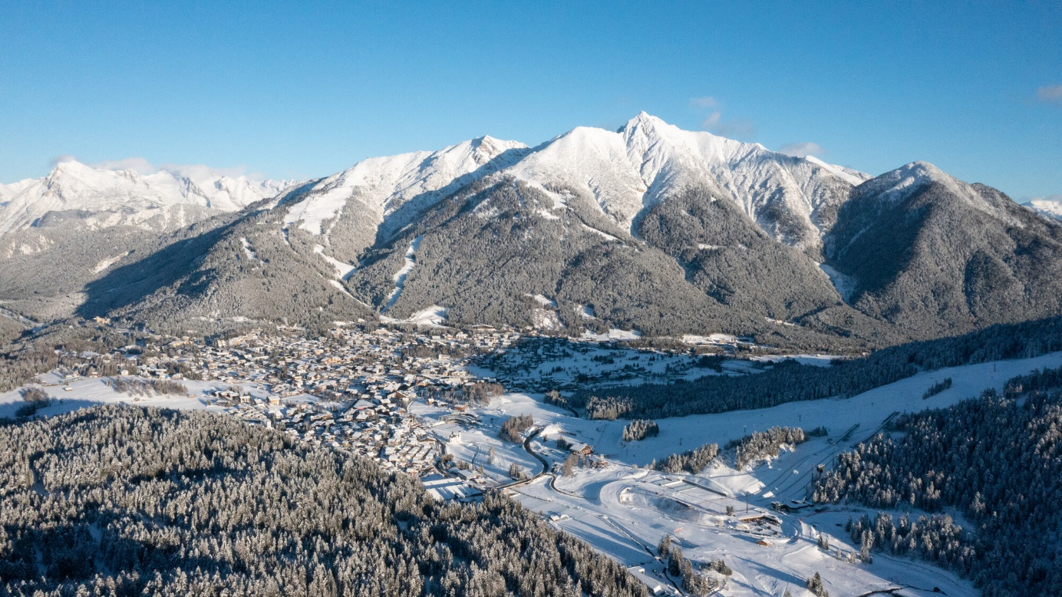

Every year at the start of the winter season we ask for the regional news of our guest houses and infrastructures. Below you will find the list of our regional news for the coming winter season 2022/2023. If you have any queries, please do not hesitate to contact christian.weittenhiller@seefeld.com from the Seefeld Tourism Board.

- The Alpenhotel Karwendel in Leutasch has been completely renovated and now welcomes guests with even more Alpine charm: a fresh look for the reception and restaurant, a separate information corner for guests, 16 new rooms, a modernised wellness area with new day spa offers and a heated indoor and outdoor pool.
- After extensive renovation work, the Hotel Kristall in Leutasch also shines in a contemporary look with local woods, an inviting lighting concept, noble interior and also welcomes guests to the day spa in the modern wellness area with rooftop infinity pool and a stunning panoramic view.
- The Hotel Klosterbräu in Seefeld has been beautifully renovated and now offers an enlarged brewery, a new beer pub, its own family sauna, a ski cellar and climbing tower as well as guided tours of the vegetarian farm (in german).
- The Krumers Alpin in Seefeld offers an attractive yoga special for an energetic start to the new year at the beginning of 2023. Bookable from 03.01. to 07.01.2023 - with a total of 11 yoga and meditation units ranging from Yin Yoga and breathing meditation to classic Vinyasa Yoga flows.
- With the Black Pony, the historic Seefeld pedestrian zone offers a new casual bar with whisky, wine & exquisite gin and tonics for convivial hours. Fine appetisers are available from the Weisses Rössl culinary restaurant.
- Fixed cross-country skiing season start with snowfarming trail in Leutasch from 12th of November 2022 - barrier-free cross-country skiing is also no problem here.
- New cross-country-parcours for dynamic training near the A1 trail at Seekirchl. This small but beautiful cross-country course offers cross-country skiers of all levels a varied training opportunity for curve runs, solid balance and the perfect cross-country technique.

Pictures can be downloaded here. The copyright information must be included.
Contact and Requests:
Region Seefeld – Tirols Hochplateau
c/o Christian Weittenhiller
Kirchplatzl 128a
A-6105 Leutasch
M: +43 (0)660 / 96 90 696
christian.weittenhiller@seefeld.com
www.seefeld.com

