Keep it Reel –
be part of the Serfaus-Fiss-Ladis #bestbikereel-challenge
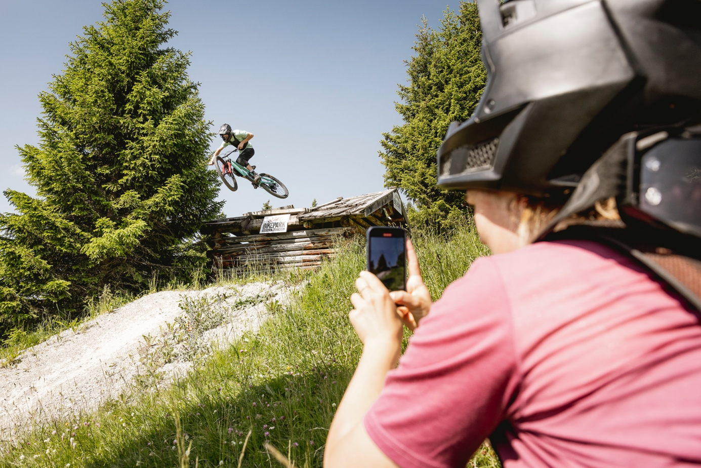
“Keep it Reel” becomes the motto of Serfaus-Fiss-Ladis, as the Tyrolean mountain bike region kicks-off the second edition of the #bestbikereel-challenge in July 2022. Do you and your bike buddy plan to go shred the Bikepark Serfaus-Fiss-Ladis and the surrounding single trails? Well, don’t forget to bring your smartphone or GoPro to create enough content for your personal highlight-reel. All you need to do, is upload it to Instagram and tag it the right way to be in the draw for the main prize – a short bike holiday in Serfaus-Fiss-Ladis! How would this dream of a bike trip look like? Bike filmer Marius Prell has already made an edit of what it could look like:

youtu.be/IrAO-64YoDg

After the success of last year’s #bestbikereel-challenge with over 120 entertaining and action-packed reels, the holiday region Serfaus-Fiss-Ladis can’t wait to see the Instagram-gems that the mountain bike community will come up with this year. The Bikepark Serfaus-Fiss-Ladis provides the perfect canvas for your banger edits: Collecting airtime on the “Strada del Sole”, tackling the north shore elements or the hut drop of the “Hill Bill” or just sending it down the downhill line – the possibilities to film your #bestbikereel are nearly endless. If you’re more into classic trail action and breathtaking sceneries, go get your shots on one of the eight marvelous single trails meandering through the region.

Marius Prell himself loves the many options in Serfaus-Fiss-Ladis, both in front of and behind the camera: "I usually take the perspective behind the camera. As a filmer you can find a really great variety here in Serfaus-Fiss-Ladis – a lot of different places to produce cool content, like the landing bag near the bottom station, the big wall ride, some of the big drops or the single trails high in the mountains. Also, if you take a little time, you can usually quickly discover a new perspective that might make the difference between a good and a very good reel. On the bike I'm still more of a beginner, but even for my level there are numerous suitable trails here, which are a lot of fun to ride."

Here's how you can join:

In order to take part in the challenge, simply post your #bestbikereel on Instagram, regardless of whether it was created in the bike park or on the single trails in Serfaus-Fiss-Ladis. Use the hashtags #bestbikereel and #serfausfissladis2022 and tag the IG account @bikeparkserfausfissladis – that’s it.

The videos don’t need to display the most insane bike skills but are more about the good combination of riding and filming with a good dose of creativity. The challenge is open to everyone. For inspiration and tips check out this short clip by Fabio Wibmer's go-to-filmer Marius Prell: https://youtu.be/H7V5mRLNQgY

The challenge runs until the end of the summer season on October 16, 2022. To increase your chances of scooping up a prize, you can of course also post multiple reels during this time. And if you can't make it to Serfaus-Fiss-Ladis this year for some inexplicable reason, you're welcome to share throwbacks from the last few years.
A jury consisting of bike filmmaker Marius Prell, representatives of the Serfaus-Fiss-Ladis Tourist Office and the Bikepark Serfaus-Fiss-Ladis will select the lucky winners at the end of the season.

Bike Park Manager Christian Zangerl is expecting numerous submissions again this year: "I'm already looking forward to the new reels because I was really impressed by how many top-class entries, especially from female participants we had last season. The quality of the reels and the riding level were really great! This year we are again giving away two overnight stays for two people including bike tickets, and I wish lots of fun and success to everyone who wants to take part.”

There's something to win

The main prize includes two overnight stays with breakfast in Serfaus-Fiss-Ladis as well as All-Mountain Bike Tickets for two days for the Serfaus-Fiss-Ladis bike region for two people for the 2023 summer season.
In addition, four more prizes can be won, for example tires, caps, shirts, jerseys and more.
You can find more information and the conditions of participation here: www.bike-sfl.at/en/service/bike-challenge.

More information about biking in Serfaus-Fiss-Ladis can be found on www.bike-sfl.at/en, while those looking for more information about the region should look here: www.serfaus-fiss-ladis.at/en.

Find us on:

#serfausfissladis #wearefamily #weilwirsgeniessen
#bikeschulesfl #bikesfl #bikeparksfl #gooddaysfl #propain
#bestbikereel #serfausfissladis2022

Reprint free of charge
Copy requested

Texts and pictures for download: www.bike-sfl.at/en/service/press

Media Contact:

Serfaus-Fiss-Ladis Tourist Board
Alexandra Hangl
Gänsackerweg 2
6534 Serfaus
Telefon: +43 (0)5476 6239 72
E-Mail: a.hangl@serfaus-fiss-ladis.at

About the region Serfaus-Fiss-Ladis
Serfaus-Fiss-Ladis is the place to be for a family holiday. Regardless whether it is summer or winter, there is always something going on. In summer the cable cars and bus shuttles connect the mountainous region of Serfaus-Fiss-Ladis. Apart from many other attractions the Serfaus-Fiss-Ladis high plateau offers bike fun for the whole family. From gentle bike rides for young and old, to mountain bike tours in the middle of breath-taking mountain scenery, to action-packed descents on single trails or courses through Bikepark Serfaus-Fiss-Ladis. The Waldbahn takes riders and their bikes to the trails within the bike park, which have different levels of difficulty from blue (easy) and red (medium) to black (expert). There is also a kids park, slopestyle area with a landing bag, pumptrack, dirt line and training area at the bottom station, where beginners can try out and get used to their new equipment. Experts in the bike shop advise in bike and safety equipment matters and the bike school and rental office shop can also be found here. Beside the shop there is also a chill out area and a snack bar.

