First class skiing experiences, culinary highlights and journeys with the new eco-check
St. Anton am Arlberg begins the winter season on 2nd December 2022

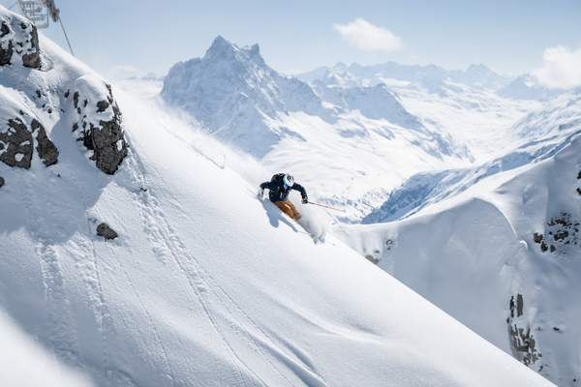
As the birthplace of Alpine skiing, St. Anton am Arlberg has shaped the development of winter sports for over 120 years. On 2nd December 2022, the Austrian mountain region will embark on a new winter season full of memorable milestones and highlights for guests, spectators and participants from all over the world. In January 2023, for example, the crème de la crème of the ski world will once again meet to compete in the Audi Women’s FIS Ski World Cup at the traditional Arlberg Kandahar Race. Following in the footsteps of the women's elite, St. Anton am Arlberg is forging ahead as an international host for major sporting events, providing the venue for the FIS Alpine Junior Ski World Championships 2023 under the motto "(Y)our next step". The heart of the Ski Arlberg Region offers over 300 kilometres of marked runs and 200 kilometres of backcountry terrain. Food-lovers can look forward to the renovated Galzig Restaurant, while the famous Verwallstube also enjoys a resplendent new look. The best way for holidaymakers to reach St. Anton am Arlberg, which has been energy self-sufficient since 2006 thanks to hydroelectric power, is to take the climate-neutral train. Journeys with the smallest possible CO2 footprint can be easily planned with the newly developed "GreTA” tool. www.stantonamarlberg.com
Photo (download): Popular amongst the freeriding scene - in addition to 300 kilometres of marked runs, St. Anton am Arlberg in Tyrol offers a staggering 200 kilometres of off-piste variants
Picture courtesy of: TVB St. Anton am Arlberg/photographer Patrick Bätz

News and highlights in the ski resort

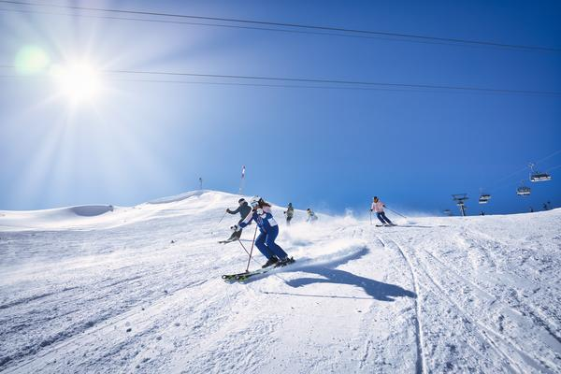
Start of the winter season on 2nd December 2022. As the calendar year draws to a close, a highlight for mountain sports fans is yet to come: winter returns to the "global village" of St. Anton am Arlberg on 2nd December! The start of official lift operations at 8.45 in the morning heralds a particularly sporty ski season in the Tyrolean region. During the entire opening weekend, visitors can test new ski and board models from renowned manufacturers for free on the slopes of St. Anton am Arlberg.
Photo (download): The new ski season in St. Anton am Arlberg, the very heart of the Ski Arlberg Region, begins on 2nd December 2022. Picture courtesy of: TVB St. Anton am Arlberg/photographer Patrick Bätz

New culinary heights. “Kaiserschmarrn” pancake or bouillabaisse, cuisine of award-winning standards or Tyrolean classics - the choice of fare in St. Anton am Arlberg is just as diverse as its ski slopes. The renowned "Gault&Millau" regularly distinguishes restaurants from the holiday region, which is home to over 90 different eateries ranging from fine to informal dining, as well as mountain huts for cosy get-togethers. St. Anton am Arlberg is also forging ahead in terms of culinary delights in the 2022/23 winter season, with reconstruction of the restaurants at Galzig mountain station, which also includes the popular Verwallstube.
New skiing experience thanks to V-Edge edge grinding. Numerous chapters in the history of winter sports have been written in St. Anton am Arlberg. In its function as pioneer of alpine ski technology, the mountain village has been home to yet another industry innovation since winter 2021/22. Because Stanton Service Centre, the largest workshop of its kind in the world, is now using the revolutionary V Edge Technology from world market leader Wintersteiger for edge grinding. This facilitates a variable edge angle at the front and back of the ski, yet remains constant in the binding area. The result is optimum edge grip and effortless turns on the mountain, which translates to easy control for skiers of every ability and an entirely new skiing experience on the slopes of St. Anton am Arlberg.

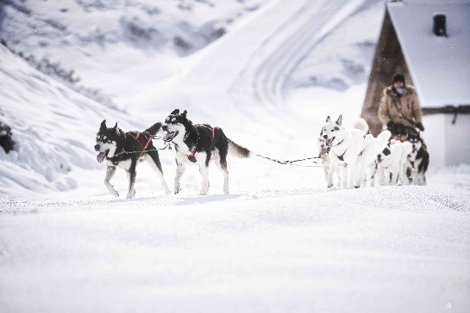
A whole pack of new winter adventures. In cooperation with Wild Paws Adventures, guided husky tours in the Austrian region of St. Anton am Arlberg complement the range of leisure activities offered to winter holidaymakers. On Monday and Friday mornings, holidaymakers with or without children can accompany these tenacious dogs on foot or sleds through the spectacular winter landscapes surrounding this Tyrolean mountain village.
Photo (download): Furry winter adventures - holidaymakers have been enjoying husky tours in St. Anton am Arlberg/Tirol since the 2021/22 season. Picture courtesy of: TVB St. Anton am Arlberg

Ladies First on the Arlberg. Upgrade for her skiing holiday: female winter sports lovers enjoy some very special benefits in and around St. Anton am Arlberg from 7th to 28th January 2023. An attractive array of special perks and discounts for spas, shopping, restaurants and on the slopes await them as part of the Ladies First Weeks. The Tourist Information Office has a personal "Ladies First Book" and small welcome gift ready for every lady staying in in St. Anton, Pettneu, Flirsch or Strengen.

Not suitable for inexperienced alpine enthusiasts. The starting point of one of Tyrol’s most beautiful winter via ferrates can be found next to the top terminal of the Riffel II lift on Mount Rendl (2,645 metres), high above St. Anton am Arlberg. Secured in its entirety by steel rope, ski-touring fans can start the 850-metre-long high alpine ridge crossing from here. Views extend over the entire Verwallgruppe Mountain Range and Lechtal Alps - even as far as South Tyrol on clear days. The heart of every ski enthusiast will skip a beat once they arrive at the Rossfallscharte Ridge (2,732 metres), where the downhill run through backcountry terrain beckons. Guided tours and equipment can be booked at St. Anton am Arlberg ski schools.

Arrival and service

New tool for journey planning. Thanks to GreTA (Green Travel Alternatives), holidaymakers can now plan their entire journey to St. Anton am Arlberg - with the objective of creating the smallest possible CO2 footprint. GreTA always suggests the most sustainable option first, finds the best time to depart and has integrated other options - local public transport as well as international transport connections and hotel shuttles.

Take the Nightjet to the snow. Austrian Rail (ÖBB) will again offer special combined tickets for guests from certain regions in winter 2022/23. Holidaymakers can travel comfortably to St. Anton am Arlberg from Hamburg, Düsseldorf, Amsterdam, Vienna or Graz without having to worry about traffic and in climate neutral style. The Nightjet Combi Ticket includes the (return) train journey in the ÖBB Nightjet including seat reservation, a 3 to 6-day lift pass, as well as transfer to the desired hotel in the Tyrolean mountain village.

Take the train straight to the village centre. St. Anton am Arlberg in Tyrol is an attractive destination for rail travellers from all over Europe. The mountain village is a Railjet station, with seven direct connections a day from Vienna and Zurich. St. Anton am Arlberg Tourist Board use the local railway station ticket office as an additional Service Centre. Overnight guests don’t need a car to reach their destination throughout the entire holiday region: a sophisticated bus system ensures maximum mobility to and from all parts of the village as well as surrounding regions in the Stanzertal Valley. By the way: short distances mean that those staying directly in St. Anton am Arlberg can access everything on foot anyway.

About St. Anton am Arlberg. As the birthplace of Alpine skiing, St. Anton am Arlberg is recognised as one of the world’s most prestigious winter sports resorts. Every year, piste and freeride fans from over 50 nations visit this mountain village and ski area with a total of over 300 kilometres of marked runs, 200 kilometres of backcountry terrain and 87 lift and cable car systems. The “SKI ARLBERG“ region extends from St. Anton in Tyrol to Lech and Zürs, as well as Warth and Schröcken in Vorarlberg. Cross-country skiing, tobogganing or a thrilling ride on one of the five twisting toboggan runs in the region are just as inherent to the inimitable Arlberg experience as its iconic events, international World Cup races or multi-award-winning Tyrolean cuisine.

