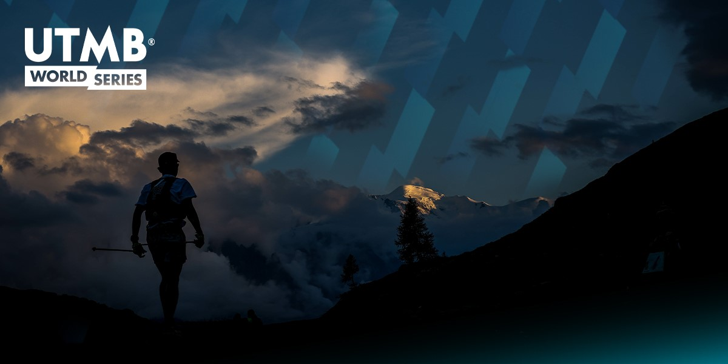

Kitz Alps Trail in Austria joins the UTMB World Series in 2023

- KAT100 by UTMB offers eight routes in the famous Kitzbühel Alps from 3-5 August 2023

- 31 events currently confirmed for 2023 UTMB World Series, including new events in Europe, South America, and Africa, with further expansion across Asia and the USA still to be announced

- Entries due to open at 3pm CET, 24 November at https://kat100.at/en/

(Tyrol, Austria/Chamonix, France/Tampa, USA.) 17 November 2022 – Austria’s longest trail running race, the KAT100 by UTMB®, has been confirmed as the latest event to join the 2023 UTMB® World Series, giving runners the chance to explore the famous Kitzbühel Alps during what will be the event’s fourth edition. Runners will have the option of eight different routes of varying distances, including relay formats, all taking place from the 3-5 August 2023.

All races begin and end at the center of Fieberbrunn, a market town in the West-Austrian state of Tyrol that is known for its year-round mountain sports. The 100-mile KAT100 is set to become the longest trail running race in Austria in 2023, and with 9,996 meters of elevation gain, is as tough as it is beautiful. The course passes through nine villages in the Kitzbühel Alps, allowing runners to experience a mixture of gentle grassy mountains and magnificent ridge landscapes in the PillerseeTal, including the fantastic summits of Wildseeloder, Kitzbüheler Horn, and Jakobskreuz. Winner of the 2022 KAT100 and Austrian native, Michael Deng, described the race as, “walking from highlight to highlight through a grandiose landscape – just fantastic.”

As well as the 100-miler, runners can test their limits on seven other routes of varying distances, with Running Stones - which can be used to enter the lottery for the UTMB World Series Finals - rewarded to all finishers of races in the 100M, 100K, 50K and 20K race categories. An additional 8km and a kid’s race ensures that the event is open to everyone, new or experienced in the sport.

Finishers of the Endurance Trail (91.5km / 5,100m+ elevation) and the Ekiden Trail two-person relay (91.5km / 5,100m+ & 82.7km / 4,870m+) will each get three Running Stones; the Marathon Trail (48.2km / 3,220m+) will award two Running Stones; the Ekiden Trail four-person relay will award one or two Running Stones depending on the leg distance; with the KAT100 Speed Trail (24.2km / 1,640m+) awarding one.

Race Director Thomas Bosnjak said: “We are very happy to be part of the UTMB World Series with the KAT100 by UTMB and are convinced that we fit perfectly into the race calendar with our fantastic trail offer in the Kitzbühel Alps. So, we are already looking forward to many visitors and athletes at next year's event.”

Armin Kuen, Managing Director of the PillerseeTal Tourism Association commented: “The PillerseeTal is proud to be a partner of a strong global event brand with the KAT100 by UTMB. The KAT100 by UTMB is the perfect platform to present our region and its most beautiful places. We are looking forward to numerous international participants.”

KAT100 by UTMB joins mozart 100 by UTMB as the second UTMB World Series event in Austria, both offering runners their own unique experience through the country’s wildest regions. The UTMB World Series has now confirmed 31 events in 2023, including new events in Europe, South America, and Africa, with further expansion across Asia and the USA still to be announced.

UTMB World Series 2023 confirmed events (as of 17 November 2022):
- Tarawera™ Ultramarathon by UTMB® (New Zealand), 11-12 February
- Amazean Jungle Thailand by UTMB (Thailand), 17-19 February
- Istria 100 by UTMB® (Croatia), 13-16 April
- Canyons Endurance Runs by UTMB® (USA), 28-29 April
- Transvulcania by UTMB® (Spain), 4-6 May
- Ultra-Trail Australia™ by UTMB® (Australia), 11-14 May
- Ultra-Trail Snowdonia by UTMB® (Wales), 12-14 May
- Valhöll Argentina by UTMB® (Argentina), 12-14 May
- Trail Alsace Grand Est by UTMB® (France), 18-21 May
- Mountain Ultra-Trail by UTMB® (South Africa), 26-28 May
- Trail du Saint-Jacques by UTMB® (France), 3-4 June
- mozart 100™ by UTMB® (Austria), 17-18 June
- La Sportiva® Lavaredo Ultra-Trail® by UTMB® (Italy), 22-25 June
- Trail 100 Andorra™ by UTMB® (Andorra), 24-25 June
- Western States® 100-Mile Endurance Run (USA), 24-25 June
- Val d'Aran by UTMB® (Spain), 6-9 July
- Restonica Trail by UTMB® (France), 6-8 July
- Trail Verbier Saint-Bernard by UTMB® (Switzerland), 7-9 July
- Eiger Ultra Trail by UTMB® (Switzerland), 12-16 July
- Speedgoat Mountain Races by UTMB® (USA), 21-22 July
- KAT100 by UTMB® (Austria), 3-5 August
- UTMB® World Series Finals; UTMB® Mont-Blanc (France, Italy, Switzerland), 28 August – 3 September
- Wildstrubel by UTMB® (Switzerland), 14-17 September
- Paraty Brazil by UTMB® (Brazil), 22-24 September
- Julian Alps Trail Run by UTMB® (Slovenia), September
- Nice Côte d’Azur by UTMB® (France), September
- Puerto Vallarta México by UTMB® (Mexico), 3-4 November
- Kullamannen by UTMB® (Sweden), 3-4 November
- TransLantau™ by UTMB® (Hong Kong), November
- Doi Inthanon Thailand by UTMB® (Thailand), 8-10 December
- Ultra-Trail Kosciuszko by UTMB® (Australia), December

###

UTMB® World Series
UTMB® World Series is the world’s ultimate trail-running circuit that unites the sport’s biggest stars and passionate runners through the best, leading international events in the most stunning locations. Built on a passion for the mountains with sustainability at its heart, UTMB® World Series gives all trail runners the chance to experience the UTMB® adventure across the world, with events taking place across Asia, Oceania, Europe, Africa and the Americas. It is the only place where runners can begin their quest to UTMB® Mont-Blanc, France, where the prestigious UTMB® World Series Finals will be held. For more information, visit www.utmb.world.

About UTMB Group
Over the last 18 years, and since the creation of UTMB® Mont-Blanc in 2003 by a group of passionate friends, UTMB Group has been the driving force behind the development of trail running. The UTMB® Mont-Blanc is the sports pinnacle event, and every year, 10,000 runners earn their place on the start line. UTMB Group also pioneered the LiveTrail® technology, an innovative digital service that supports the management of endurance races. Revered by hundreds of thousands of athletes, UTMB® has become a global, premium, and leading brand. In May 2021, UTMB Group partnered with The IRONMAN Group to launch the UTMB® World Series, which brings together many of the best international events on the planet to provide exclusive access to the sport’s pinnacle event, UTMB® Mont-Blanc. The UTMB® World Series is built on the founding principles of UTMB® Mont-Blanc: surpassing oneself; fair-play; respect for people and the environment; and solidarity. Find out more at www.utmb.world.

About The IRONMAN Group
The IRONMAN Group operates a global portfolio of events that includes the IRONMAN® Triathlon Series, the IRONMAN® 70.3® Triathlon Series, the IRONMAN® Virtual Racing™ (VR™) Series, 5150™ Triathlon Series, the Rock ‘n’ Roll® Running Series, the Rock ‘n’ Roll Virtual Running™ Series, IRONKIDS®, World Triathlon Championship Series, premier running events including the Standard Chartered Singapore Marathon™ and City2Surf®, UTMB® World Series events including Tarawera Ultra and Ultra-Trail Australia™, Epic Series™ mountain bike races including the Absa Cape Epic®, road cycling events including Haute Route®, and other multisport races. The IRONMAN Group is the largest operator of mass participation sports in the world and provides more than a million participants annually the benefits of endurance sports through the company’s vast offerings. Catering to the full athlete experience, the company portfolio also includes FulGaz® virtual cycling, the most realistic indoor riding experience connected fitness application aimed at preparing athletes for real-world events. Since the inception of the iconic IRONMAN® brand and its first event in 1978, athletes have proven that ANYTHING IS POSSIBLE® by crossing finish lines around the world. Beginning as a single race, The IRONMAN Group has grown to become a global sensation with hundreds of events across 55+ countries. The IRONMAN Group is owned by Advance, a private, family-owned business. For more information, visit www.ironman.com/about-ironman-group.

CONTACTS

UTMB World Series international media enquiries:
presse@utmb.world
Sabina Mollart Rogerson – International press Officer
t: +44 7922 140148

nicola.dawson@utmb.world
Nicola Dawson, UTMB® World Series Media & PR Manager
T: +44 (0) 7919051417

The IRONMAN Group media enquiries:
olivia.mcculla@ironman.com
Olivia McCulla Director, Communications (EMEA)

press@ironman.com
Dan Berglund, Vice President, Global Communications

Tourismusverband PillerseeTal
Marion Pichler
Tel.: +43 5354 56304 53
E-Mail: marion.pichler@pillerseetal.at
Tourismusverband PillerseeTal, Dorfplatz 1, A- 6391 Fieberbrunn

