New rail connection from Hamburg to St. Anton am Arlberg, Austria
ICE service now takes you directly to the village centre

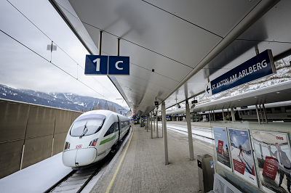
Sporting highlights were the primary focus of the current 2022/23 winter season in St. Anton am Arlberg/Austria and its skiing area. However, the mountain village has also set a new mobility milestone with "Ski Express Tirol": because in December 2022, an ICE train sped directly from Hamburg via Munich to St. Anton am Arlberg for the very first time. Tourism Director Martin Ebster is delighted: "When St. Anton's former visionaries built the Arlberg railway line and our station, they were undoubtedly unaware of the far-reaching implications this would have. 140 years later, both are more significant than ever in terms of sustainability. We are therefore delighted to be able to take another step towards climate-neutral travel for our guests with the new, direct ICE connection from Hamburg." Following the arrival of the first ICE 1201, St. Anton am Arlberg (1,303 metres) is now officially home to the world's highest ICE station. www.stantonamarlberg.com
Photo (download): A milestone in mobility for St. Anton am Arlberg and its guests - from winter 2022/23, "Ski Express Tirol" becomes the first ICE connection to operate weekly from northern Germany to the Austrian mountain village and its ski area. © TVB St. Anton am Arlberg/Photographer Patrick Bätz

Traveling by rail to the ski resort of St. Anton am Arlberg

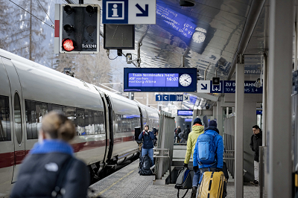
The new "Ski Express Tirol" departs from Hamburg at 06:05 hrs every Saturday during the winter season until 25th March 2023 and whisks holidaymakers via Hanover, Munich and Innsbruck to the " birthplace of alpine skiing" and back in around ten hours. Furthermore, there is another direct ICE connection from Munich to St. Anton that departs on Saturdays at 06:26 hrs. The arrival time at 11:03 hrs means that winter sports fans can still enjoy almost a whole day on the slopes. An ICE connection will also operate between Munich and St. Anton in the summer season from 24th June to 9th September.
Photo (download):The train ends where the holiday begins - thanks to the new "Ski Express Tirol" from Hamburg via Hanover, Munich and Innsbruck, the " birthplace of alpine skiing" is now officially home to the world’s highest ICE train station. © TVB St. Anton am Arlberg/Photographer Patrick Bätz

New tool for environmentally friendly travel is already up and running
St. Anton am Arlberg is considered an attractive rail destination throughout Europe. The tourism association use the local railway station ticket office as an additional Service Centre. Overnight guests don’t need a car to get around the entire Tyrolean region anyway: a sophisticated bus system ensures maximum mobility to and from all parts of the village as well as surrounding regions in the Stanzertal Valley. Those staying directly in St. Anton am Arlberg can access everything on foot anyway on account of the short distances. Thanks to GreTA (Green Travel Alternatives), holidaymakers have already been managing their journey from beginning to end with a view to minimising their carbon footprint since summer 2022. Austrian Rail also have special offers for guests from certain regions, who can travel from Hamburg, Düsseldorf, Amsterdam, Vienna or Graz without having to contend with traffic jams. The so-called Nightjet Combi-Ticket includes the (return) train journey with seat reservation, a three to six-day ski pass and transfer to the desired hotel.

About St. Anton am Arlberg. As the birthplace of Alpine skiing, St. Anton am Arlberg is recognised as one of the world’s most prestigious winter sports resorts. Every year, piste and freeride fans from over 50 nations visit this mountain village and ski area with a total of over 300 kilometres of marked runs, 200 kilometres of backcountry terrain and 87 lift and cable car systems. The “SKI ARLBERG“ region extends from St. Anton in Tyrol to Lech and Zürs, as well as Warth and Schröcken in Vorarlberg. Cross-country skiing, tobogganing or a thrilling ride on one of the five twisting toboggan runs in the region are just as inherent to the inimitable Arlberg experience as its iconic events, international World Cup races or multi-award-winning Tyrolean cuisine.

