Springtime Skiing 2023 in St. Anton am Arlberg, Tyrol
Sun-kissed season finale on the Arlberg

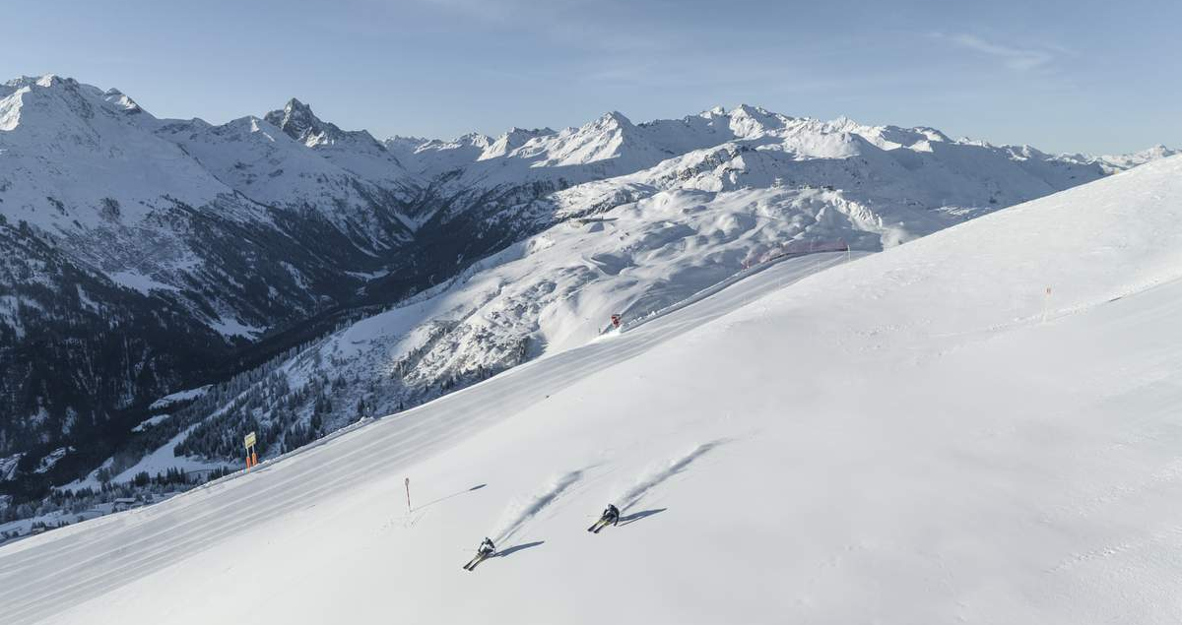
Spring in St. Anton am Arlberg is synonymous with fun, groove and entertainment like virtually nowhere else. Amid sunshine, superbly groomed slopes and unique events, the Tyrolean mountain village and its hosts welcome holidaymakers to enjoy their last turns of the winter season right up to and including 23rd April 2023. In addition to the "New Orleans meets Snow" music festival and probably the most legendary downhill race in the Alpine region, “The White Thrill", guests are advised not to miss other stunning highlights such as the 360-degree mountain panorama of the Valluga viewing platform at 2,811 metres - the highest point in the St. Anton am Arlberg ski area. While the newly designed restaurant at Galzig lift mountain station boasts of a spacious sun terrace, amateur film-makers can capture their day on skis or board with the latest action camera models from Mountain Media Center until 31st March and take their personal film back home with them free of charge. Tip: holidaymakers will be able to reach the mountains by ICE train from the end of 2022, which shuttles from Hamburg via Hanover, Munich and Innsbruck directly to the village centre. In turn, those interested can "listen to the mountains" in a German language Podcast from the St. Anton am
Arlberg region.www.stantonamarlberg.com
Photo (download): Late winter downhill fun with panoramic views at Kapall above St. Anton am Arlberg in Tyrol. © TVB St. Anton am Arlberg/Photographer Patrick Bätz

Music for the ears and legs: New Orleans meets Snow - 30th March to 2nd April 2023
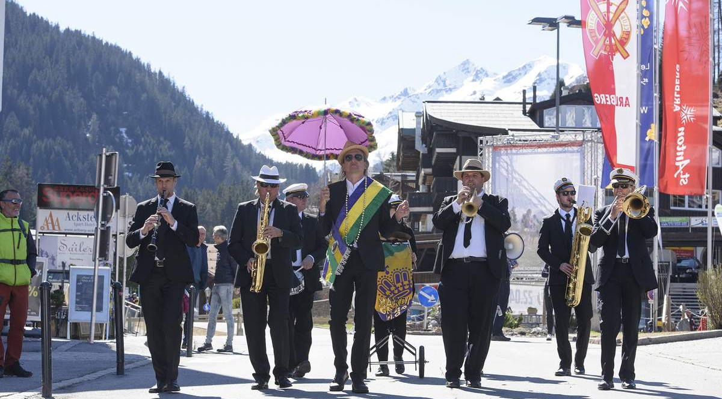
From 30th March to 2nd April 2023, the “New Orleans meets Snow“ Festival will get everyone dancing in the streets, bars and mountain huts of St. Anton am Arlberg every day from 11 a.m. - be it up on the mountain or down in the valley, in street shoes or ski boots. Austrian musician and cabaret artist Markus Linder is the initiator of this concert series, which brings the Mississippi to the Rosanna River in Tyrol with sounds ranging from jazz to rhythm and blues to funk. Under his direction, the Marching Band will groove repeatedly through the St. Anton pedestrian zone all weekend - delivering a sound and optical sensation. Admission to all concerts is free.
Photo (download): Tyrol in the groove - Markus Linder’s marching band provides feel good sounds and eye-catching entertainment in St. Anton am Arlberg during the "New Orleans meets Snow" festival in spring 2023. © TVB St. Anton am Arlberg/Photographer Patrick Bätz

The best comes last: The White Thrill - 22nd April 2023
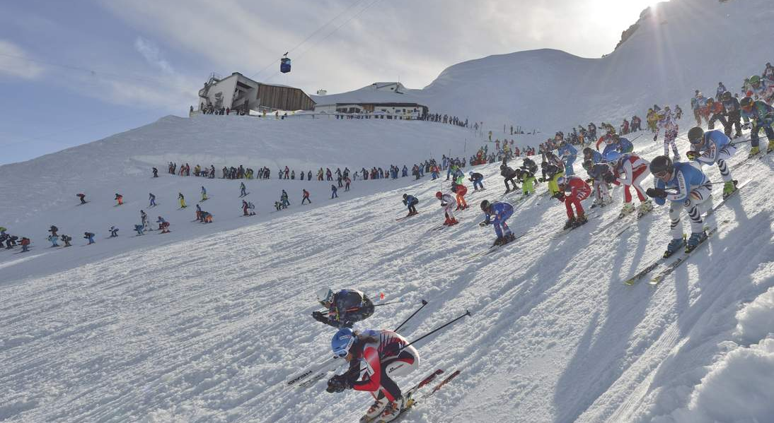
A spectacular ski race traditionally brings the ski season to an end in St. Anton am Arlberg. On 22nd April 2023, the “White Thrill” downhill race will have participants’ muscles screaming in protest, when 555 athletes from all over the world hurtle simultaneously down 7.5 kilometres of unprepared slopes to the valley after a mass start from the Valluga Ridge. Olympic ideals and great ambitions provide an eclectic mix here: as some contenders have their sights on a medal, while others enjoy the hullabaloo at a more leisurely pace. Every contender that slides over the finish line with their last shreds of strength is equally celebrated, however, by the fervent spectators. Check out scenes in the video Der weisse Rausch (The White Thrill) 2022.
Photo (download):Start signal on the Valluga Ridge - at the iconic ”White Thrill" race in St. Anton am Arlberg, when hundreds of international athletes meet to compete again on the 22nd April 2023. © TVB St. Anton am Arlberg/Photographer Josef Mallaun

About St. Anton am Arlberg. As the birthplace of Alpine skiing, St. Anton am Arlberg is recognised as one of the world’s most prestigious winter sports resorts. Every year, piste and freeride fans from over 50 nations visit this mountain village and ski area with a total of over 300 kilometres of marked runs, 200 kilometres of backcountry terrain and 87 lift and cable car systems. The “SKI ARLBERG“ region extends from St. Anton in Tyrol to Lech and Zürs, as well as Warth and Schröcken in Vorarlberg. Cross-country skiing, tobogganing or a thrilling ride on one of the five twisting toboggan runs in the region are just as inherent to the inimitable Arlberg experience as its iconic events, international World Cup races or multi-award-winning Tyrolean cuisine. www.stantonamarlberg.com

