Serfaus-Fiss-Ladis: Season Kick-Off 2023 in the Family Bike Paradise
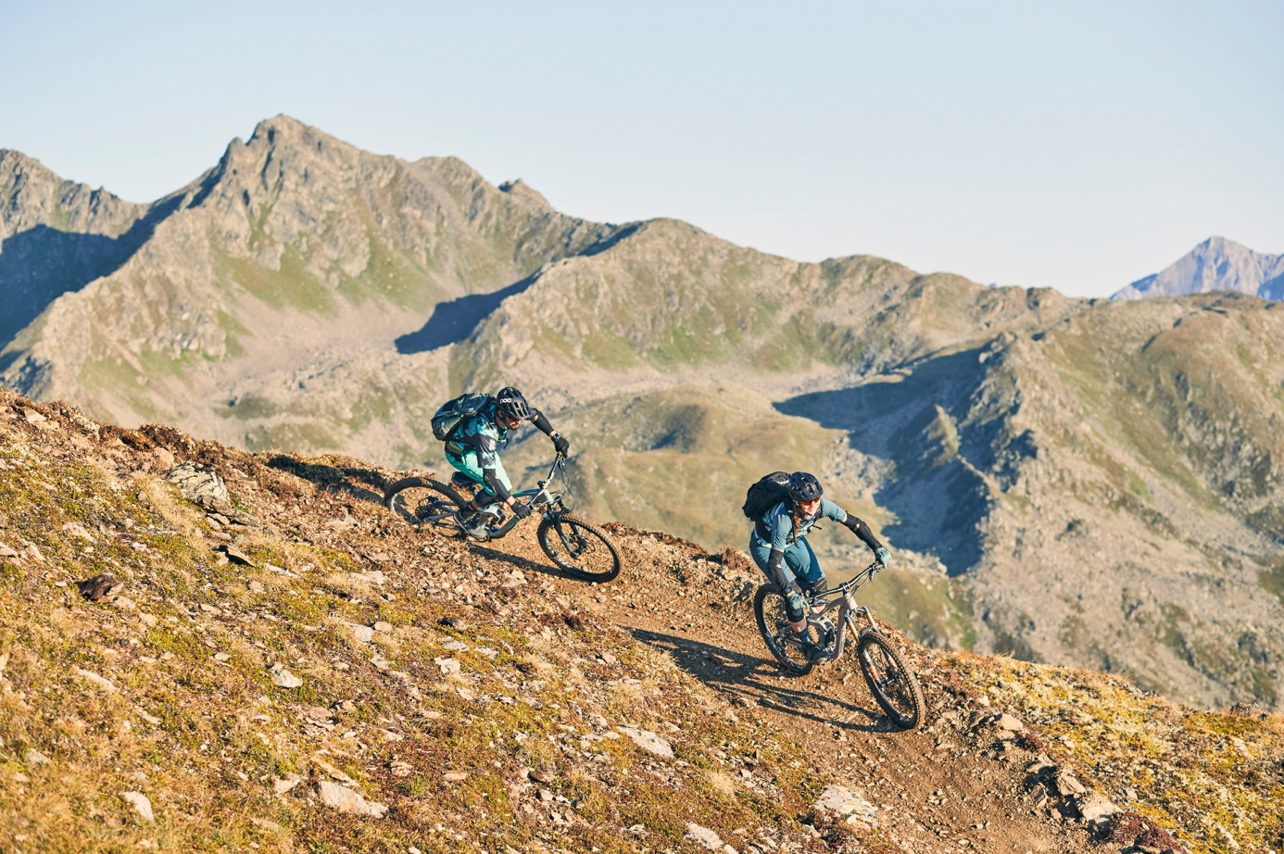
Serfaus-Fiss-Ladis – The mountain bike region Serfaus-Fiss-Ladis welcomes mountain bikers of all levels to its bike park and its surrounding trails for the 2023 season. Mountain bike kick-off on the sunny high plateau in the Tyrolean Upper Inntal valley is on 17 June. The brand-new Zirbentrail, will open this year as the longest trail in the bike region so far, with an incredible 9.1 kilometers. Meanwhile, Bikepark Serfaus-Fiss-Ladis celebrates its tenth anniversary.
The new Zirbentrail can certainly be seen as one of the future trail gems in Serfaus-Fiss-Ladis. It is based on three former trails, Almtrail, Flüstertrail and the old Zirbentrail, which have been cleverly connected and completely redesigned in specific sections to give mountain bike enthusiasts more trail action. With 9.1 kilometers it even surpasses the legendary Frommestrail (8.7 km) in terms of length. Starting at 2,600 meters above sea level, the Zirbentrail winds its way down with plenty of flow towards the Fisser Joch, passing through breathtaking, high-alpine terrain. From there on, it leads in gentle switchbacks, flowy curves and both small and large waves to the Heustadldorf – the perfect feel-good station for a short rest. In the lower third, the trail finally dives into the eponymous Zirbenwald (Swiss Pine Forest), where a whole series of north shore elements, waves and doubles allow for a varied choice of lines, being suitable for experienced riders as well as beginners and families. On its way down to the valley, the track offers plenty of new things to try out each run and many spots to rediscover.
Right next to it, at the Bikepark Serfaus-Fiss-Ladis, the nine bike park lines have been shaped and polished particularly neat this year – after all, the bike park celebrates its tenth anniversary. Bike park manager Christian Zangerl is very delighted about this special occasion: “It’s hard to believe that we have been keeping the doors and gates open for our mountain bike guests for a decade now, providing them with the best bike park action each and every year. That is something that makes me and my team very proud. Especially when you look at how many downhill cracks but also families keep coming here for mountain biking year after year, we are more than happy and look forward to the next ten years.”
With nine bike park lines as the centerpiece and six breathtaking single tracks spread across the entire mountain bike region surrounding the three villages Serfaus, Fiss and Ladis, no wishes are left unfulfilled. Yet, various events and camps guarantee that special touch. The Girl’s Shred Camp, for example, is all about offering young up-and-coming female mountain bike riders a protected atmosphere to push and motivate each other. The aim is to connect like-minded people of the same age, have a good time but also encourage the girls to experiment and try out new things on their bikes. Adults can have a go at the respective Women’s and Men’s camps. Finally, in August it is time for “bike park shredding and trail riding” for five days, when the Propain Rookie Camp invites youngsters between the age of 10 and 18 to Serfaus-Fiss-Ladis.
For more information on biking in Serfaus-Fiss-Ladis, visit: www.bike-sfl.at/en.
Details about the vacation region Serfaus-Fiss-Ladis can be found at: www.serfaus-fiss-ladis.at/en.
Find us on:

#serfausfissladis #wearefamily #weilwirsgeniessen
#bikesfl #bikeparksfl #bikeschulesfl #gooddaysfl #propain

REPRINT FREE OF CHARGE
COPY REQUESTED

Text and image download: www.serfaus-fiss-ladis.at/en/Service/Press

For media requests:
Serfaus-Fiss-Ladis Tourist Board
Alexandra Hangl
Gänsackerweg 2
6534 Serfaus, Austria
Phone: +43 (0)5476 6239 72
Email: a.hangl@serfaus-fiss-ladis.at

About the region Serfaus-Fiss-Ladis
Serfaus-Fiss-Ladis is the place to be for a family holiday. Regardless of whether it is summer or winter, there is always something going on. In summer cable cars and bus shuttles connect the mountainous region of Serfaus-Fiss-Ladis apart from many other attractions, the Serfaus-Fiss-Ladis high plateau offers bike fun for the whole family. From gentle bike rides for the whole family to mountain bike tours in the middle of breath-taking mountain scenery to action-packed descents on single trails or courses through Bikepark Serfaus-Fiss-Ladis, which celebrates its tenth anniversary this year. The Waldbahn takes riders and their bikes to the trails within the bike park, which have different levels of difficulty, from blue (easy) and red (medium) to black (expert). There is also a kid's park, slopestyle area with an air bag, pump track, dirt line and training area at the bottom station, where beginners can try out and get used to their new equipment. Experts in the bike shop advise on bike and safety equipment matters, and the bike school and rental office shop can also be found here. Besides the shop, there is also a chill-out area and a snack bar.

