A walking tour of discovery from St. Anton am Arlberg/Tyrol
Hut hopping along the Verwall Circuit

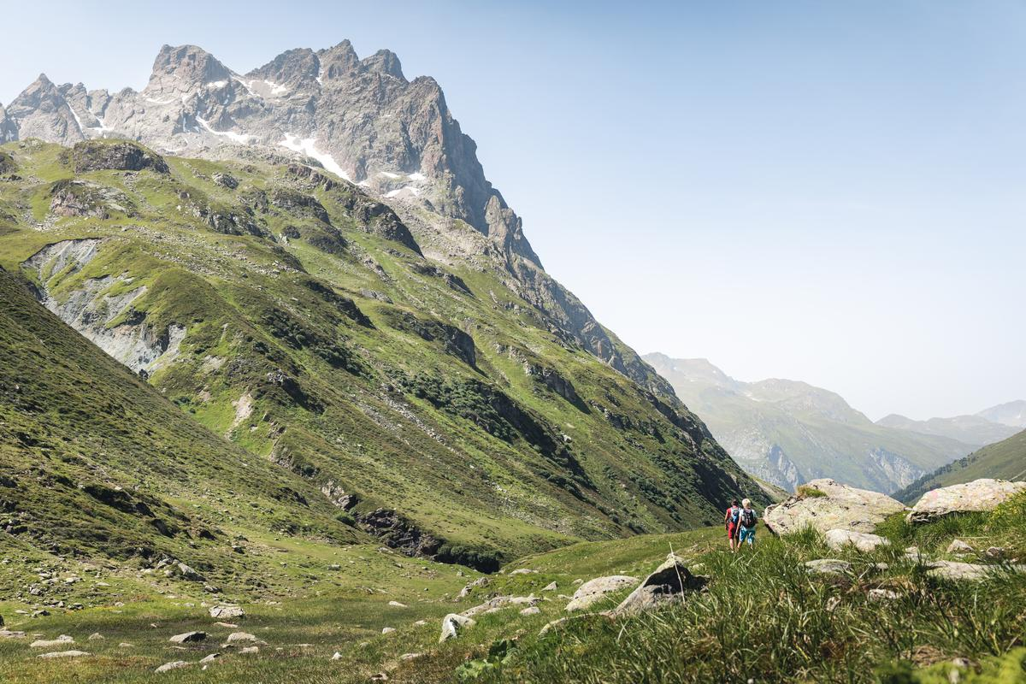
The expansive region of St. Anton am Arlberg in Austria is home to the Verwall Circuit, renowned for its panoramic views.
© TVB St. Anton am Arlberg/photographer Patrick Bätz

A network of around 400 kilometres of trails in and around St. Anton am Arlberg opens the Tyrolean mountain world up for hikers. The expansive mountain range of the Verwall Alps between the Lechtal and Silvretta Alps are considered to be a particularly scenic insider’s tip. Mountain sports enthusiasts surmount up to 3,710 metres in elevation difference on the specially designed Verwall Circuit, while enjoying first-class hut-hopping along the way on tours of two to eight days. From the starting point in St. Anton am Arlberg, the route leads via the Konstanzer Hut, Darmstädter Hut, Niederelbe Hut, Edmund Graf Hut and Malfon Alm back to the original departure point. The 44-kilometre round tour takes around 18 hours of pure walking time (level of difficulty: challenging); you can rest at all the huts and, apart from the latter, even spend the night there. In-between stops for refreshments at these mountain huts, which are all set in breathtaking locations, the alpine trails also lead over loose scree, snow and ice. Rewards for all these exertions are manifold: in addition to wide open spaces to regenerate, motivated hikers can look forward to enjoying a host of Tyrolean specialities. With several award-winning gourmet restaurants as well as international cuisine in the valley-based villages, hearty alpine cuisine creates a charming counterbalance and reflects the culinary versatility of Austria's "global village," St. Anton am Arlberg. The Verwall Circuit is featured on the interactive map with a detailed route and altitude profile, points of interest and interesting facts about the individual huts. Those who do not wish to undertake a multi-day hike can also explore these mountain eateries as part of a day tour. All paths are marked throughout, steep sections are secured with ropes. The tour is open until late September. For more information, variants and hiking suggestions, please visit www.stantonamarlberg.com
Tip for a day trip destination and stop for refreshments: Wagner Hut (1,509 metres)

Mountain lovers can start the Verwall Circuit in the eponymous valley, the entrance to which is located at Mooserkreuz on the western boundary of St. Anton am Arlberg. After a good three-and-a-half kilometres, having passed the Stations of Legends, “EldoRADo“ biking area and the high and low rope climbing garden, hikers reach the historic Wagner Hut in around 45 minutes. This pleasant meeting place for locals and visitors alike enriches the experience of this short hike through the Verwall Valley, especially for families. The guesthouse can look back on a long and eventful history, as the foundation stone of this former warden’s house was originally laid back in 1880. A few years later, engineer Carl Wagner converted it into a hunting lodge and gavet it the name it bears to this day. Guests have been welcomed and entertained here since the 1920s. Palates are pampered with delicious Tyrolean cuisine: ranging from flattened cheese dumplings, to beef goulash and quark strudel. Fresh and predominantly regional ingredients are carefully prepared and used in accordance with traditional recipes. After enjoying some refreshments, a detour (approx. 500 metres) to the glistening green waters of Verwallsee Lake is well worth making for all those not hiking the whole circuit. Open: 16th June to 3rd October 2023 (warm meals available from 10-18 hrs, overnight stays not possible). www.wagnerhuette.at

Konstanzer Hut (1,688 metres)

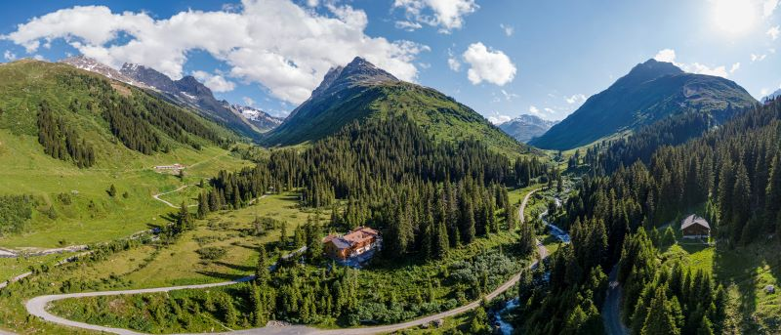
Konstanzer Hut in St. Anton am Arlberg, Austria © TVB St. Anton am Arlberg/Photographer Patrick Bätz
Few people are aware of just how extensive the St. Anton am Arlberg region is. Even locals only know of some of the remote high valleys from hearsay. The Konstanzer Hut, however, is idyllically located in the forest where the Pfluntal, Schönverwalltal and Fasultal valleys merge. After first opening in 1885, it was destroyed by a mudslide and rebuilt in a safer location 700 metres further on in 1990, before being expanded again in 2019. The approximately three-and-a-half-hour ascent from St. Anton encompasses some eleven kilometres, passing the Wagner Hut and Verwallsee Lake, before continuing through the valley over some steeper serpentines. Once there, guests are spoiled by the Schöpf-Eberhart family with Austrian-European cuisine. Alongside favourite classics such as apple strudel, bowls have been recently added to the menu. One highlight is the in-house aperitif,” Paterol,“ which can be savoured beautifully in the sunny garden with views of the eponymous 3,056 metre high Mount Patteriol – described by mountain enthusiasts as a "dream of a mountain" and the "Matterhorn of St. Anton". Konstanzer Hut is even suitable for young explorers from the age of seven, as part of the Alpine Club's "Mit Kindern auf Hütten" (With children to huts) initiative. Open: 23rd June to 23rd September 2023 (warm meals available from 10-18 hrs). www.konstanzerhuette.com

Darmstädter Hut (2,385 metres)

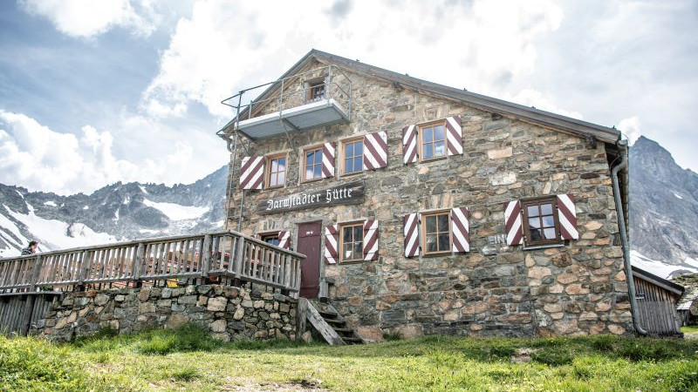
Darmstädter Hut in St. Anton am Arlberg, Austria © TVB St. Anton am Arlberg/Photographer Patrick Bätz

The Darmstädter Hut lies nestled amidst lush alpine flora in the impressive Moostal Valley south of St. Anton am Arlberg. The splendid stone house with its striking red-and-white striped shutters can be reached from the centre of St. Anton from the Rendlbahn cable car valley station in around three and a half hours. The twelve-kilometre route may be shortened somewhat by taking a gondola ride (operating days in summer: Wednesday and Thursday). Set against views of the Verwall mountain range, innkeeper Andreas Weiskopf rewards hikers on the sun terrace with his popular dumpling variations, and freshly baked pastries for dessert. Seven climbing routes, as well as a marked bouldering area for day trips can be found near the Darmstädter Hut, as well as the mighty Kuchenspitze Peak (3,148 metres). A crash pad is available to rent from the hut. For children, the accommodation offers adventure areas with climbing blocks and equipped climbing gardens, as well as four-legged housemates including marmots, ponies and domestic pigs. Open: 24th June to 17th September 2023 (warm meals available from 10-18 hrs). www.alpenverein.de/Darmstaedter-Huette

Niederelbe Hut (2,310 metres)

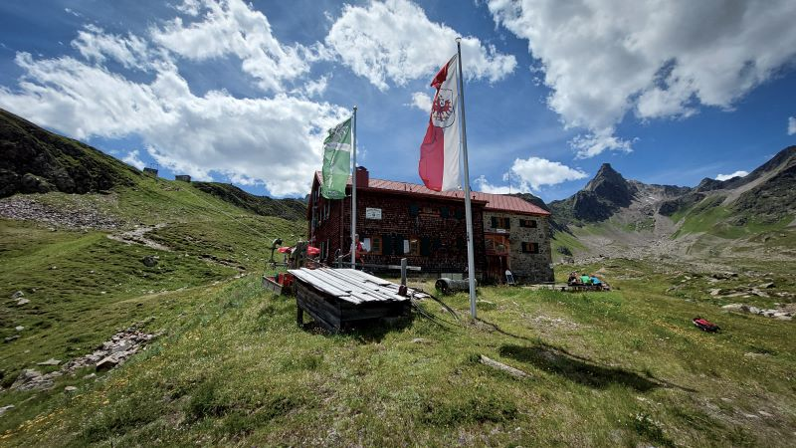
Niederelbe Hut in St. Anton am Arlberg, Austria © TVB St. Anton am Arlberg

Built between 1930 and 1931, the Niederelbehütte stands picturesquely next to Lake Seßsee on a plateau in the upper Sessladtal Valley, from where Paznaun Valley opens up beneath its perches. The accommodation can be reached from St. Anton am Arlberg in around four and a half hours walking time over a distance of 14 kilometres. As a member of the Austrian Gourmet Region, the Jehle family serves hearty and typical regional dishes such as “Brettljause” cold platter or “Tyrolean Gröstl” sautéed potatoes with meat and fried egg. In the past, guests have even been able to sample fine cuisine from star chefs at 2,310 metres above sea level. Niederelbe Hut has already featured several times on the "Culinary Way of St. James" by star chef Eckart Witzigmann, where international master chefs showcase their gourmet skills. Open: 23rd June to 24th September 2023 (warm meals available from 10-18 hrs). www.niederelbehuette.at

Edmund Graf Hut (2,375 metres)

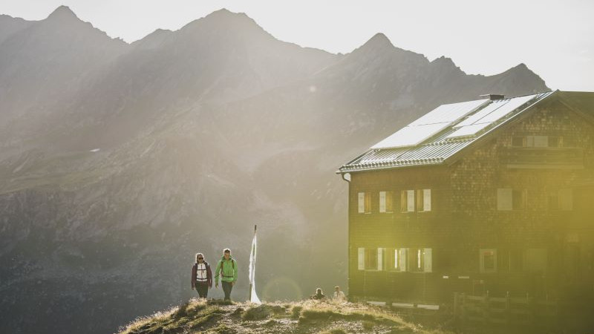
Edmund Graf Hut in St. Anton am Arlberg, Austria © TVB St. Anton am Arlberg/Photographer Patrick Bätz

The three-and-a-half-hour hike from Pettneu, a municipality in the St. Anton am Arlberg region, through Malfontal Valley to the Edmund Graf Hut is considered a moderately difficult mountain tour - there are just under 1,200 metres of altitude difference to be surmounted over a good seven-and-a-half kilometres.. This mountain refuge on the upper Kapplerboden, which dates back to 1884, is now under young management: host Fabian Kolp is just 20 years old and has been managing the hut since summer 2021. Even as a child, he loved the trips to the Edmund Graf Hut. On hearing that the previous tenants were retiring, he seized his chance. The sun terrace with views of the Tyrolean Verwall mountain range is particularly popular among visitors, while the small lake right next to the hut and stream with a water wheel are especially popular with children. In terms of cuisine, roast pork is a top favourite. Alternatively, guests can choose between cold meat and cheese platters, hearty soups and apple strudel. Open 24th June to 24th September 2023 (warm meals available from 10-18 hrs). www.edmund-graf-hütte.at

Malfon Alm (1,687 metres)

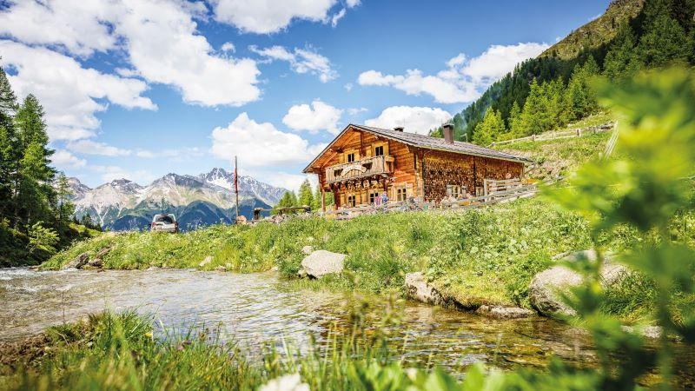
Malfon Alm in St. Anton am Arlberg, Austria © TVB St. Anton am Arlberg/Photographer Patrick Bätz

A stop at Malfon Alm makes a most befitting end to the final few kilometres of the Verwall Circuit hut hopping tour, high above St. Anton am Arlberg. The mountain inn owned by Gabriel Neururer and Pia Zimmermann, however, is also well worth visiting for just a day trip. Starting in the municipality of Pettneu, the approximately five-kilometre-long trail alongside Zeinisbach stream first leads downhill before heading uphill again, parallel to the Malfonbach stream. After a steep section through a shady forest, the one-and-a-half-hour route takes you past grazing cows and a few more serpentine bends to your final destination. Since early June, the Malfon Alm owners have provided summer grazing pastures for 91 calves, cattle and mother cows. In addition to soul-soothing animal encounters, hikers can look forward to enjoying delicious dishes, such as “Käsespätzle” (cheesy pasta), roasted pork and Tyrolean dumplings with bacon straight from the wood-fired stove. “Kaiserschmarrn” pancake made with eggs from the farm’s own chickens also comes highly recommended. Open: 27th May to late September 2023 (warm meals available from 10-18 hrs). www.stantonamarlberg.com/malfon-alm

