St. Anton am Arlberg in Tyrol kicks off the winter season on 1st December 2023
Three days of festivities at Stanton Ski Open
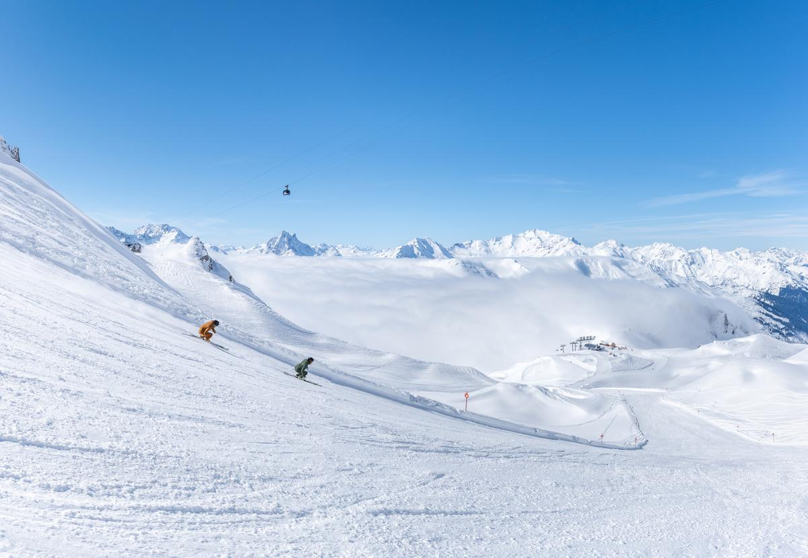
St. Anton am Arlberg in Tyrol launches the winter season on the first weekend of December 2023 with plenty of music, safety training and free material tests. © TVB St. Anton am Arlberg / Photographer Lucas Tiefenthaler

The scent of fresh snow fills the air, the hills are alive with the sound of music and the huts on the mountains and in the valley look oh-so cosy and inviting: it is the cusp of the ski season in St. Anton am Arlberg! St. Anton am Arlberg starts the winter of 2023/24 in style at the Stanton Ski Open from 1st to 3rd December 2023 with concerts on three stages and an assortment of food trucks. Cool bands, DJs and artists such as Bavarian singer-songwriter, Oimara, ensure a festival atmosphere on Friday and Saturday. At Arlberg Safety Camp and in cooperation with Tyrol Mountain Rescue Service, an avalanche safety presentation and practical training are planned (registration required). Throughout the opening weekend, guests can test the latest models from leading ski and snowboard manufacturers on the slopes of the largest inter-connected ski area in Austria free of charge. Click here for the Stanton Ski Open 2023 programme.
www.stantonamarlberg.com/en

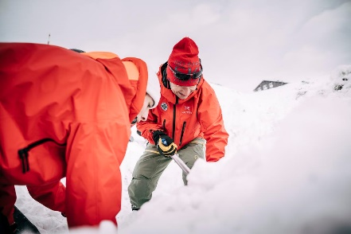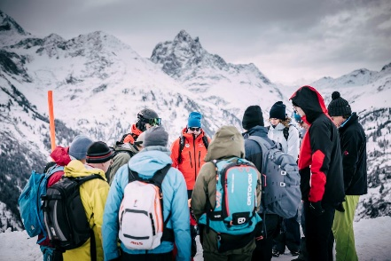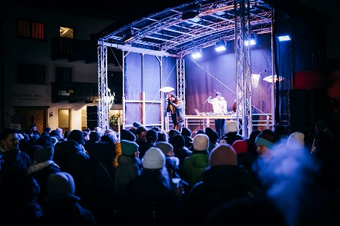
On the mountain the focus is on safety and in the evening it's on the atmosphere - as part of the newly designed Stanton Ski Open, St. Anton am Arlberg in Tyrol welcomes its first winter season guests from 1st to 3rd December 2023.
© TVB St. Anton am Arlberg / Photographer Patrick Bätz

A season of superlatives beckons

With over 300 kilometres of marked downhill runs as well as 200 kilometres of back country variants, the mountain village at the heart of "Ski Arlberg" ranks as one of the largest ski resorts in the world. Winter holidays in the Stanzer Valley region are characterised by many other superlatives, including the huge choice of fabulous cuisine which ranges from traditional Tyrolean fare to one of the most elevated award-winning restaurants in Europe, or what is probably the most legendary downhill race in the Alpine region. With a route that encompasses some 1,350 metres in elevation difference and seven-and-a-half kilometres in distance, “The White Thrill” does more than justice to its name and enjoys an awesome reputation amongst ski freaks. On 20th April 2024, participants and spectators can look forward to an "anniversary of madness" on the last weekend of the ski season (ends: 21st April), when this iconic race celebrates its 25th jubilee. For all those who would like to spend their holidays in St. Anton am Arlberg before then, the climate-friendly and comfortable train journey to the highest ICE train station in the world, located directly at the village centre, is well worth looking into. More comfort on the slopes is also assured in winter 2023/24 with the new 8-seater Albonabahn I gondola in Stuben, which can be reached from the Alpe Rauz hub and transports guests up the Albona in weatherproof conditions. http://www.stantonamarlberg.com/en

About St. Anton am Arlberg. As the birthplace of Alpine skiing, St. Anton am Arlberg is recognised as one of the world’s most prestigious winter sports resorts. Every year, piste and freeride fans from over 50 nations visit this mountain village and ski area with a total of over 300 kilometres of marked runs, 200 kilometres of backcountry terrain and 87 lift and cable car systems. The “SKI ARLBERG“ region extends from St. Anton in Tyrol to Lech and Zürs, as well as Warth and Schröcken in Vorarlberg. Cross-country skiing, tobogganing or a thrilling ride on one of the five twisting toboggan runs in the region are just as inherent to the inimitable Arlberg experience as its iconic events, international World Cup races or multi-award-winning Tyrolean cuisine.www.stantonamarlberg.com/en

