St. Anton am Arlberg, Tyrol: Springtime skiing and season finale 2024
All set for the 25th “White Thrill”

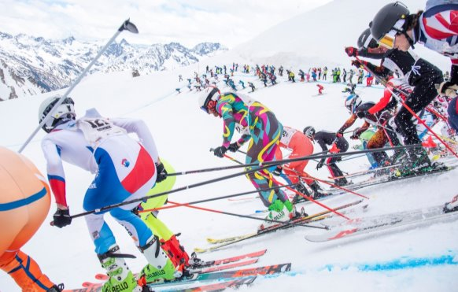
Many participants hesitate for a second or two after the mass start on Valluga Ridge above St. Anton am Arlberg, while the most ambitious are already gunning for a podium position. “The White Thrill” returns in April 2024 for the 25th time.
© St. Anton am Arlberg Tourist Board/Patrick Säly

Ride the gondola up to the top for a final time, soak up the fabulous view. Take a deep breath, before the bindings click. Pulses quicken, a shot is fired - the “The White Thrill" anniversary event in St. Anton am Arlberg/Tyrol begins. The most legendary downhill race in the Alps will demand every ounce of strength from its intrepid participants for the 25th time on 20th April 2024, when 555 international skiers, snowboarders and telemark enthusiasts hurtle simultaneously down unprepared slopes to the valley after a mass start at Vallugagrat Ridge. The fastest skiers take less than eight minutes to cover the seven-and-a-half-kilometre course with 1,300 metres in altitude difference. Throngs of spectators, however, cheer everyone on who crosses the finish line - irrespective of whether they are a sweat-soaked medal contender, or leisurely skier in fancy dress. Impressive footage of this iconic Austrian ski race is featured on this video, while all participant information can be found at www.stantonamarlberg.com or der-weisse-rausch.at

Lungs on fire and pushing personal limits

The last weekend of the ski season in St. Anton am Arlberg traditionally belongs to hardcore riders and enthusiastic spectators. “The White Thrill” is basically a race in which everyone can compete - but even experienced downhill skiers reach their limits when they hurtle down into the valley from the "monster" and highest point of the ski area, Valluga Ridge, together with several hundred fellow daredevils. Valuable seconds can be won by finding the right position at the mass start-line, before the arduous interim ascent on the aptly called “Schmerzensberg - Pain Mountain” sets racers’ lungs on fire. “No matter whether you're a professional athlete or hobby skier, everyone pushes themselves to the limit here," says German multiple winner Florian Holzinger, describing the special appeal of the “White Thrill". The downhill race begins on 25th April 2024 at 17 hrs on Vallugagrat Ridge above St. Anton am Arlberg. Plucky children aged eleven to 16 years start their shortened version a little earlier at 16.30 hrs above the Senn Hut.

Consummate flagship for the " global village" of St. Anton am Arlberg

Tourism Director Martin Ebster sees the "White Thrill" as the kind of event "that perfectly befits St. Anton am Arlberg". It's in keeping with our long-standing tradition of professional skiing and yet designed for everyone to take part. "There's no other event like it in the world." As usual, Ebster will moderate at the season finale live from the valley in St. Anton am Arlberg. Speaking about the significance of this iconic race for the destination, he says: "St. Anton is recognised as being one of the most sports-oriented regions in the Alps - in both summer and winter. The “White Thrill” may seem like a pretty crazy event, but it has developed into a consummate flagship for our internationally acclaimed mountain village. Nobody expected this turn of events 25 years ago, but the huge rush of registrations to take part bears witness to its appeal. As a region, this is something we can be proud of! "der-weisse-rausch.at

The best of springtime skiing until 21st April 2024

Before the “White Thrill” attracts international athletes and spectators to the western outreaches of Tyrol for the 25th time, springtime skiing in St. Anton am Arlberg is still at its best. With sun-drenched and superbly groomed slopes, the Tyrolean mountain village and its hosts welcome holidaymakers to enjoy their last turns of the winter season right up to and including 21st April 2024. For those wanting to spend a few days in St. Anton am Arlberg, recently named "Best Tourism Village", the climate-friendly and comfortable train journey to the highest ICE train station in the world located directly at the village centre, is well worth looking into. The new 8-seater Albonabahn I gondola in Stuben, which can be reached from the Alpe Rauz hub, assured yet more comfort from this winter onwards, transporting guests to Albona in weatherproof conditions.

"Cordula Grün" and co. as guests to the fifth largest ski area in the world

Sun, snow, skis and sounds: the Tanzcafé Arlberg Music Festival with international artists is set to take place across the entire Arlberg region for the first time in spring 2024. The tenth edition of the concert series from 31st March to 14th April 2024 will bring Tyrol and Vorarlberg even closer together for the spring skiing season. After all, the open-air event, which was previously based in Lech Zürs, will be held nationwide for the very first time - with additional concerts in St. Anton, St. Christoph and Stuben am Arlberg. Holidaymakers will be able to enjoy some exciting stage sets and dance floors with over 30 acts, located just a few steps away from some of the best ski slopes in the world. Highlights include Viennese chart toppers Josh and Julian le Play, the dynamic neo-Austropop band Granada, live techno experts Elektro Guzzi and Balkan beat king Shantel. Admission to all concerts is free. www.tanzcafe-arlberg.com

About St. Anton am Arlberg. St. Anton am Arlberg is one of the world’s most renowned winter sports resorts. Piste and freeride fans from more than 50 nations visit the mountain village and its ski area every year, with a total of more than 300 kilometres of marked downhill runs, 200 kilometres of off-piste variants and 85 lifts and cableways. The Arlberg-Arena extends from St. Anton in Tyrol to Lech and Zürs, as well as Warth and Schröcken in Vorarlberg. Cross-country skiing, tobogganing or a thrilling ride on one of the five winding toboggan runs in the region are just as inherent to the inimitable Arlberg experience as its iconic events, international World Cup races or multi-award-winning Tyrolean cuisine. The “birthplace of alpine skiing” is also a founding member of the “Best of the Alps“; a quality association of the 10 most prestigious mountain resorts in the Alps.

