Holidays in St. Anton am Arlberg, Tyrol
Top events in summer 2024

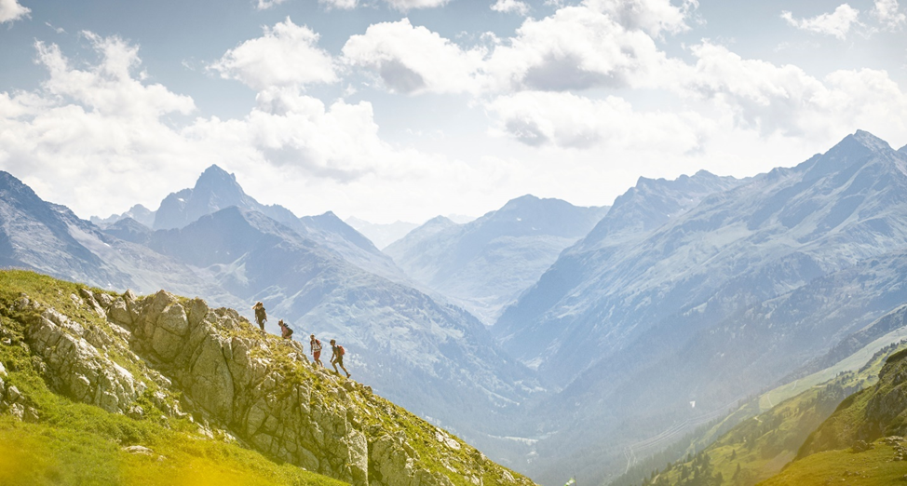
Mountain sports enthusiasts will gather in St. Anton am Arlberg from 28 to 30 June 2024 to discover the magic of the mountains together in breathtaking nature! © TVB St. Anton am Arlberg / Photographer Patrick Bätz

In summer, the year-round sport-loving St. Anton am Arlberg is transformed from a white ski Mecca into a colourful mountain village, brimming with exciting opportunities. The colour green plays a key role against this spectacular alpine backdrop - because as an official KLAR! model region, the conscientious local community is working intensively on various sustainability and climate change adaptation projects. And this has a long tradition: eco-friendly electricity was generated as early as 1921 here with the first local hydroelectric power plant, while the municipality has in fact been self-sufficient in terms of energy supply with its self-generated “Arlbergstrom” electricity since 2006. St. Anton am Arlberg has also been home to the world's highest ICE (inter-city express) railway station at 1,303 metres above sea level since 2023. On receiving the "Best Tourism Village" award in 2023 from the UN World Tourism Organisation, the Tyrolean municipality has once again proved that tourism and sustainability can go hand in hand. In addition to the revised "Mountain Sports Festival" for all abilities, intrepid athletes can look forward to a quirky obstacle course in St. Anton am Arlberg for the first time in summer 2024. www.stantonamarlberg.com

Mountain Sports Festival from 28th to 30th June

Whether you are an experienced mountaineer or a beginner, interested in new sports or just looking to improve your skills: visitors to the Mountain Sports Festival from 28th to 30th June 2024 in St. Anton am Arlberg will experience the joys of alpine sports in all its multi-faceted diversity. Whether e-biking, hiking, mountaineering, climbing, trail running, road biking, kayaking, paragliding or yoga - local guides will share their valuable knowledge during guided tours and courses so that guests can enjoy their Tyrolean mountain summer safely and optimally prepared. The Expo Area in St. Anton am Arlberg's village centre is the starting point on all days. Interested guests can test the latest equipment and e-bikes from renowned manufacturers of various outdoor brands to their heart's content (availability permitting). The weekend is rounded off by a varied programme, including live music, a “Movie Night” and activities for kids.
Montafon Arlberg Marathon on 29th June

Perhaps the most beautiful mountain marathon in the Alps is known for taking its participants to their physical limits, but rewards them time and time and again with fabulous views. Transcending borders and well away from traffic, the trail leads over 42 kilometres of forest and hiking trails (1,500 metres in elevation difference) from the Montafon municipality of Silbertal via Winterjöchle and on to St. Anton am Arlberg. Those who don't feel up to the marathon distance can still take part: there are two shorter variants as well as a children's trail.

St. Anton Film Festival from 21st to to 24th August

The alpine outdoor film festival is a firmly anchored fixture in St. Anton am Arlberg. True to the tagline "Mountains, People, Adventure", extreme athletes, filmmakers and mountain-loving audiences have been getting together in late summer for 28 years now. This major event is made particularly charming by the welcoming atmosphere of the Tyrolean mountain community: where protagonists and directors share their experiences with the audience and comment on their recordings live in relaxed ambience.

NEW: Arlberger Wadlbeisser on 31st August

"Sightseeing the hard way" is the motto of this quirky obstacle course, which will take place for the first time in St. Anton am Arlberg in summer 2024. During the Arlberger Wadlbeisser, participants, fired up by cool DJ tunes, a moderator and spectators, will compete in two impressive distances - over 350 metres in altitude and 15 obstacles along a seven-and-a-half-kilometre route between the mountain and the village. More hardcore runners are invited to attempt the 13.5-kilometre variant, which includes 700 metres in elevation difference and 24 obstacles.

Mountain Yoga Festival from 5th to 8th September

The soothing surroundings of St. Anton am Arlberg lend this yoga festival a retreat character. Many yoga enthusiasts will meet again in late summer for the ninth time to practise together in the midst of beautiful nature. The programme includes a wide variety of styles and ability levels and is therefore also suitable for beginners. Beyond the mat, guided walks, workshops, lectures, soft sounds and healthy cuisine with regional ingredients complete the holistically aligned activities on offer.

Line Dance Festival from 13th to 15th September

A whole weekend dominated by country beats, cowboy hats and boots: for the sixth time now, the Tyrolean community of St. Anton am Arlberg will be transformed into a giant dance floor at the Line Dance Festival. Participants from near and far come together to celebrate what line dancing is all about: pure joie de vivre. The successful world record attempt in 2010 was quickly followed by a veritable "line dance boom" - a new record is to be set in 2024, during which 20 fully choreographed dances must be accomplished in one hour.

Summer 2024 calendar of events at a glance:

14.06. Start of the Summer Season
28.-30.06. Mountain Sports Festival
29.06. Montafon Arlberg Marathon (Mountain Run)
14.07. Hour of reflection for car drivers outside Arlberg WellCom
19.-21.07. Village Festival at St. Anton am Arlberg
27.-28.07. Parish Fair in St. Jakob
09.-11.08. Arlberg Riflemen Marquee Festival in St. Anton am Arlberg
14.-15.08. Parish Fair in Pettneu
15.08. 12th Arlberg Herb Festival at the Sennhütte
21.-24.08. 28th Film Festival ”Mountains, People, Adventure“
23.-25.08. Parish Fair in Flirsch
31.08. Arlberger Wadlbeisser
01.09. Parish Fair in Schnann
05.-08.09. 9th Mountain Yoga Festival St. Anton
13.-15.09. Line Dance Festival
14.09. Almabtrieb (Cattle Drive) and Farmers’ Festival

