Superb sporting events in a summery St. Anton am Arlberg/Tirol
When your calves scream for mercy

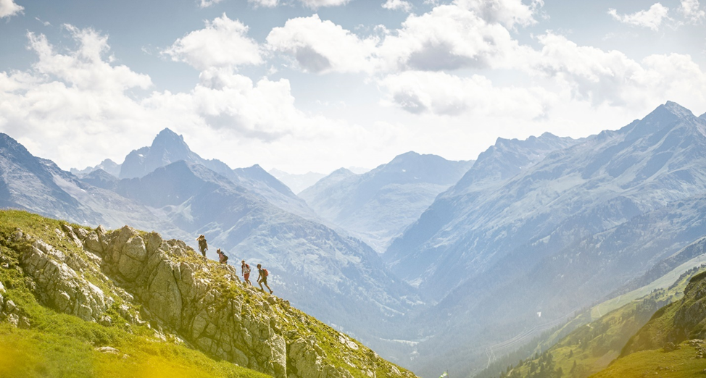
Outdoor enthusiasts will meet at the ”Bergsport Festival“ in St. Anton am Arlberg from 28th to 30th June 2024.
© TVB St. Anton am Arlberg/Photographer Patrick Bätz

Mountain aficionados, cross-border travellers and endurance sport fans meet up in St. Anton am Arlberg during the warmer season. After all, a plethora of summer sports events have established themselves against the striking backdrop of this Austrian “global village”. The competitions are often fast-paced and physically challenging – whether on two wheels or on foot. Less strenuous alternatives, however, also attract more leisurely or younger participants to the starting blocks. All those who who prefer to savour the Tyrolean mountain air as spectators are equally welcome. In addition to the revised “Bergsport Festival” for all levels of ability at the start of the season, intrepid athletes can look forward to a quirky obstacle course called the ”Wadlbeisser” for the first time in summer 2024. Those travelling environmentally friendly to the events by train will disembark right in the centre of St. Anton am Arlberg. The municipality is home, namely, to the world’s highest inter-city “ICE” railway station. www.stantonamarlberg.com

Top events in summer 2024

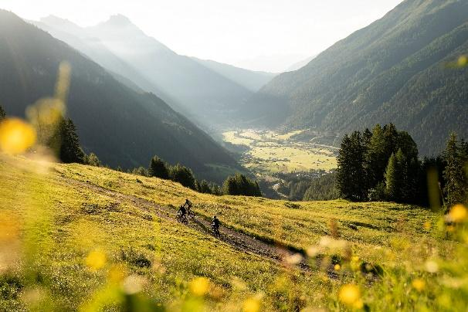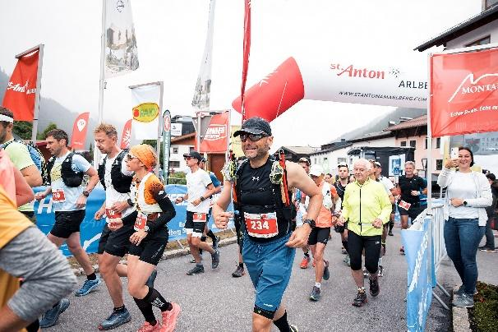
© ebikefests/Stefan Voitl © TVB St. Anton am Arlberg/Photographer Patrick Bätz

Mountain Sports Festival from 28th to 30th June

Whether you are an experienced mountaineer or a beginner, interested in new sports or just looking to improve your skills: visitors to the Mountain Sports Festival from 28th to 30th June 2024 in St. Anton am Arlberg will experience the joys of alpine sports in all its multi-faceted diversity. Whether e-biking, hiking, mountaineering, climbing, trail running, road biking, kayaking, paragliding or yoga - local guides will share their valuable knowledge during guided tours and courses so that guests can enjoy their Tyrolean mountain summer safely and optimally prepared. The Expo Area in St. Anton am Arlberg's village centre is the starting point on all days. Interested guests can test the latest equipment and e-bikes from renowned manufacturers of various outdoor brands to their heart's content (availability permitting). The weekend is rounded off by a varied programme, including live music, a “Movie Night” and activities for kids.

Montafon Arlberg Marathon on 29th June

Perhaps the most beautiful mountain marathon in the Alps is known for taking its participants to their physical limits, but rewards them time and time and again with fabulous views. Transcending borders and well away from traffic, the trail leads over 42 kilometres of forest and hiking trails (1,500 metres in elevation difference) from the Montafon municipality of Silbertal via Winterjöchle and on to St. Anton am Arlberg. Those who don't feel up to the marathon distance can still take part: there are two shorter variants as well as a children's trail.

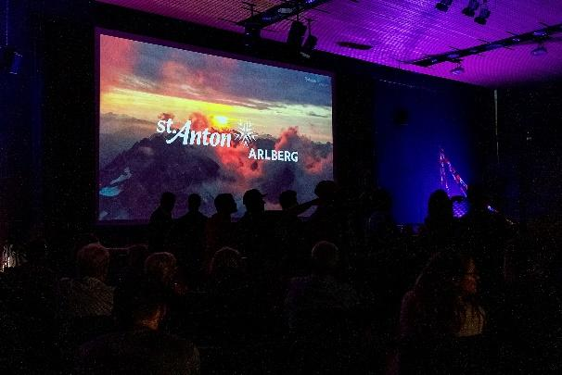
© Timmy Schröder © TVB St. Anton am Arlberg/Photographer Patrick Bätz

St. Anton Film Festival from 21st to to 24th August

The alpine outdoor film festival is a firmly anchored fixture in St. Anton am Arlberg. True to the tagline "Mountains, People, Adventure", extreme athletes, filmmakers and mountain-loving audiences have been getting together in late summer for 28 years now. This major event is made particularly charming by the welcoming atmosphere of the Tyrolean mountain community: where protagonists and directors share their experiences with the audience and comment on their recordings live in relaxed ambience.

NEW: Arlberger Wadlbeisser on 31st August

"Sightseeing the hard way" is the motto of this quirky obstacle course, which will take place for the first time in St. Anton am Arlberg in summer 2024. During the Arlberger Wadlbeisser, participants, fired up by cool DJ tunes, a moderator and spectators, will compete in two impressive distances - over 350 metres in altitude and 15 obstacles along a seven-and-a-half-kilometre route between the mountain and the village. More hardcore runners are invited to attempt the 13.5-kilometre variant, which includes 700 metres in elevation difference and 24 obstacles.

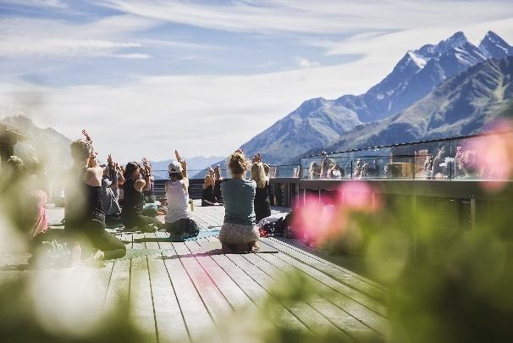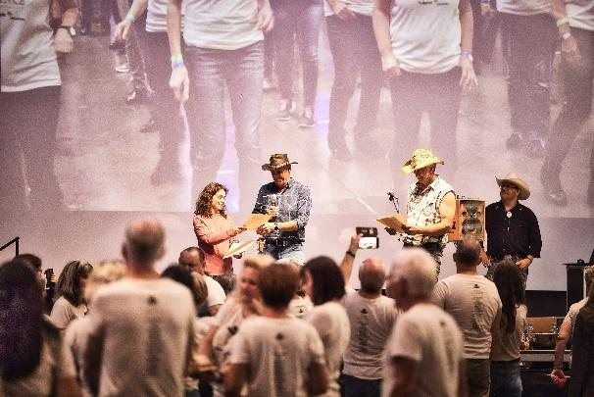
© TVB St. Anton am Arlberg/Photographer Patrick Bätz © TVB St. Anton am Arlberg/Photographer Patrick Bätz

Mountain Yoga Festival from 5th to 8th September

The soothing surroundings of St. Anton am Arlberg lend this yoga festival a retreat character. Many yoga enthusiasts will meet again in late summer for the ninth time to practise together in the midst of beautiful nature. The programme includes a wide variety of styles and ability levels and is therefore also suitable for beginners. Beyond the mat, guided walks, workshops, lectures, soft sounds and healthy cuisine with regional ingredients complete the holistically aligned activities on offer.

Line Dance Festival from 13th to 15th September

A whole weekend dominated by country beats, cowboy hats and boots: for the sixth time now, the Tyrolean community of St. Anton am Arlberg will be transformed into a giant dance floor at the Line Dance Festival. Participants from near and far come together to celebrate what line dancing is all about: pure joie de vivre. The successful world record attempt in 2010 was quickly followed by a veritable "line dance boom" - a new record is to be set in 2024, during which 20 fully choreographed dances must be accomplished in one hour.

