Viewed from a mountain top or even from the air: the very best vistas of St. Anton am Arlberg, Tyrol
The global village from above

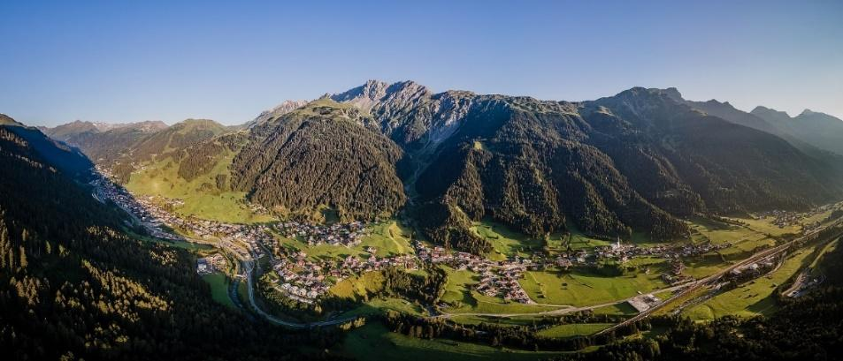
The village of vantage points – St. Anton am Arlberg exudes its inimitable Tyrolean charm not only in the valley, but also from an aerial perspective. © St. Anton am Arlberg Tourist Board/Photographer Patrick Bätz

Viewing St. Anton am Arlberg from above induces an immediate sense of tranquillity. As one takes a deep breath of the clear mountain air, realisation dawns that this Tyrolean charm is not something that can be grasped, but should be fully experienced from head to toe. From your sunglasses right down to your mountain boots. Whether hiking, climbing, cycling, or paragliding, on foot or comfortably by cable car –many ways lead holidaymakers to the mountaintops.
www.stantonamarlberg.com

Combine, combine!

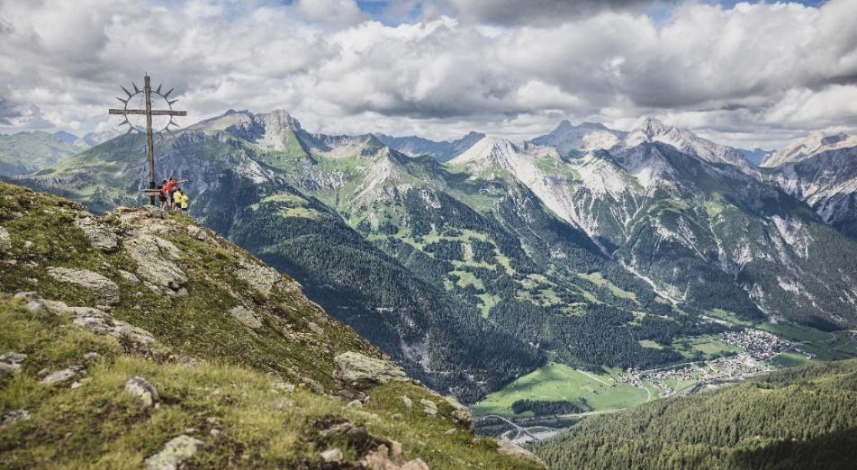
There are 1,076 metres in elevation difference to surmount on the (E-)Bike & Hike Tour from St. Anton am Arlberg to Zwölferkopf Peak. The reward: this incredible view of the surrounding peaks and Stanzertal Valley © St. Anton am Arlberg Tourist Board/Photographer Patrick Bätz

These summit moments don’t come for free. The view of St. Anton am Arlberg and the Stanzertal Valley from Zwölferkopf Peak (2,556 metres) needs to be earned: with some hard pedalling and a mountain hike. The combined (E-)Bike & Hike tour starts on two wheels at the Tyrolean municipality’s tourist information office, heading eastwards and initially along Stanzertal cycle path. Outdoor fans continue past alpine rose strewn meadows and a forest trail towards Rendlalm. Those who wish can then take a short break before the real challenge begins, as things get much steeper from here! The route leads up through the northern mountain flank to the bike parking area at 2,050 metres – don’t forget your bike lock! Those who are sure-footed and have a good head for heights can hike along the western ridge for around one and a half hours to Zwölferkopf Peak. The summit cross only reveals itself on the last few metres of the hike. Alpine combiners will need around five hours to conquer this moderately difficult route of 23.4 kilometres (1,076 metres in altitude).

Rock solid at 3,056 metres

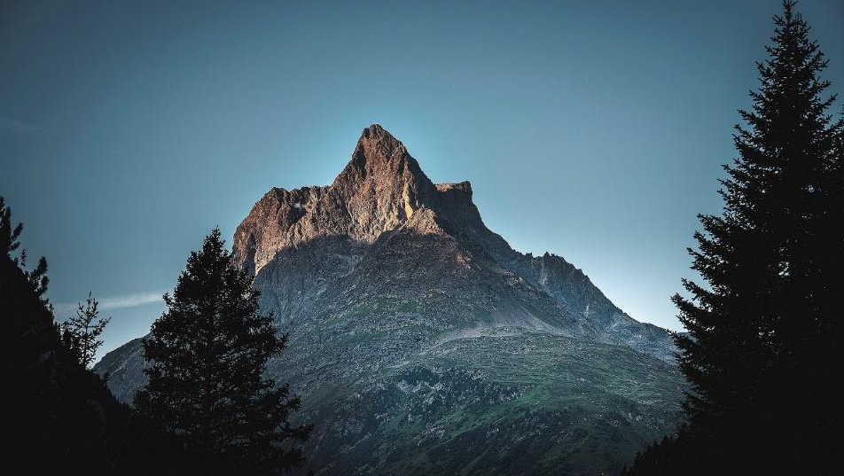
Experienced alpinists can climb the Patteriol – affectionately known as the “Matterhorn of Arlberg” – in around nine hours from St. Anton am Arlberg via its north-eastern ridge. © St. Anton am Arlberg Tourist Board/Photographer Patrick Bätz

Harnesses fastened, equipment checked, courage mustered - it's time to embark on an adventure to the 3,056 metre-high Patteriol. The route to the striking summit in the Verwall Alps is a ‘must do’ for experienced climbers visiting St. Anton am Arlberg. The tourism association's experts only recommend this challenging north-eastern ridge climb to experienced alpinists. The high-alpine tour with a difficulty level of 4+ comprises a full 26 pitches on solid rock and 1,085 metres of ascent and descent. The route back to the starting point is particularly challenging. There’s no turning back, but safety is guaranteed. The Tyrolean region’s state-certified mountain guides provide alpinists and climbers with the necessary equipment and oversee every arduous metre. Despite having competent companions, the route requires a high level of technical ability, physical fitness and practical experience. The guided excursion is available for up to two people and costs from €200/person.

The art of paragliding

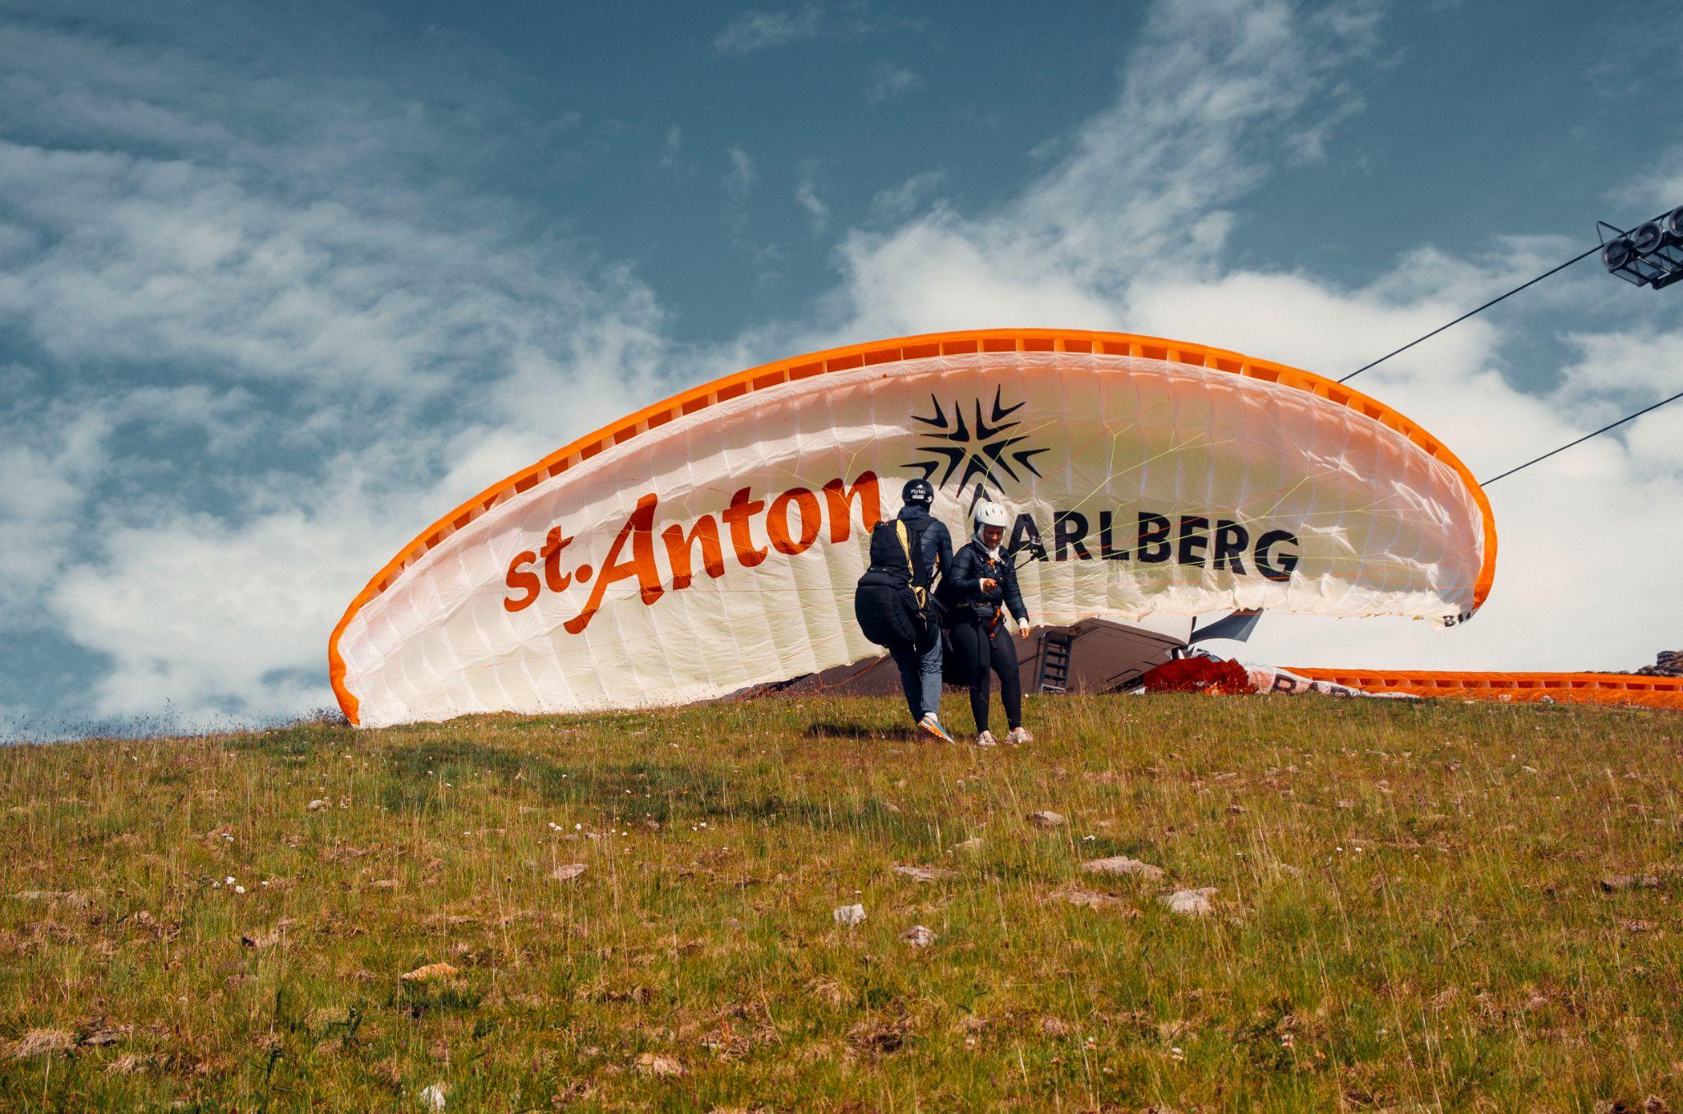
A tandem paragliding flight over St. Anton am Arlberg offers unimagined views of the Tyrolean mountains to holidaymakers with a good head for heights. © TandemSky.at

Take a deep breath, feel terra firma slipping slowly away as you take off into sky: altitude-loving Alpine fans can admire the Tyrolean village and its surrounding region not only from the peaks, but from the air in St. Anton am Arlberg. While the municipality and its surrounding mountain landscape serves as an extensive training area for experienced paragliders, this wonderful experience is not just reserved for them. Accompanied by experienced pilots, tandem flights offer holidaymakers of every age an incredible bird's eye perspective - in both summer and winter. What to bring: sturdy shoes, gloves, long trousers and a warm jacket. The adventure starts near the mountain station of Kapall cable car. Intrepid adventurers can easily reach the meeting point at 2,328 metres above sea level in around 35 minutes, by using the Gampen and Kapall lifts. After take-off, tandem flyers experience a 10- to 15-minute-long spurt of pure adrenalin with the world at their feet, before coming back down to earth on a green area in the Nasserein district. The landing site may vary, depending on wind conditions. This excursion, which can be booked all year round, takes around 1.5 hours and costs € 175/person.

One portion of summit bliss, please!

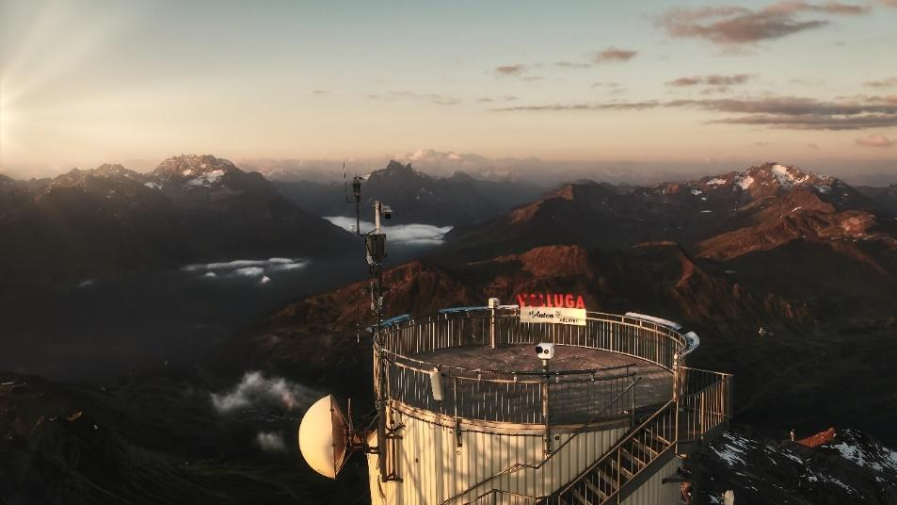
360 degrees of three-thousand-metre-high peaks at 2,811 Metern – those wanting to avoid the arduous ascent take the Arlberger Bergbahnen cable cars to Valluga summit. © St. Anton am Arlberg Tourist Board/Photographer Patrick Bätz

No matter whether you want to shorten a challenging hike to the viewing point or prefer to take a leisurely gondola ride from start to finish – Arlberger Bergbahnen cable cars make the upward journey to enjoy the view a little easier. Once at Valluga Peak, holidaymakers are surrounded by three-thousand metre-high mountains. Summit seekers with a good head for hikes can access the circular platform at 2,811 metres above sea level after completing two cable car connections and a descent to the valley terminal of Galzigbahn cable car. The first gondola change takes place on the eponymous mountain, before continuing with the Vallugabahn I cable car via the Steißbach Valley. The final section is a more technically original experience with the small blue Vallugabahn II gondolas transporting visitors up to the mountain station, 161 metres higher in just two minutes, where they find themselves on the border between Vorarlberg and Tyrol. Views extend from the Lechtal and Allgäu Alps across the Verwall and Ötztal Alps to Graubünden in Switzerland. Five countries blend into the scenery: Germany, Austria, Switzerland, Italy and Lichtenstein form the so-called five-country view. Cable cars are in operation from 14th June to 6th October 2024.

Tip: St. Anton Summer Card. Guests receive the “holiday ticket“ free of charge from accommodation providers as from their very first overnight stay. Benefits multiply, depending on the length of stay. For example, use of all cable car systems for one day is included for stays of three nights or more. www.sommerkarte.at

Further information is available from the Tourist Information Office in St. Anton am Arlberg/Austria
under +43 5446 2269-0 or www.stantonamarlberg.com

