Season kick-off 2024 at the Serfaus-Fiss-Ladis bike paradise – new single tracks, camps, workshops and the Bike Festival
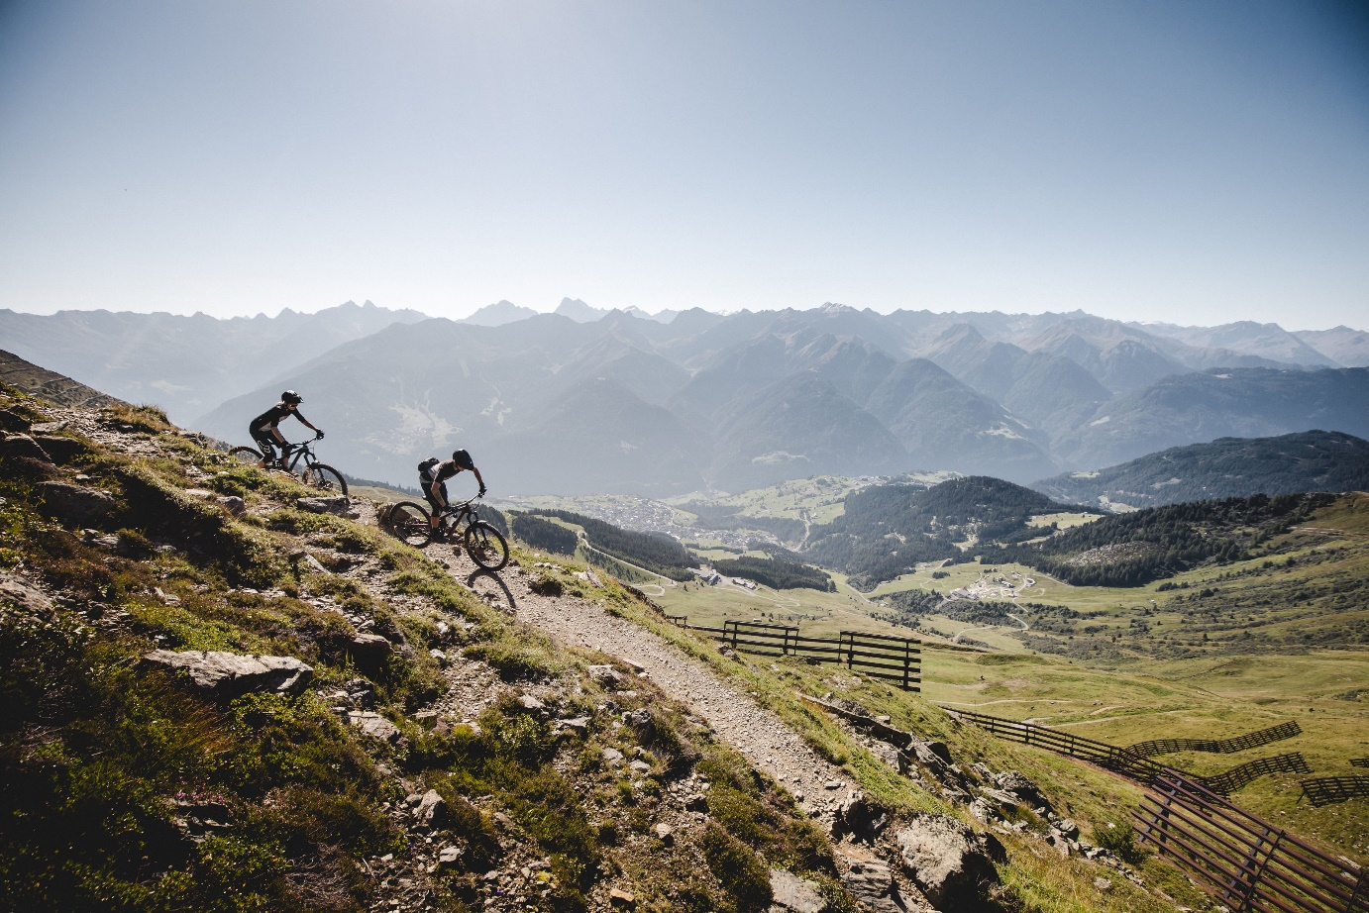
The family-friendly bike region of Serfaus-Fiss-Ladis kicks off the 2024 summer season on 15 June and is proud to add two brand new trails, the Leithetrail and the Bifitrail, to their mountain bike portfolio, raising the total number of single tracks to eight. Combined with nine bike park lines, the region now has more than 56 kilometres of trails, that make the hearts of all mountain bikers, no matter their ability, beat faster. In addition to trail novelties and well-loved classics, the bike destination also offers a packed calendar of events.

Situated on the sunny high plateau in the Tyrolean Upper Inntal valley at 1,200 to 1,400 metres above sea level, the Serfaus-Fiss-Ladis bike region often needs a little longer to break free from the grip of winter. However, from 15 June to the end of the season on 20 October, over 2,000 hours of sunshine per year guarantee the best biking conditions with picturesque views of the surrounding three thousand metre peaks.

Leithetrail, Bifitrail and more

Mountain bikers in Serfaus-Fiss-Ladis have always had the choice between (high) alpine single trails, such as the legendary Frommestrail or the new since 2023 Zirbentrail and the perfectly shaped lines at Bikepark Serfaus-Fiss-Ladis. This unique bike offer is aimed at experienced riders who are looking for challenging trail adventures or adrenaline packed downhill action as well as beginners and families alike, who are just learning the ropes on a bike. The two new single tracks in Serfaus-Fiss-Ladis, Leithetrail and Bifitrail, with their beginner-friendly character, are aimed more at mountain bike newcomers who want to venture into more challenging riding slowly and safely.

The 6.9-kilometre-long Bifitrail starts with a fantastic panorama and a combination of mellow rollers, easy turns and plenty of flow. The trailhead is reached via the Waldbahn cable car and then the Milky Way bike park line from which the Bifitrail branches off. With many berms, the trail winds its way down a total descent of 390 metres through mountain meadows and alpine forests to the Waldbahn bottom station. Northshore elements, rollers and corners provide a great variety, especially in the last section. Despite the green level of the trail, more advanced mountain bikers will also get their money's worth here thanks to numerous small obstacles.

If you branch off right from the Bifitrail after a few hundred metres, you’ll find yourself on the 4.3-kilometre-long Leithetrail. The blue trail connects the bike park with the single trails around Serfaus. It starts with small rollers, doubles and easy berms before alternating between steep bends and Northshore elements further down. From the middle station of the Komperdellbahn cable car - via which you can also reach the Scheid, Alpkopf or Högtrail - the trail continues down into the valley with plenty of flow. The Leithetrail ends at the valley station of the Alpkopfbahn and Komperdellbahn.

Workshops, camps and Bike Festival

Of course, a successful bike season in Serfaus-Fiss-Ladis also includes the camps and workshops, which offer bike guests the opportunity to improve their skills within a group of like-minded people. Various women's workshops are planned, as well as men's and women's camps and, of course, the renowned Propain Rookie Camp, which will take place this year from 5-9 August.

Around a month later, from 6-8 September, the Bike Festival Serfaus-Fiss-Ladis will take place for the second time. Just like last year, a great programme awaits festival guests. With an expo area and free testing opportunities on the event site, music from Mountain Reggae Radio and a trampoline park, party atmosphere is guaranteed. Furthermore, you can put your bike skills to the test at the Cash for Trick Sessions on the pump track or at the Braap Off Session – and of course on the above-mentioned bike park lines and single tracks.

For more information on biking in Serfaus-Fiss-Ladis, visit: www.bike-sfl.at/en.
Details about the holiday region Serfaus-Fiss-Ladis can be found at: www.serfaus-fiss-ladis.at/en.
Find us on:

#serfausfissladis #wearefamily #weilwirsgeniessen
#bikesfl #bikeparksfl #bikeschulesfl #gooddaysfl #propain

PUBLICATION FREE OF CHARGE
COPY/LINK REQUESTED

Text and image download: www.bike-sfl.at/en/service/press

For media requests:

Serfaus-Fiss-Ladis Tourist Board
Alexandra Hangl
Gänsackerweg 2
6534 Serfaus, Austria
Phone: +43 (0)5476 6239 72
Email: a.hangl@serfaus-fiss-ladis.at

About the region Serfaus-Fiss-Ladis
Serfaus-Fiss-Ladis is the place to be for a family holiday. Regardless of whether it is summer or winter, there is always something going on. In summer cable cars and bus shuttles connect the mountainous region of Serfaus-Fiss-Ladis apart from many other attractions, the Serfaus-Fiss-Ladis high plateau offers bike fun for the whole family. From gentle bike rides for the whole family to mountain bike tours in the middle of breath-taking mountain scenery to action-packed descents on single trails or courses through Bikepark Serfaus-Fiss-Ladis. The Waldbahn takes riders and their bikes to the trails within the bike park, which have different levels of difficulty, from blue (easy) and red (medium) to black (expert). There is also a kid's park, slopestyle area with an air bag, pump track, dirt line and training area at the bottom station, where beginners can try out and get used to their new equipment. Experts in the bike shop advise on bike and safety equipment matters, and the bike school and rental office shop can also be found here. Besides the shop, there is also a chill-out area and a snack bar.

