Start of the 2024/25 Ski Season in St. Anton am Arlberg

**A new winter beckons**

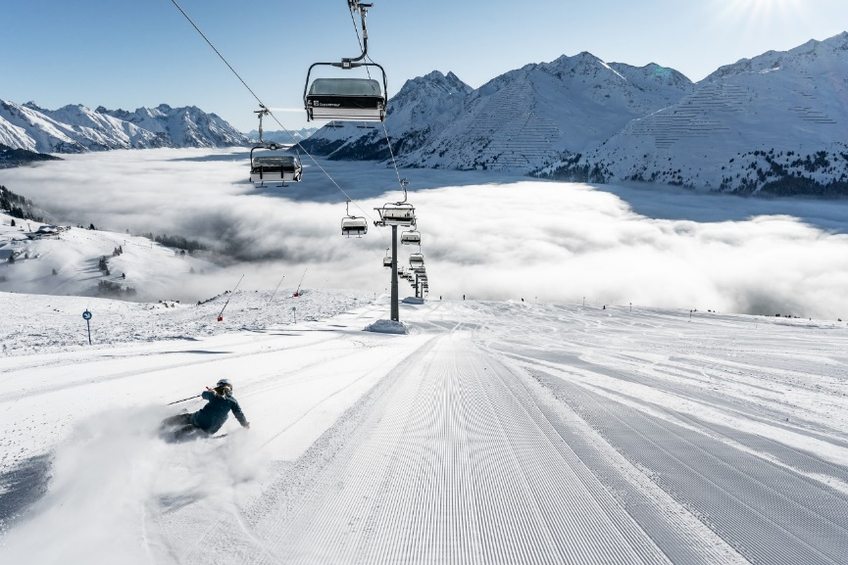

4th December 2024 marks the start of the new winter season in the Tyrolean region of St. Anton am Arlberg.

© TVB St. Anton am Arlberg/Photographer Patrick Bätz

**As snow slowly swathes the mountains of St. Anton am Arlberg, its hospitality providers eagerly await the start of the new winter season. The winter season in this Tyrolean mountain village kicks off, in fact, before Stanton Ski Open (6th to 8th December 2024): namely on Wednesday 4th December, when  
St. Anton's accommodation providers and the ski lifts in Austria's largest interconnected ski area start the new season.** [**www.stantonamarlberg.com**](https://www.stantonamarlberg.com)

**New and proven attractions: what guests can look forward to in winter 2024/25**

Excitement for the spectacular season-finale starts early in the sports-loving resort of St. Anton am Arlberg: [registration](https://der-weisse-rausch.at/at/information/anmeldung) for the iconic **White Thrill Race** (19th April 2025), which heralds the end of the ski season in the Tyrolean mountain village, opens on 1st December 2024. The limited starting places are usually snapped up in no time at all. Those keen to clock up as many downhill kilometres as possible, can sign up for the new **Race the Arlberg** [app challenge](https://www.stantonamarlberg.com/de/winter/skigebiet/race-the-arlberg), which offers the chance to win two one-day ski passes every month. The traditional Tyrolean cuisine served in the mountain huts is just as impressive as the more sophisticated culinary delights offered by one of the highest **gourmet restaurants** in Europe. **ARL ONE** (the former Heustadl) right next to the downhill valley run, offers a new and innovative culinary experience. Local ski hero, Mario Matt, double World Champion and Olympic Champion in slalom skiing, will soon be managing it as an exclusive après-ski bar. DJ Ötzi (singer of the famous “Anton aus Tirol“) will be on hand to perform an exclusive concert at the opening on 14th December. That same weekend, St. Anton will once again become the **pickleball** capital at the European finals, before hosting the **Audi FIS Ski World Cup Women** in January 2025, when the international women's ski elite will compete in the Downhill and Super-G disciplines.

And while we’re talking of highlights: train travellers can reach the mountain village comfortably and environmentally friendly via the **world’s highest ICE intercity train station** and disembark right in the village centre. So, no matter whether you are coming for one of the many events, a short trip or to improve your skiing skills, as a beginner or accomplished skier: another fascinating winter in St. Anton am Arlberg is just about to begin.

**Stanton Ski Open – training, tests and tunes**

**Ein Bild, das Konzert, Musik, Ort für Musikveranstaltungen, Rockkonzert enthält.
Ein Bild, das draußen, Schnee, Person, Himmel enthält.
**

While concerts by “Avaion“, or “Stompin' Howie and The Voodoo Train“ get the good vibes going at Stanton Ski Open on 6th and 7th December 2024 (left), participants at the Arlberg Safety Camp on 8th December learn all about avalanche safety (right).

© TVB St. Anton am Arlberg/Photographer Patrick Bätz

Welcome back to the birthplace of alpine skiing! St. Anton am Arlberg celebrates the first days of the new winter season with [Stanton Ski Open](https://www.stantonamarlberg.com/de/events/winter/start-der-wintersaison) from **6th to 8th December 2024**, featuring concerts on three stages and an array of food trucks. Throughout the opening weekend, guests can test the latest ski and snowboard models from leading manufacturers for free on the slopes of Austria's largest interconnected ski area. A lecture on avalanche awareness and practical training are on the programme at Arlberg Safety Camp, which is held in cooperation with the Tyrolean Mountain Rescue Services (registration required). Stanton Ski Open 2024 then ends on Sunday evening with “Advent Magic in the Park“ at the museum.

**Tip**: The successful annual RTL II show will be hosted by the Mooserwirt next to the St. Anton am Arlberg valley run again this year on the 6th and 7th December. International stars from the entertainment scene are expected to attend the TV recordings of the **“Après Ski Hits”** and **“Schlagerliebe”** TV shows, admission for visitors is free.

**Just like in the good old days – Advent Magic in the Park**

**Ein Bild, das draußen, Kleidung, Person, Menschen enthält.
**

From 1st December 2024, the “Christmas Adventure Trail“ will spread “Advent Magic” no less than five times in the Tyrolean mountain village of St. Anton am Arlberg. © TVB St. Anton am Arlberg/Photographer Patrick Bätz

A festive atmosphere pervades the streets of St. Anton am Arlberg even before the start of the new ski season: the bells will ring out for the first [Advent Magic in the Park](https://www.stantonamarlberg.com/de/events/winter/adventzauber-im-park) on **1st December 2024.** The beautifully designed Christmas adventure trail leads through the park of St. Anton Museum, where themed areas invite you to linger and sample local specialities, like the typical “Kiachla” (delicious warm doughnuts topped with jam or sauerkraut). Additional dates: 8th, 15th, 21st and 22nd December 2024.

**Arlberg Pickleball Championship – European Finals**

**Ein Bild, das Sport, Sportspiele, Sportausrüstung, Schlägersportarten enthält.
**

Four European events culminate in the grand finale in Tyrol – from 13th to 15th December 2024, the best players will once again compete for the title at the European Finals of the Arlberg Pickleball Championship in St. Anton am Arlberg.

© TVB St. Anton am Arlberg/Photographer Patrick Bätz

In accordance with the “Road to Arlberg“ motto, the best pickleball players in Europe were able to collect points at tournaments in Rota (Spain), Shropshire (UK), Nyköping (Sweden) and Stuttgart (Germany) over the past few months to qualify for the Arlberg Pickleball Championship European Finals. **From 13th to 15th December 2024**, St. Anton am Arlberg will once again host the largest event of its kind in Austria. Participants will be competing for prize money totalling 20,000 euros, and entry for spectators is free. In addition to the ‘Invitation’ competition with matches between the 40 best European players, there will be an ‘Open Tournament’ for amateurs in various categories at Arlberg WellCom. [www.arlberg-pickleball.com](http://www.arlberg-pickleball.com/)

**Audi FIS Ski World Cup Women – Arlberg Kandahar Rennen**

**Ein Bild, das draußen, Schnee, Himmel, Skigebiet enthält.
**

Every hundredth of a second counts: athletes will face the challenging Karl-Schranz racecourse as part of the Audi FIS Ski  
World Cup Women in St. Anton am Arlberg on 11th and 12th January 2025. © GEPA pictures

St. Anton am Arlberg is an integral part of the international World Cup circuit. After junior talents competed on the famous Karl-Schranz racecourse at the Junior World Championships at the beginning of 2023, big names in the world of ski racing are now eagerly anticipating one of the world’s most challenging racecourses. The international women’s ski elite will compete in the two fastest alpine disciplines at the Audi FIS Ski World Cup Women on **11th and 12th January 2025,** when participants battle for precious hundredths of a second, coveted World Cup points and sporting prestige. [www.worldcup-stanton.com](http://www.worldcup-stanton.com)

**Travel with ICE express to the village centre**

The ”Ski Express Tirol“ rail service has been operating regularly as an ICE (intercity express) direct from Hamburg via Munich to St. Anton am Arlberg since winter 2022/23 – setting a milestone in mobility for the tourist region. St. Anton am Arlberg (1,303 metres above sea level), is home to the world's highest ICE station. Visitors to the entire holiday region can easily reach their destinations without a car, as buses shuttle regularly to and from all parts of the village and surrounding regions in the Stanzer Valley. Those staying directly in St. Anton am Arlberg can make the most of the convenient location and access everything on foot anyway. Thanks to the new [GreTA](https://www.stantonamarlberg.com/de/die-region-st-anton-am-arlberg/anreise/anreise-planen) (Green Travel Alternatives) tool, guests can coordinate their journey from the first to the last metre with regard to creating the smallest possible CO2 footprint.

***About St. Anton am Arlberg.*** *St. Anton am Arlberg is one of the world’s most renowned winter sports resorts. Piste and freeride fans from more than 50 nations visit the mountain village and its ski area every year, which offers a total of more than 300 kilometres of marked downhill runs, 200 kilometres of off-piste variants and 85 lifts and cableways. The Arlberg-Arena extends from St. Anton am Arlberg in Tyrol to Stuben, Lech and Zürs, as well as Warth and Schröcken in Vorarlberg. Cross-country skiing, winter hiking or a thrilling ride on one of the five winding toboggan runs in the region are just as inherent to the inimitable Arlberg experience as its iconic events, international sporting events and multi-award-winning Tyrolean cuisine. The “birthplace of alpine skiing” is also a founding member of the “Best of the Alps“; a quality association comprising of the 10 most prestigious mountain resorts in the Alps.*