**Trailrunning Retreats in Wipptal: Training and Alpine Performance in Untouched Nature**Wipptal, known for its pristine nature and breathtaking mountain landscapes, invites trail running enthusiasts to unforgettable retreats. These events, focused on technique, endurance, and mental strength, offer everything a trail runner's heart desires.

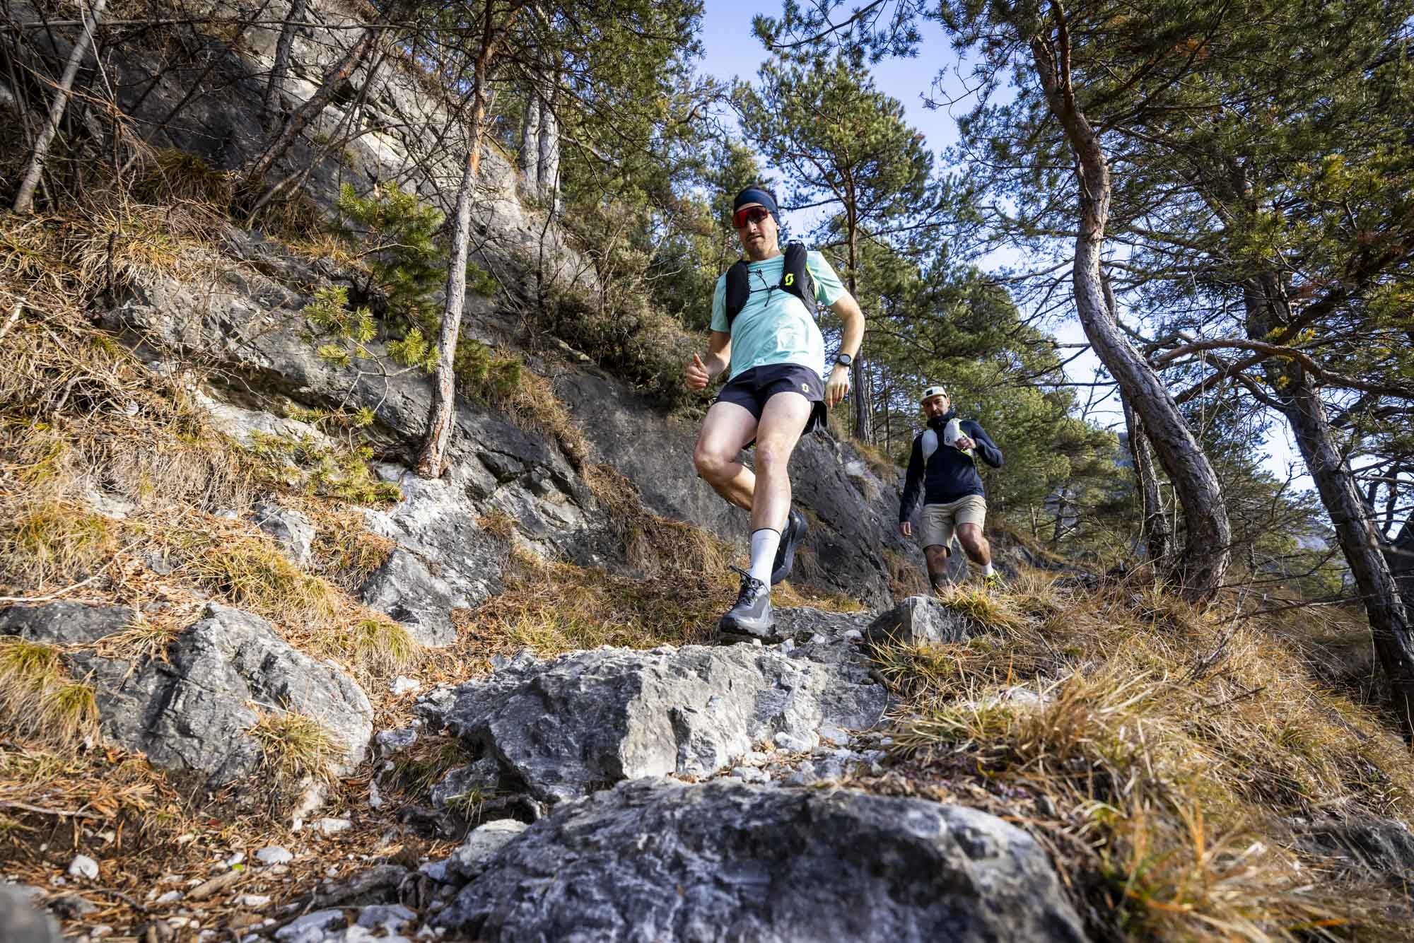

**Trail Running for Every Level**

Whether you're just starting out or already an experienced runner, our retreats are tailored to the needs and abilities of all participants. Beginners kick off in May with the Training Retreat at the JUFA Hotel in Steinach, where they learn the fundamentals of trail running in a relaxed and supportive atmosphere. More experienced runners can take part in the Alpine Performance Retreats in July and September.



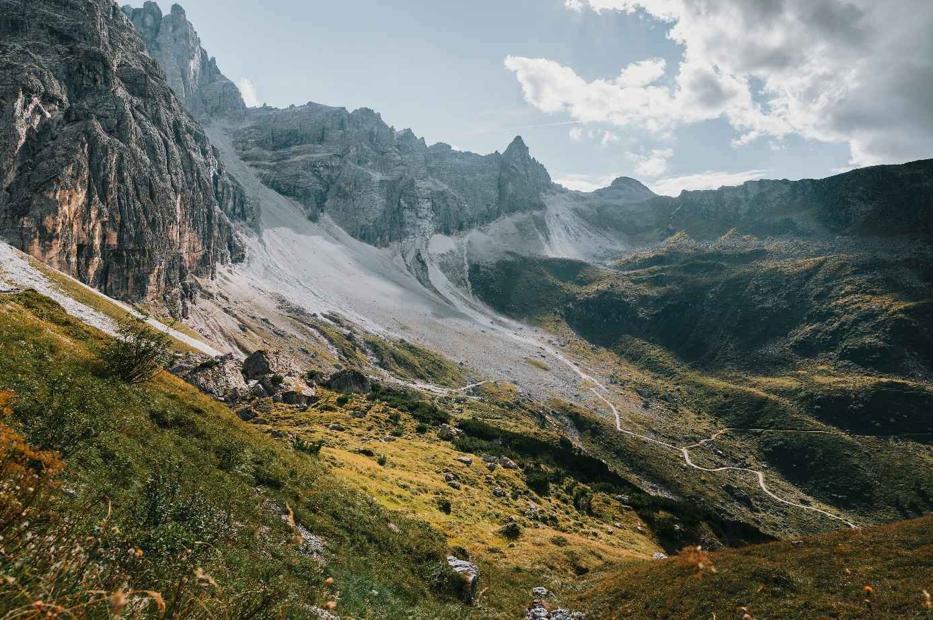

**Guided by Experts**

Participants benefit from the guidance of experienced and ASTA-certified trail running guides, certified physiotherapists, and nutrition coaches. In addition to technique tips, there is time for recovery sessions or a refreshing ice bath in a mountain stream. The retreats are rounded off with optional yoga sessions and shared evening meals.

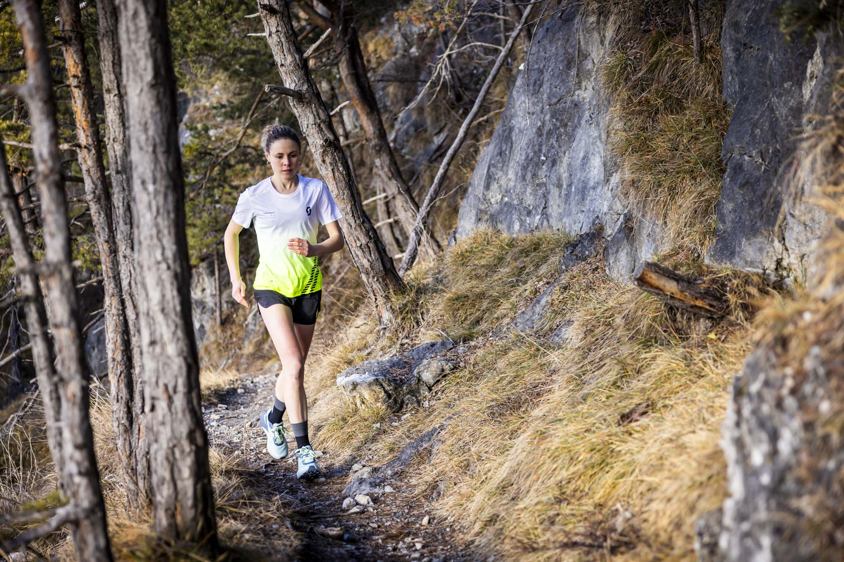

**Data en locaties**

**May 23 - May 25, 2025**: Training Focus, JUFA Hotel in Steinach  
**July 4 - July 6, 2025**: Alpine Performance Focus, Almi’s Berghotel in Obernberg  
**September 26 - September 28, 2025**: Alpine Performance Focus, JUFA Hotel in Steinach  
**Oktober 10 - Oktober 12, 2025**: Alpine Performance Focus, Almi’s Berghotel in Obernberg

The retreats can also be booked without accommodation upon request.

For more information on the Trail Running Retreats, [click here](https://www.wipptal.at/en/trailrunning).

**Introductory Course for Absolute Beginners**

If you want to try trail running for the first time, you have the opportunity from May to September: Every third Tuesday of the month, a two-hour introductory trail running course takes place. Bookable from April via the [‘eperience store’](https://www.wipptal.at/en/experience-store/experiences/experiences).

Bottom of Form