The Season’s Top Events and Dates 2025/26
139 Days of Winter in St. Anton am Arlberg

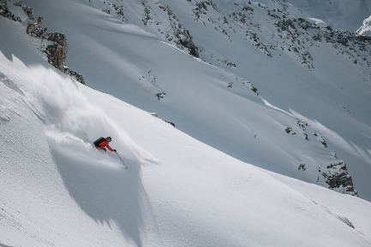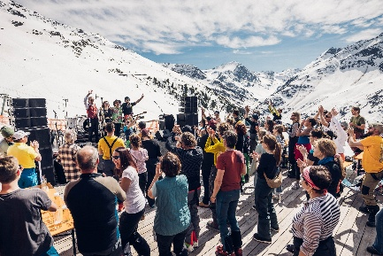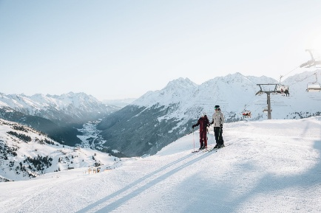
Glorious mountain sports, world-class events, and countless highlights – the ski season in St. Anton am Arlberg/Tirol runs from 3rd December 2025 to 19th April 2026. © TVB St. Anton am Arlberg/Eva Beer (left & right); Simon Rainer (centre)

Feel the chill mountain air as you carve powerful, elegant turns while leaving huge elevation differences in your wake. You can stop dreaming now – as winter is only just around the corner! Hotels and ski lifts in St. Anton am Arlberg open for the new season on Wednesday, 3rd December 2025. The first big weekend, “Stanton Ski Open” (5th-7th December), kicks off with a lively welcome concert by the brass-pop crossover band Fäaschtbänkler, performing on stage at Arlberg WellCom. With 300 km of marked slopes and 200 km of off-piste terrain, this legendary ski region is renowned as one of the largest and most prestigious in the world. The winter season runs all the way through until 19th April 2026. Visit www.stantonamarlberg.com for more information.

Training, Tests and Tunes

The winter season in St. Anton am Arlberg traditionally kicks off with several stages and food trucks as part of the Stanton Ski Open (5th-7th December). The festival weekend includes free ski and snowboard tests, the Arlberg Safety Camp, and a concert by "Fäaschtbänkler" on Sunday evening, 7th December (tickets available at www.stanton-tickets.at). No sooner does that curtain fall than the next big event takes centre stage: just two weeks later, from 19th to 21st December, St. Anton hosts the Arlberg Pickleball Championship – European Finals, where the continent’s best pickleball players – all qualified through tournaments – will battle it out. Spectator entry is free.

Festive cheer sets in even before the ski season begins: the first bells for Advent Magic in the Park will ring out on 30th November, with further dates for the Christmas Adventure Trail on: 8th, 14th, 20th and 21st December. Then, on 30th December, the ski slope transforms into a vast open-air cinema with 150 performers on skis, presenting a whistle-stop tour through winter sport history: the spectacular 45-minute “Schneetreiben” ski show at the Karl Schranz-Finish Stadium. Those seeking a more exclusive experience can watch from the Show-Lounge or from the stadium rooftop under the stars. Limited tickets cost €46 per person, including buffet and drinks. From 7th January 2026, the show will take place every Wednesday at 21 hrs.

Great Ambitions and High-Octane Events

After the Women’s World Cup 2025 saw the stars of international ski racing tackle the Karl Schranz run, it’s now the turn of the rising generation to confront the challenges presented by one of the world’s most demanding racing slopes. On 19th/20th January 2026, they will compete in the FIS Ski European Cup Women in St. Anton am Arlberg, much to the delight of locals and guests who can learn a thing or two from the best in the field.

Then, as springtime skiing begins, the 12th Tanzcafé Arlberg Music Festival (April 2026) draws a host of international acts to St. Anton am Arlberg and St. Christoph in Tyrol, as well as Stuben, Lech and Zürs in Vorarlberg. Holidaymakers can look forward to eclectic music, buzzing dance floors and live stages – all just a few turns away from some of the world’s best ski runs. And finally, on 18th April 2026, the legendary White Thrill downhill race brings the season to a dramatic close, when 555 athletes from around the globe hurtle en masse from the Vallugagrat, plunging down 7.5 km of ungroomed terrain in one breathless dash. Some aim for glory, others for sheer enjoyment – but all will feel the fire of winter’s last great challenge.

Practical Information for Holidaymakers

Getting here. Those travelling by train will alight directly in the village centre of St. Anton am Arlberg. The Tyrolean resort is home to the world’s highest official ICE railway station (1,304 m). Austrian Railways (ÖBB) also offer combined travel-and-lift-pass tickets for guests from selected regions.

Getting around. Regular buses connect the different parts of the resort and the neighbouring villages in the Stanzertal valley. If you’re staying in St. Anton itself, everything is within easy walking distance.

Children’s ski pass. Despite its reputation as a sporty destination, the ski area caters brilliantly for younger guests, with 128 km of blue runs and plenty of gentle practice slopes. Children up to the age of 8 (born in 2018 or later) can get the “Snowman Card” season pass for just €11.

Cross-country skiing – from leisurely to sporty. St. Anton am Arlberg boasts a 40 kilometre network of trails, awarded Tirol’s seal of quality thanks to its reliable snow, excellent variety and clear signage. Most trails also have a skating track.

Alpine wellness on winter walks. Fresh air, crunching snow and a healthy dose of altitude training come free of charge: around 80 kilometres of trails on 31 winter walking routes await in St. Anton am Arlberg. If you fancy trying snowshoeing, local ski schools offer guided tours.

Springtime is ski touring time. From March, conditions are perfect in St. Anton am Arlberg for tours into the white wilderness, especially with the soft “firn” snow that appears as the days grow longer and warmer. Certified mountain and ski guides are on hand to introduce beginners to equipment and safety basics – and even seasoned tourers are well advised to book a local guide.

Further tips:
- Arlberg winter via ferrata at Rendl
- Run of Fame ski circuit in memory of Arlberg legends
- Winter adventures: Out and about with huskies
- Verwall Valley and the Wagner Hut: winter paradise with a sociable meeting point
- Arlberg WellCom and Wellnesspark Arlberg Stanzertal
- arl.park indoor sports centre with trampoline hall

Green Arlberg Energy and Snow Pure Enough to Drink

St. Anton am Arlberg takes its environmental responsibilities seriously, with initiatives ranging from alternative energy and waste management to eco-friendly slope maintenance. As far back as 1921, the village was already generating green electricity with its first local hydroelectric power plant. Since 2006, this Tyrolean community has been completely energy self-sufficient. As an officially designated KLAR! Region, the people of St. Anton are actively engaged in wide-ranging sustainability and climate protection projects.

Today, 88 percent of the slopes in St. Anton am Arlberg can be covered with artificial snow. Following the principle of “as much as necessary, as little as possible“, piste machines use integrated GPS systems to measure snow depth in real time, allowing snowmaking to be carefully controlled and environmentally considerate. Tirol also enforces strict regulations, including a ban on chemicals. The snow crystals blown onto the slopes are made of nothing more than drinking quality water and air – later melting back into nature in spring. This meltwater, in turn, supports hydroelectric power generation in the valley, which then helps to power the snowmaking systems the following winter – creating a truly sustainable cycle.

For more information, please contact the Information Office, St. Anton am Arlberg, Austria
on +43 5446 2269-0 or www.stantonamarlberg.com

About St. Anton am Arlberg. With 85 cable cars and ski lifts, over 300 kilometres of marked downhill runs, and 200 kilometres of off-piste variants, St. Anton am Arlberg ranks among the most prestigious and largest ski regions in the world. In summer, this Austrian holiday region impresses with mountain activities and sporting events of all kinds against a spectacular Alpine backdrop. Holidaymakers with a taste for fine dining will appreciate the award-winning cuisine in this traditional Tyrolean mountain village. Since 2021, St. Anton am Arlberg has been an official Climate Change Adaptation Model Region and is home to the world's highest ICE train station at an altitude of 1,304 metres. Recognised as the "Best Tourism Village" by the UN World Tourism Organisation in 2023, the community has once again demonstrated that tourism and sustainability can thrive side by side.

