Springtime Skiing in St. Anton am Arlberg with speed, sunshine and ski touring:
Line-up announced for the Tanzcafé Arlberg Music Festival 2026
Welcome to the season at its most inviting

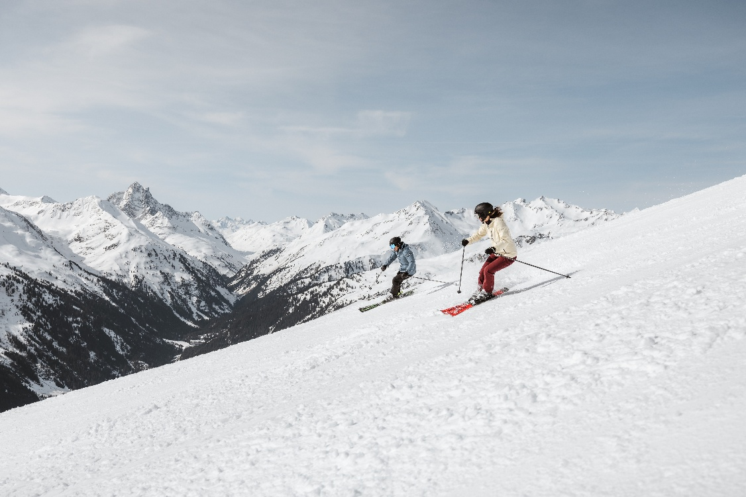
Bluebird ski days, sunglasses and sun-soaked winter moments right through to the end of April – many visitors regard the final weeks of winter in St. Anton am Arlberg/Tyrol as the best the season has to offer. © TVB St. Anton am Arlberg/Roman Huber

When the days grow longer from March onwards, springtime skiing begins in the Tyrolean mountain village of St. Anton am Arlberg. The snow reflects the sunlight more intensely, while the most inviting time of the season settles in on the terraces of the huts and restaurants. Long days on the pistes are paired with relaxed moments in deckchairs, and the ski touring season gets into full swing as enthusiasts make the most of the quiet light of early mornings. It’s a time for soaking up the sun, carving turns, dancing and singing along – especially when the Tanzcafé Arlberg Music Festival kicks off over the Easter weekend with an impressive line-up. The winter season ends on 19 April 2026. www.stantonamarlberg.com

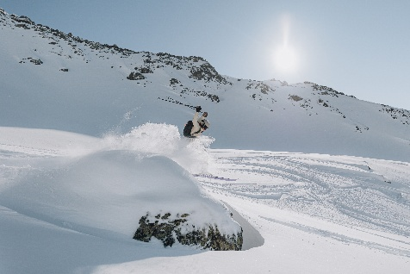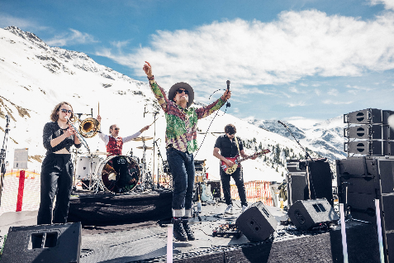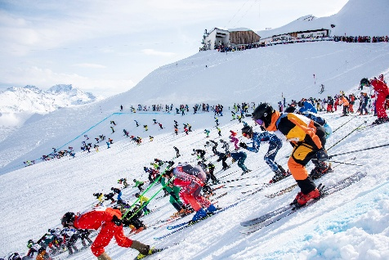
© TVB St. Anton am Arlberg/Eva Beer (le.) | Tanzcafé Arlberg/Simon Rainer (mi.) | TVB St. Anton am Arlberg/Patrick Säly (ri.)

Springtime is ski touring season. From late February onwards, St. Anton am Arlberg offers excellent conditions for venturing into the white expanses, particularly thanks to the firn snow that forms as days grow warmer and longer. Certified mountain and ski guides accompany newcomers, providing expert advice on equipment and safety. Even experienced ski tourers are advised to use the services of a local guide.

Springtime skiing continues both on and off the slopes well beyond Easter. On 4 April 2026, the Tanzcafé Arlberg Music Festival begins and runs through to the end of the season (19 April). Now in its 12th year, the concert series once again attracts numerous international acts to St. Anton am Arlberg and St. Christoph in Tyrol, as well as Stuben, Lech and Zürs in neighbouring Vorarlberg. The 2026 line-up includes Belgian singer Milow and British artist James Cottriall, alongside leading Austrian performers such as Julian le Play, Chris Steger, AVEC, Eli Preiss and Lemo. From the Easter weekend onwards, guests can enjoy an exciting programme of stage performances and dance floors just a few turns away from some of the world’s finest ski slopes. The full programme is available at www.tanzcafe-arlberg.com.

Those dancing legs will be called upon once more on 18 April 2026, as 555 international athletes gather at the Vallugagrat for the mass start of the legendary downhill race, The White Thrill. At the end of the 7.5-kilometre unprepared course, cheering crowds celebrate – in true Olympic spirit – not only the fastest competitors, but everyone bold enough to take on the challenge.

About St. Anton am Arlberg. With 85 cable cars and ski lifts, over 300 kilometres of marked downhill runs, and 200 kilometres of off-piste variants, St. Anton am Arlberg ranks among the most prestigious and largest ski regions in the world. In summer, this Austrian holiday region impresses with mountain activities and sporting events of all kinds against a spectacular Alpine backdrop. Guests with a taste for fine dining will appreciate the award-winning cuisine in this traditional Tyrolean mountain village. Since 2021, St. Anton am Arlberg has been an official Climate Change Adaptation Model Region and is home to the world's highest ICE train station at an altitude of 1,304 metres. Recognised as the "Best Tourism Village" by the UN World Tourism Organisation in 2023, the community has once again demonstrated that tourism and sustainability can thrive side by side.

